







Clean public areas, facilities and equipment
D1.HHK.CL3.02
Trainer Guide

Clean public areas, facilities and equipment

D1.HHK.CL3.02

Trainer Guide





Project Base
William Angliss Institute of TAFE
555 La Trobe Street
Melbourne 3000 Victoria
Telephone: | (03) 9606 2111
Facsimile: | (03) 9670 1330
Acknowledgements
Project Director: | Wayne Crosbie
Chief Writer: | Alan Hickman
Subject Writer: | Nick Hyland
Project Manager: | Alan Maguire
Editor | Jim Irwin
DTP/Production | Daniel Chee, Mai Vu, Jirayu Thangcharoensamut, Kaly Quach

The Association of Southeast Asian Nations (ASEAN) was established on 8 August 1967. The Member States of the Association are Brunei Darussalam, Cambodia, Indonesia, Lao PDR, Malaysia, Myanmar, Philippines, Singapore, Thailand and Viet Nam.
The ASEAN Secretariat is based in Jakarta, Indonesia.
General Information on ASEAN appears online at the ASEAN Website: www.asean.org.
All text is produced by William Angliss Institute of TAFE for the ASEAN Project on “Toolbox Development for Priority Tourism Labour Division”.
This publication is supported by the Australian Government’s aid program through the ASEAN-Australia Development Cooperation Program Phase II (AADCP II).
Copyright: Association of Southeast Asian Nations (ASEAN) 2012.
All rights reserved.
Disclaimer
Every effort has been made to ensure that this publication is free from errors or omissions. However, you should conduct your own enquiries and seek professional advice before relying on any fact, statement or matter contained in this book. The ASEAN Secretariat and William Angliss Institute of TAFE are not responsible for any injury, loss or damage as a result of material included or omitted from this course. Information in this module is current at the time of publication. Time of publication is indicated in the date stamp at the bottom of each page.
Some images appearing in this resource have been purchased from stock photography suppliers Shutterstock and iStockphoto and other third party copyright owners and as such are non-transferable and non-exclusive. Clip arts, font images and illustrations used are from the Microsoft Office Clip Art and Media Library. Some images have been provided by and are the property of William Angliss Institute.
Additional images have been sourced from Flickr and SXC and are used under Creative Commons licence: http://creativecommons.org/licenses/by/2.0/deed.en

File name: TG_Clean_public_areas_facilities_&_equipt_refined





Table of Contents
Competency Based Training (CBT) and assessment an introduction for trainers 1
Competency standard 11
Notes and PowerPoint slides 21
Recommended training equipment 203
Instructions for Trainers for using PowerPoint – Presenter View 205
Appendix – ASEAN acronyms 207

Competency Based Training (CBT) and assessment an introduction for trainers

Competency
Competency refers to the ability to perform particular tasks and duties to the standard of performance expected in the workplace.
Competency requires the application of specified knowledge, skills and attitudes relevant to effective participation, consistently over time and in the workplace environment.
The essential skills and knowledge are either identified separately or combined.
Knowledge identifies what a person needs to know to perform the work in an informed and effective manner.
Skills describe the application of knowledge to situations where understanding is converted into a workplace outcome.
Attitude describes the founding reasons behind the need for certain knowledge or why skills are performed in a specified manner.
Competency covers all aspects of workplace performance and involves:
- Performing individual tasks
- Managing a range of different tasks
- Responding to contingencies or breakdowns
- Dealing with the responsibilities of the workplace
- Working with others.

Unit of Competency
Like with any training qualification or program, a range of subject topics are identified that focus on the ability in a certain work area, responsibility or function.
Each manual focuses on a specific unit of competency that applies in the hospitality workplace.
In this manual a unit of competency is identified as a ‘unit’.
Each unit of competency identifies a discrete workplace requirement and includes:
- Knowledge and skills that underpin competency
- Language, literacy and numeracy
- Occupational safety and health requirements.
Each unit of competency must be adhered to in training and assessment to ensure consistency of outcomes.

Element of Competency
An element of competency describes the essential outcomes within a unit of competency.
The elements of competency are the basic building blocks of the unit of competency. They describe in terms of outcomes the significant functions and tasks that make up the competency.
In this manual elements of competency are identified as an ‘element’.

Performance criteria
Performance criteria indicate the standard of performance that is required to demonstrate achievement within an element of competency. The standards reflect identified industry skill needs.
Performance criteria will be made up of certain specified skills, knowledge and attitudes.

Learning
For the purpose of this manual learning incorporates two key activities:
- Training
- Assessment.
Both of these activities will be discussed in detail in this introduction.
Today training and assessment can be delivered in a variety of ways. It may be provided to participants:
- On-the-job – in the workplace
- Off-the-job – at an educational institution or dedicated training environment
- As a combination of these two options.
No longer is it necessary for learners to be absent from the workplace for long periods of time in order to obtain recognised and accredited qualifications.

Learning Approaches
This manual will identify two avenues to facilitate learning:
Competency Based Training (CBT)
This is the strategy of developing a participant’s competency.
Educational institutions utilise a range of training strategies to ensure that participants are able to gain the knowledge and skills required for successful:
- Completion of the training program or qualification
- Implementation in the workplace.
The strategies selected should be chosen based on suitability and the learning styles of participants.

Competency Based Assessment (CBA)
This is the strategy of assessing competency of a participant.
Educational institutions utilise a range of assessment strategies to ensure that participants are assessed in a manner that demonstrates validity, fairness, reliability, flexibility and fairness of assessment processes.

Flexibility in Learning
It is important to note that flexibility in training and assessment strategies is required to meet the needs of participants who may have learning difficulties. The strategies used will vary, taking into account the needs of individual participants with learning difficulties. However they will be applied in a manner which does not discriminate against the participant or the participant body as a whole.
Catering for Participant Diversity
Participants have diverse backgrounds, needs and interests. When planning training and assessment activities to cater for individual differences, trainers and assessors should:
- Consider individuals’ experiences, learning styles and interests
- Develop questions and activities that are aimed at different levels of ability
- Modify the expectations for some participants
- Provide opportunities for a variety of forms of participation, such as individual, pair and small group activities
- Assess participants based on individual progress and outcomes.
The diversity among participants also provides a good reason for building up a learning community in which participants support each other’s learning.
Participant Centred Learning
This involves taking into account structuring training and assessment that:
- Builds on strengths – Training environments need to demonstrate the many positive features of local participants (such as the attribution of academic success to effort, and the social nature of achievement motivation) and of their trainers (such as a strong emphasis on subject disciplines and moral responsibility). These strengths and uniqueness of local participants and trainers should be acknowledged and treasured
- Acknowledges prior knowledge and experience – The learning activities should be planned with participants’ prior knowledge and experience in mind
- Understands learning objectives – Each learning activity should have clear learning objectives and participants should be informed of them at the outset. Trainers should also be clear about the purpose of assignments and explain their significance to participants
- Teaches for understanding – The pedagogies chosen should aim at enabling participants to act and think flexibly with what they know
- Teaches for independent learning – Generic skills and reflection should be nurtured through learning activities in appropriate contexts of the curriculum. Participants should be encouraged to take responsibility for their own learning
- Enhances motivation – Learning is most effective when participants are motivated. Various strategies should be used to arouse the interest of participants
- Makes effective use of resources – A variety of teaching resources can be employed as tools for learning
- Maximises engagement – In conducting learning activities, it is important for the minds of participants to be actively engaged
- Aligns assessment with learning and teaching – Feedback and assessment should be an integral part of learning and teaching
- Caters for learner diversity – Trainers should be aware that participants have different characteristics and strengths and try to nurture these rather than impose a standard set of expectations.
Active Learning
The goal of nurturing independent learning in participants does not imply that they always have to work in isolation or solely in a classroom. On the contrary, the construction of knowledge in tourism and hospitality studies can often best be carried out in collaboration with others in the field. Sharing experiences, insights and views on issues of common concern, and working together to collect information through conducting investigative studies in the field (active learning) can contribute a lot to their eventual success.
Active learning has an important part to play in fostering a sense of community in the class. First, to operate successfully, a learning community requires an ethos of acceptance and a sense of trust among participants, and between them and their trainers. Trainers can help to foster acceptance and trust through encouragement and personal example, and by allowing participants to take risks as they explore and articulate their views, however immature these may appear to be. Participants also come to realise that their classmates (and their trainers) are partners in learning and solving.
Trainers can also encourage cooperative learning by designing appropriate group learning tasks, which include, for example, collecting background information, conducting small-scale surveys, or producing media presentations on certain issues and themes. Participants need to be reminded that, while they should work towards successful completion of the field tasks, developing positive peer relationships in the process is an important objective of all group work.

Competency Based Training (CBT)
Principle of Competency Based Training
Competency based training is aimed at developing the knowledge, skills and attitudes of participants, through a variety of training tools.
Training Strategies
The aims of this curriculum are to enable participants to:
- Undertake a variety of subject courses that are relevant to industry in the current environment
- Learn current industry skills, information and trends relevant to industry
- Learn through a range of practical and theoretical approaches
- Be able to identify, explore and solve issues in a productive manner
- Be able to become confident, equipped and flexible managers of the future
- Be ‘job ready’ and a valuable employee in the industry upon graduation of any qualification level.
To ensure participants are able to gain the knowledge and skills required to meet competency in each unit of competency in the qualification, a range of training delivery modes are used.
Types of Training
In choosing learning and teaching strategies, trainers should take into account the practical, complex and multi-disciplinary nature of the subject area, as well as their participant’s prior knowledge, learning styles and abilities.
Training outcomes can be attained by utilising one or more delivery methods:
Lecture/Tutorial
This is a common method of training involving transfer of information from the trainer to the participants. It is an effective approach to introduce new concepts or information to the learners and also to build upon the existing knowledge. The listener is expected to reflect on the subject and seek clarifications on the doubts.
Demonstration
Demonstration is a very effective training method that involves a trainer showing a participant how to perform a task or activity. Through a visual demonstration, trainers may also explain reasoning behind certain actions or provide supplementary information to help facilitate understanding.
Group Discussions
Brainstorming in which all the members in a group express their ideas, views and opinions on a given topic, is a free flow and exchange of knowledge among the participants and the trainer. The discussion is carried out by the group on the basis of their own experience, perceptions and values. This will facilitate acquiring new knowledge. When everybody is expected to participate in the group discussion, even the introverted persons will also get stimulated and try to articulate their feelings.
The ideas that emerge in the discussions should be noted down and presentations are to be made by the groups. Sometimes consensus needs to be arrived at on a given topic. Group discussions are to be held under the moderation of a leader guided by the trainer. Group discussion technique triggers thinking process, encourages interactions and enhances communication skills.
Role Play
This is a common and very effective method of bringing into the classroom real life situations, which may not otherwise be possible. Participants are made to enact a particular role so as to give a real feel of the roles they may be called upon to play. This enables participants to understand the behaviour of others as well as their own emotions and feelings. The instructor must brief the role players on what is expected of them. The role player may either be given a ready-made script, which they can memorise and enact, or they may be required to develop their own scripts around a given situation. This technique is extremely useful in understanding creative selling techniques and human relations. It can be entertaining and energising and it helps the reserved and less literate to express their feelings.

Simulation Games
When trainees need to become aware of something that they have not been conscious of, simulations can be a useful mechanism. Simulation games are a method based on "here and now" experience shared by all the participants. The games focus on the participation of the trainees and their willingness to share their ideas with others. A "near real life" situation is created providing an opportunity to which they apply themselves by adopting certain behaviour. They then experience the impact of their behaviour on the situation. It is carried out to generate responses and reactions based on the real feelings of the participants, which are subsequently analysed by the trainer.
While use of simulation games can result in very effective learning, it needs considerable trainer competence to analyse the situations.
Individual /Group Exercises
Exercises are often introduced to find out how much the participant has assimilated. This method involves imparting instructions to participants on a particular subject through use of written exercises. In the group exercises, the entire class is divided into small groups, and members are asked to collaborate to arrive at a consensus or solution to a problem.
Case Study
This is a training method that enables the trainer and the participant to experience a real life situation. It may be on account of events in the past or situations in the present, in which there may be one or more problems to be solved and decisions to be taken. The basic objective of a case study is to help participants diagnose, analyse and/or solve a particular problem and to make them internalise the critical inputs delivered in the training. Questions are generally given at the end of the case study to direct the participants and to stimulate their thinking towards possible solutions. Studies may be presented in written or verbal form.
Field Visit
This involves a carefully planned visit or tour to a place of learning or interest. The idea is to give first-hand knowledge by personal observation of field situations, and to relate theory with practice. The emphasis is on observing, exploring, asking questions and understanding. The trainer should remember to brief the participants about what they should observe and about the customs and norms that need to be respected.
Group Presentation
The participants are asked to work in groups and produce the results and findings of their group work to the members of another sub-group. By this method participants get a good picture of each other's views and perceptions on the topic and they are able to compare them with their own point of view. The pooling and sharing of findings enriches the discussion and learning process.
Practice Sessions
This method is of paramount importance for skills training. Participants are provided with an opportunity to practice in a controlled situation what they have learnt. It could be real life or through a make-believe situation.

Games
This is a group process and includes those methods that involve usually fun-based activity, aimed at conveying feelings and experiences, which are everyday in nature, and applying them within the game being played. A game has set rules and regulations, and may or may not include a competitive element. After the game is played, it is essential that the participants be debriefed and their lessons and experiences consolidated by the trainer.
Research
Trainers may require learners to undertake research activities, including online research, to gather information or further understanding about a specific subject area.

Competency Based Assessment (CBA)
Principle of Competency Based Assessment
Competency based assessment is aimed at compiling a list of evidence that shows that a person is competent in a particular unit of competency.
Competencies are gained through a multitude of ways including:
- Training and development programs
- Formal education
- Life experience
- Apprenticeships
- On-the-job experience
- Self-help programs.
All of these together contribute to job competence in a person. Ultimately, assessors and participants work together, through the ‘collection of evidence’ in determining overall competence.
This evidence can be collected:
- Using different formats
- Using different people
- Collected over a period of time.
The assessor, who is ideally someone with considerable experience in the area being assessed, reviews the evidence and verifies the person as being competent or not.
Flexibility in Assessment
Whilst allocated assessment tools have been identified for this subject, all attempts are made to determine competency and suitable alternate assessment tools may be used, according to the requirements of the participant.
The assessment needs to be equitable for all participants, taking into account their cultural and linguistic needs.
Competency must be proven regardless of:
- Language
- Delivery Method
- Assessment Method.
Assessment Objectives
The assessment tools used for subjects are designed to determine competency against the ‘elements of competency’ and their associated ‘performance criteria’.
The assessment tools are used to identify sufficient:
- Knowledge, including underpinning knowledge
- Skills
- Attitudes
Assessment tools are activities that trainees are required to undertake to prove participant competency in this subject.
All assessments must be completed satisfactorily for participants to obtain competence in this subject. There are no exceptions to this requirement, however, it is possible that in some cases several assessment items may be combined and assessed together.
Types of Assessment
Allocated Assessment Tools
There are a number of assessment tools that are used to determine competency in this subject:
- Work projects
- Written questions
- Oral questions
- Third Party Report
- Observation Checklist.
Instructions on how assessors should conduct these assessment methods are explained in the Assessment Manuals.
Alternative Assessment Tools
Whilst this subject has identified assessment tools, as indicated above, this does not restrict the assessor from using different assessment methods to measure the competency of a participant.
Evidence is simply proof that the assessor gathers to show participants can actually do what they are required to do.
Whilst there is a distinct requirement for participants to demonstrate competency, there are many and diverse sources of evidence available to the assessor.
Ongoing performance at work, as verified by a supervisor or physical evidence, can count towards assessment. Additionally, the assessor can talk to customers or work colleagues to gather evidence about performance.
A range of assessment methods to assess competency include:
- Practical demonstrations
- Practical demonstrations in simulated work conditions
- Problem solving
- Portfolios of evidence
- Critical incident reports
- Journals
- Oral presentations
- Interviews
- Videos
- Visuals: slides, audio tapes
- Case studies
- Log books
- Projects
- Role plays
- Group projects
- Group discussions
- Examinations.
Recognition of Prior Learning
Recognition of Prior Learning is the process that gives current industry professionals who do not have a formal qualification, the opportunity to benchmark their extensive skills and experience against the standards set out in each unit of competency/subject.
Also known as a Skills Recognition Audit (SRA), this process is a learning and assessment pathway which encompasses:
- Recognition of Current Competencies (RCC)
- Skills auditing
- Gap analysis and training
- Credit transfer.
Assessing competency
As mentioned, assessment is the process of identifying a participant’s current knowledge, skills and attitudes sets against all elements of competency within a unit of competency. Traditionally in education, grades or marks were given to participants, dependent on how many questions the participant successfully answered in an assessment tool.
Competency based assessment does not award grades, but simply identifies if the participant has the knowledge, skills and attitudes to undertake the required task to the specified standard.
Therefore, when assessing competency, an assessor has two possible results that can be awarded:
- Pass Competent (PC)
- Not Yet Competent (NYC).
Pass Competent (PC)
If the participant is able to successfully answer or demonstrate what is required, to the expected standards of the performance criteria, they will be deemed as ‘Pass Competent’ (PC).
The assessor will award a ‘Pass Competent’ (PC) if they feel the participant has the necessary knowledge, skills and attitudes in all assessment tasks for a unit.
Not Yet Competent’ (NYC)
If the participant is unable to answer or demonstrate competency to the desired standard, they will be deemed to be ‘Not Yet Competent’ (NYC).
This does not mean the participant will need to complete all the assessment tasks again. The focus will be on the specific assessment tasks that were not performed to the expected standards.
The participant may be required to:
a) Undertake further training or instruction
b) Undertake the assessment task again until they are deemed to be ‘Pass Competent’.

Competency standard
UNIT TITLE: CLEAN PUBLIC AREAS, FACILITIES AND EQUIPMENT |  |  |  | NOMINAL HOURS: | 60 hours
UNIT NUMBER: D1.HHK.CL3.02
UNIT DESCRIPTOR: This unit deals with skills and knowledge required to clean public areas, facilities and equipment, including nominated external areas.
ELEMENTS AND PERFORMANCE CRITERIA | UNIT VARIABLE AND ASSESSMENT GUIDE
Element 1: Apply leather upholstery cleaning techniques  - Assess leather upholstery to be cleaned  - Select appropriate equipment and chemicals  - Prepare work site  - Clean upholstery  - Tidy work site  - Clean, check and store equipment and chemicals  Element 2: Apply fabric upholstery cleaning techniques  - Assess fabric upholstery to be cleaned  - Select appropriate equipment and chemicals  - Prepare work site  - Clean upholstery  - Tidy work site  - Clean, check and store equipment and chemicals  Element 3: Apply glass surfaces cleaning techniques  - Assess glass areas to be cleaned  - Select appropriate equipment and chemicals  - Prepare work site  - Clean glass areas  - Tidy work site  - Clean, check and store equipment and chemicals  Element 4: Apply ceilings, surfaces and fittings cleaning techniques  - Assess ceilings, surfaces and fittings areas to be cleaned  - Select appropriate equipment and chemicals  - Prepare work site  - Clean ceilings, surfaces and fittings  - Tidy work site  - Clean, check and store equipment and chemicals  Element 5: Apply wet area cleaning techniques  - Assess wet areas to be cleaned  - Select appropriate equipment and chemicals  - Prepare work site  - Clean wet areas  - Tidy work site  - Clean, check and store equipment and chemicals  Element 6: Apply pressure washing techniques  - Assess area to be pressure washed  - Select appropriate equipment and chemicals  - Prepare work site  - Clean areas using pressure washer  - Tidy work site  - Clean, check and store equipment and chemicals  Element 7: Apply high level cleaning techniques  - Assess high level areas to be cleaned  - Select appropriate equipment and chemicals  - Prepare work site  - Clean high level areas  - Tidy work site  - Clean, check and store equipment and chemicals | Unit Variables  The Unit Variables provide advice to interpret the scope and context of this unit of competence, allowing for differences between enterprises and workplaces. It relates to the unit as a whole and facilitates holistic assessment.  This unit applies to all industry sectors that clean public areas, facilities and equipment within the labour divisions of the hotel and travel industries and may include:  1. Housekeeping.  The cleaning of public areas, facilities and equipment may apply to:  - Foyers, corridors, waiting areas and entrance areas  - Car parks, footpaths and external walkways  - Internal and external entertainment areas  - Facilities in public areas, such as tables and chairs, pianos, elevators and escalators, doors and windows  - Delivery bays  - Swimming pool areas  - Garden areas.  Assess leather upholstery may include:  - Determining style, condition and coloration  - Identifying type of soil  - Selecting the most appropriate cleaning techniques, including conducting spot testing.  Appropriate equipment and chemicals will vary between each type of cleaning to be undertaken and will depend on the assessment of the individual job, but may include:  - Personal protective equipment and clothing  - Specialist leather products/agents and leather cleaning kits  - Barrier paper, cleaning screens, cloths and towelling, sponges, drop sheets, chamois  - Hoses  - Ladders and mechanical devices for high level cleaning  - Measuring equipment and dilution/preparation of chemicals in accordance with manufacturer’s instructions  - Selected tools and hand tools  - Mechanical and electrical equipment  - Checking safety and operational readiness of items, including adjustment of items to suit intended work  - Safety signage  - Cleaners and chemicals, including acid, alkaline, neutral and solvent cleaners.  Prepare work site may include:  - Covering items to protect them  - Securing items against movement and damage  - Placement of physical barriers and safety signage  - Moving and removing furniture and fittings  - Notifying other staff and patrons  - Cooperating with others to minimize interruption  - Covering equipment, items, etc, with protective material, drop cloths, etc  - Identifying and complying with relevant in-house policies, procedures, or other emerging needs.  Clean upholstery may include:  - Removing soil  - Applying topical treatments as required  - Using personal protective equipment and clothing as required  - Adhering to internal work practices, job breakdown sheets and training  - Complying with all legal requirements of the host country  - Following manufacturer’s instructions in the use of chemicals and equipment.  Tidy work site may include:  - Disposing of collected soil and waste  - Complying with all environmental requirements  - Replacing furniture and fittings  - Removing signage and barriers.  Clean, check and store equipment and chemicals may include:  - Cleaning equipment that has been used  - Cleaning personal protective equipment and clothing that has been used, as appropriate  - Conducting safety checks on equipment  - Undertaking basic preventative maintenance and basic repairs on equipment  - Storing equipment in accordance with enterprise requirements  - Storing chemicals in accordance with legislated requirements and enterprise requirements  - Replenishing consumables.  Assess fabric upholstery will include:  - Identifying type, condition, colour fastness and construction of fabric upholstery  - Identifying type of soil  - Identifying topical treatment through observation and/or testing  - Selecting the most appropriate cleaning techniques, including conducting spot testing.  Assess glass areas may include:  - Inspecting for faults and defects  - Identifying type of soil  - Determining type of glass which may include:  - Coated glass  - Frosted glass  - Laminated glass  - Ordinary window glass  - Textured glass  - Treated glass  - Tinted glass  - Selecting the most appropriate cleaning techniques.  Clean glass areas may include:  - Fanning  - Pre-spraying  - Scraping  - Spot cleaning  - Using a squeegee  - Drying  - Polishing.  Assess ceilings, surfaces and fittings areas may relate to:  - Identifying type of ceiling to be cleaned, including flat, suspended or raked; hard or absorbent  - Identifying type of surface to be cleaned, such as painted, wood, brick, metal  - Identifying fittings to be cleaned, which can include cameras, ceiling fans, lights, smoke detectors, speakers, sprinkler systems, televisions, vents and grilles  - Identifying soil type  - Selecting the most appropriate cleaning techniques.  Clean ceilings, surfaces and fittings may include:  - Removing cobwebs  - Wet and dry dusting  - Vacuuming  - Spot cleaning  - Wiping  - Rinsing.  Assess wet areas may include:  - Identifying areas to be cleaned using wet cleaning techniques and confirming suitability for this type of cleaning  - Identifying soil type  - Confirming condition of the area and of equipment in it to be cleaned  - Assessing graffiti damage  - Selecting the most appropriate cleaning techniques.  Clean wet areas may include:  - Removing loose dust  - Treating heavy soil  - Treating graffiti  - Mopping  - Hosing  - Pre-spraying  - Scrubbing  - Spot cleaning  - Wet wiping.  Assess area to be pressure washed may include:  - Identifying areas to be pressure washed and confirming suitability for this type of cleaning  - Identifying soil type  - Identifying surface type, including brick, car park, concrete, entertainment seating, external walls, gutters and fascia boards, awnings and facades, painted surfaces, steps and stairwells  - Confirming condition of area and/or equipment in it to be cleaned.  Clean areas using pressure washer may include:  - Detailing and hand washing  - Pre-spraying  - Pressure water blasting  - Rinsing.  High level areas refers to any area or item that needs cleaning that is 2 meters or more above ground or floor level  Assess high level areas may include:  - Identifying areas to be cleaned  - Analysing optimum method to reach the required height for safe and effective cleaning  - Identifying soil type  - Selecting the most appropriate cleaning techniques.  Clean high level areas may include:  - Pressure washing  - Scrubbing  - Vacuuming  - Glass cleaning  - Dusting  - Wiping  - Spot cleaning.  Assessment Guide  The following skills and knowledge must be assessed as part of this unit:  - The enterprise’s policies and procedures in regard to occupational safety and health  - Principles of duty of care towards patrons and co-workers  - Ability to use a variety of cleaning techniques and cleaning items  - Knowledge of the safe chemical and manual handling skills  - Ability to use negotiation, communication and problem solving skills  - Knowledge of internal reporting and emergency response requirements  - Knowledge of waste handling techniques, including safe disposal of dangerous material, chemicals, bio-waste  - Planning and adaptation skills to enable cleaning activities at the preferred times.  Linkages To Other Units  - Clean and maintain industrial work area and equipment  - Implement occupational safety and health procedures  - Manage and resolve conflict situations.  Critical Aspects of Assessment  Evidence of the following is essential:  - Understanding of safe chemical storing and handling conditions  - Demonstrated ability to undertake a hazard assessment of the job to be done  - Demonstrated ability to calculate correct dilution and usage rates  - Demonstrated ability to assess the item/area to be cleaned  - Demonstrated ability to prepare work areas  - Demonstrated ability to clean nominated soils from nominated upholstery types  - Demonstrated ability to clean nominated soils from nominated glass surfaces  - Demonstrated ability to clean nominated soils from nominated ceilings, surfaces and fittings  - Demonstrated ability to clean nominated soils from nominated wet cleaning areas  - Demonstrated ability to pressure wash nominated soils from nominated surfaces, including the removal of graffiti  - Demonstrated ability to clean nominated soils from nominated high level areas  - Demonstrated ability to tidy work areas after cleaning  - Demonstrated ability to clean, safety and store equipment after use.  Context of Assessment  This unit may be assessed on or off the job  - Assessment should include practical demonstration either in the workplace or through a simulation activity, supported by a range of methods to assess underpinning knowledge  - In all instances, assessment of the job to be done must include a comprehensive hazard assessment  - Assessment must relate to the individual’s work area or area of responsibility.  Resource Implications  Training and assessment to include access to a real or simulated workplace; and access to workplace standards, procedures, policies, guidelines, tools and equipment.  Assessment Methods  The following methods may be used to assess competency for this unit:  - Case studies  - Observation of practical candidate performance  - Oral and written questions  - Portfolio evidence
- Problem solving
- Role plays
- Third party reports completed by a supervisor
- Project and assignment work.
Key Competencies in this Unit
Level 1 = competence to undertake tasks effectively
Level 2 = competence to manage tasks
Level 3 = competence to use concepts for evaluating
 | Key Competencies | Level | Examples
 | Collecting, organising and analysing information | 2 | Read instructions and labels, cleaning schedules
 | Communicating ideas and information | 1 | Report cleaning issues to others
 | Planning and organising activities | 2 | Schedule cleaning and maintenance activities
 | Working with others and in teams | 1 | Liaise with other staff to address identified needs and problems; and undertake cleaning activities to support emerging workplace demands
 | Using mathematical ideas and techniques | 2 | Calculate dilution rates for chemicals and cleaning agents
 | Solving problems | 1 | Identify soil types and surfaces to be cleaned
 | Using technology | 1 | Operate cleaning equipment

Notes and PowerPoint slides
Slide
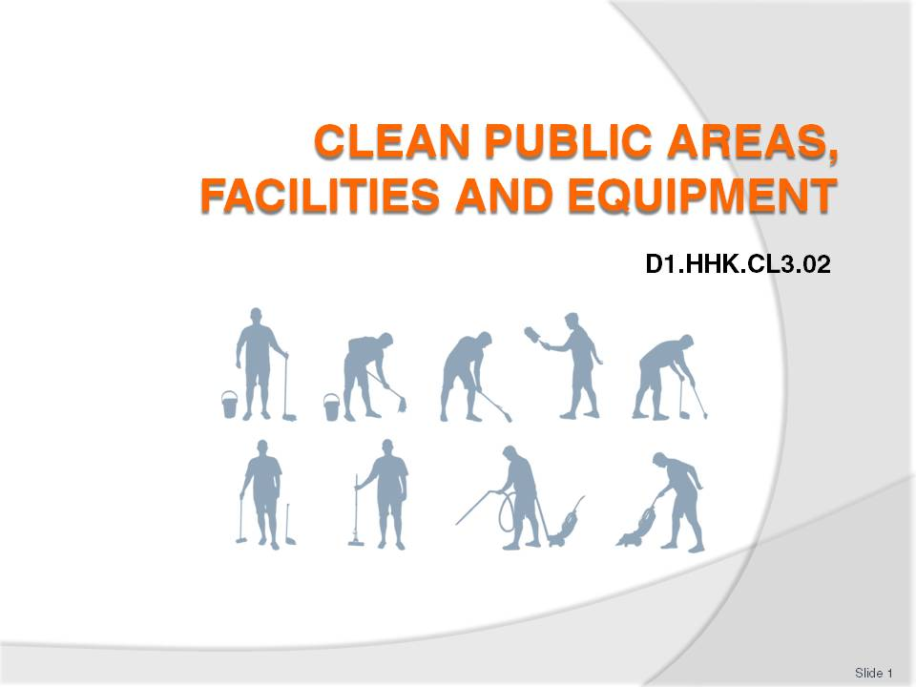
Slide No | Trainer Notes
 | Trainer welcome trainees to class.

Slide
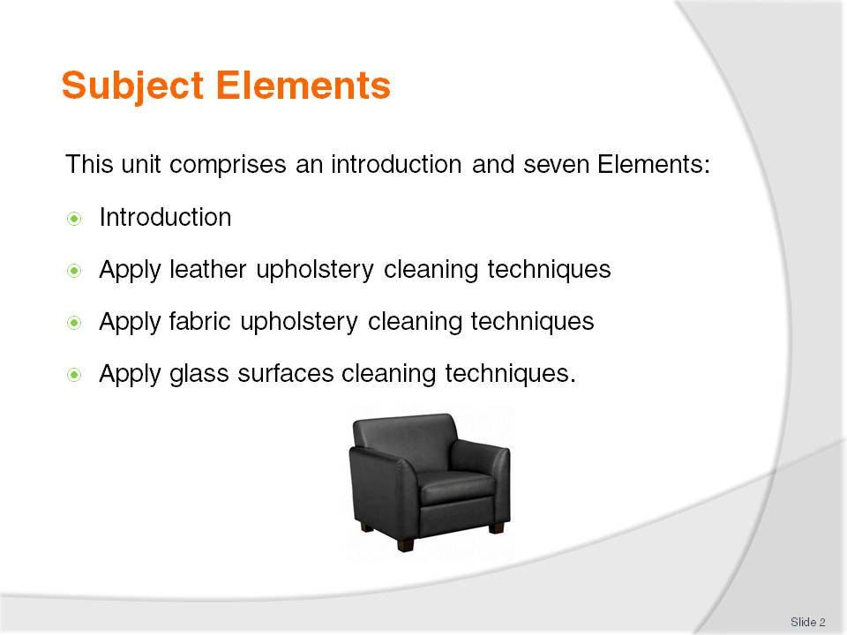
Slide No | Trainer Notes
Trainer advises this Unit comprises an introduction and seven Elements, as listed on this slide and the next slide explaining the introduction serves to provide detailed information relating to the cleaning of public areas.
Each Element comprises a number of Performance Criteria which will be identified throughout the class and explained in detail
Trainees can obtain more detail from their Trainee Manual
At times the course presents advice and information about various protocols but where their workplace requirements differ to what is presented, the workplace practices and standards, as well as policies and procedures must be observed.

Slide
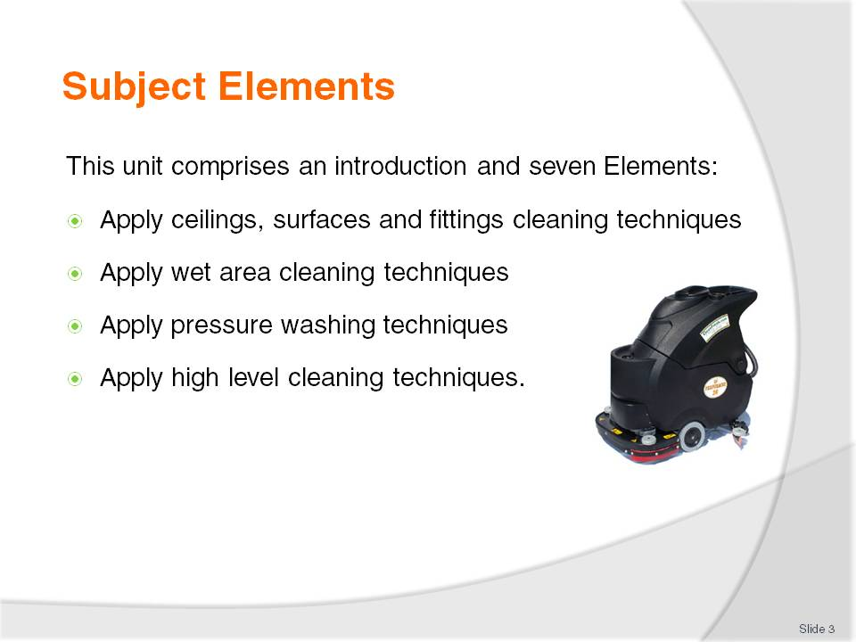
Slide No | Trainer Notes
Trainer advises this Unit comprises an introduction and seven Elements, as listed on this slide and the previous slide explaining the introduction serves to provide detailed information relating to the cleaning of public areas.
Each Element comprises a number of Performance Criteria which will be identified throughout the class and explained in detail
Trainees can obtain more detail from their Trainee Manual
At times the course presents advice and information about various protocols but where their workplace requirements differ to what is presented, the workplace practices and standards, as well as policies and procedures must be observed.

Slide
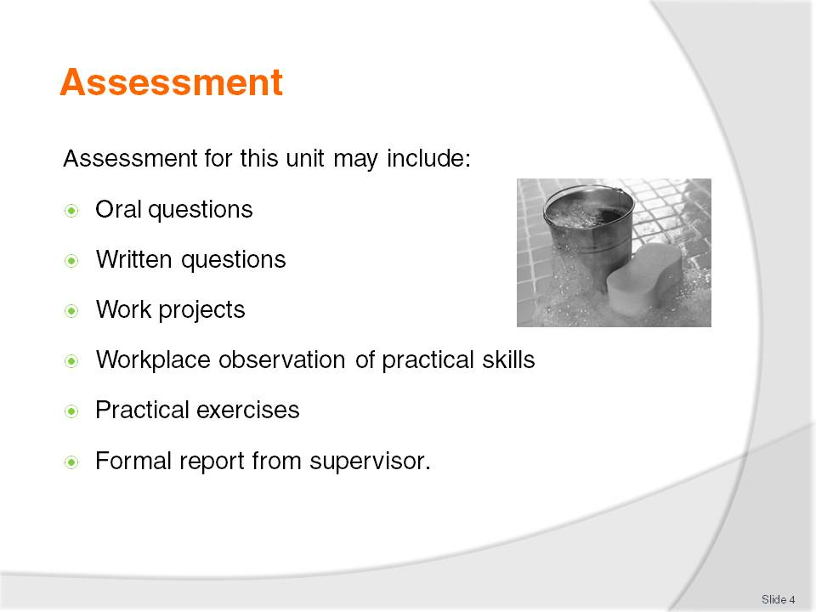
Slide No | Trainer Notes
Trainer advises that assessment for this Unit may take several forms all of which are aimed at verifying they have achieved competency for the Unit as required.
Trainer indicates the methods of assessment that will be applied to them for this Unit.

Slide
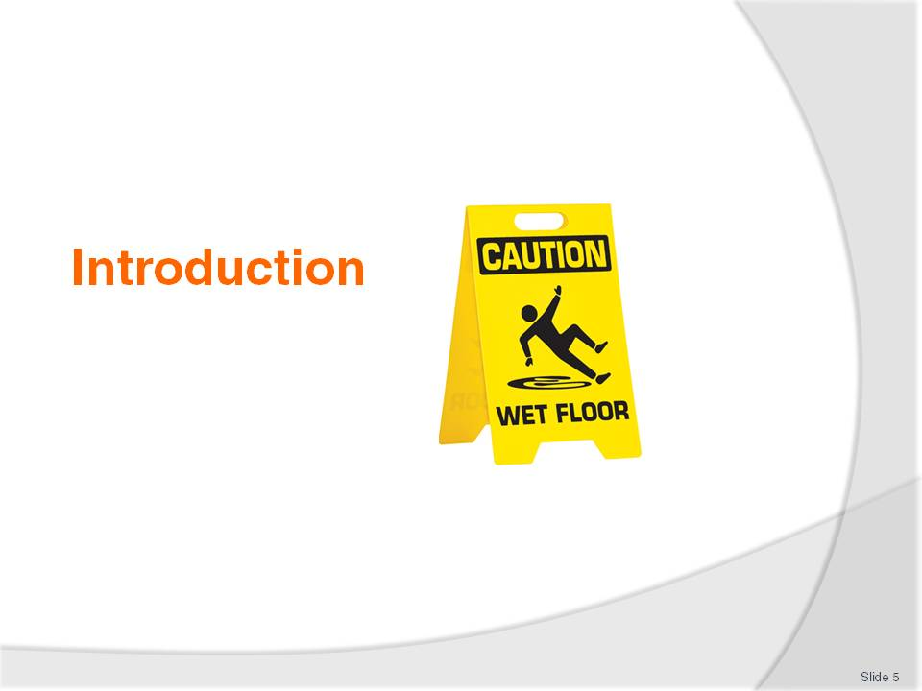
Slide No | Trainer Notes
Introduce topic.
Class Activity – General Discussion
Ask general questions:
What is a ‘public area’?
Who cleans a ‘public area’?
What types of cleaning need to be performed?
What is needed to be able to do this cleaning?

Slide
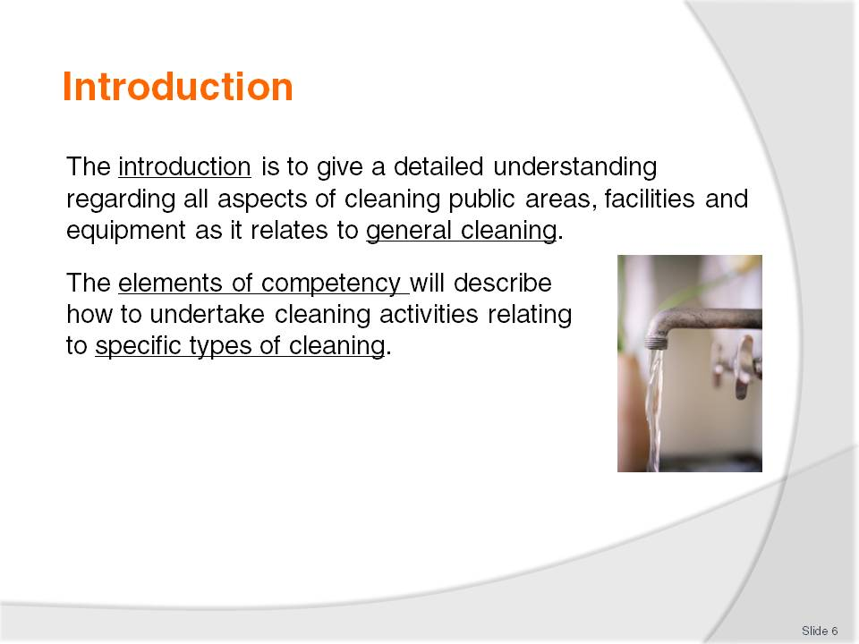
Slide No | Trainer Notes
Class Activity – Clarification
The introduction provides detailed information regarding cleaning. It applies to general cleaning.
Hence the introduction is quite extensive.
The elements of competency relates to specific types of cleaning. These will be smaller as they discuss separate cleaning activities.

Slide
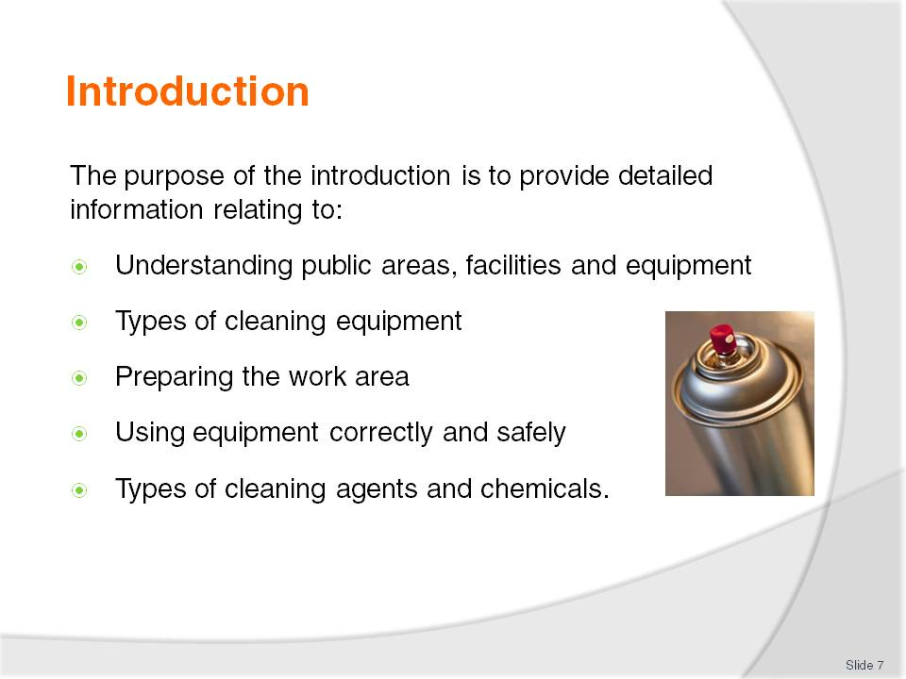
Slide No | Trainer Notes
Class Activity – General Discussion
Introduce the points.
These will be covered during the introduction.

Slide
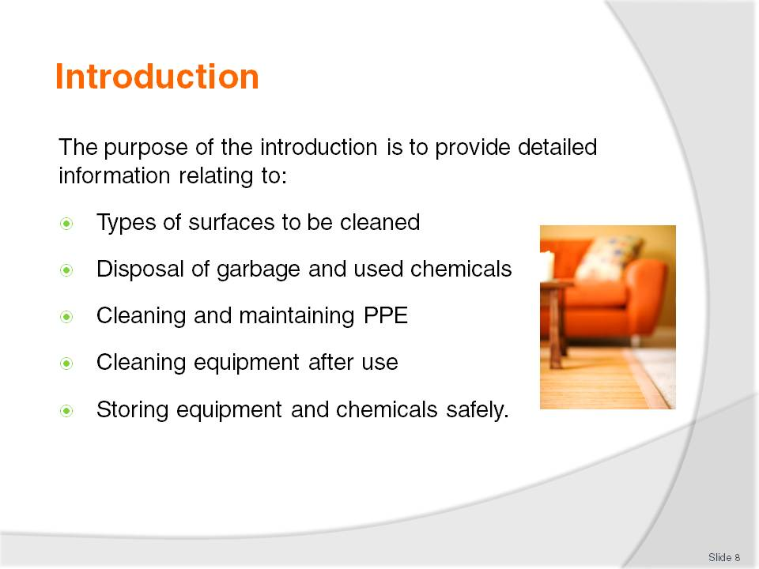
Slide No | Trainer Notes
Class Activity – General Discussion
Introduce the points.
These will be covered during the introduction.

Slide
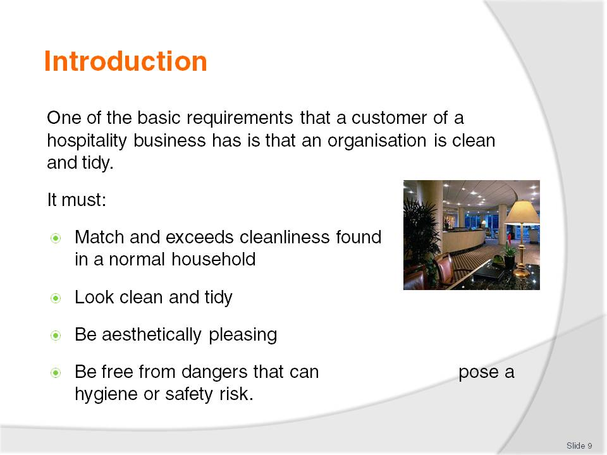
Slide No | Trainer Notes
Class Activity – Discussion
As a customer, what level of cleanliness do you expect at a hotel?
What will you accept and not accept?

Slide
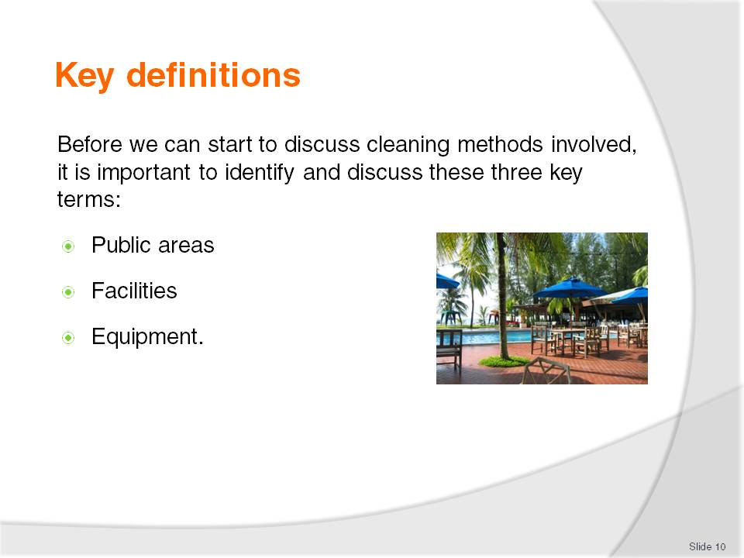
Slide No | Trainer Notes
Class Activity – Discussion
What is included in each of these terms?

Slide
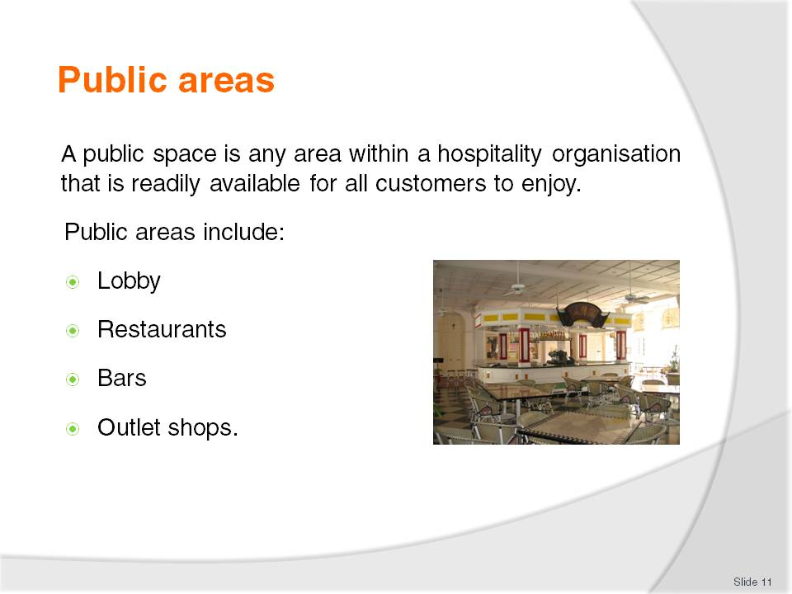
Slide No | Trainer Notes
Class Activity – Discussion
What is the difference between a ‘private’ and ‘public’ area?
What areas are considered ‘private’ and who can access these?
What makes the locations in this slide ‘public’ areas?
Discuss the types of cleaning and cleaning expectations to be undertaken in each of these locations.

Slide
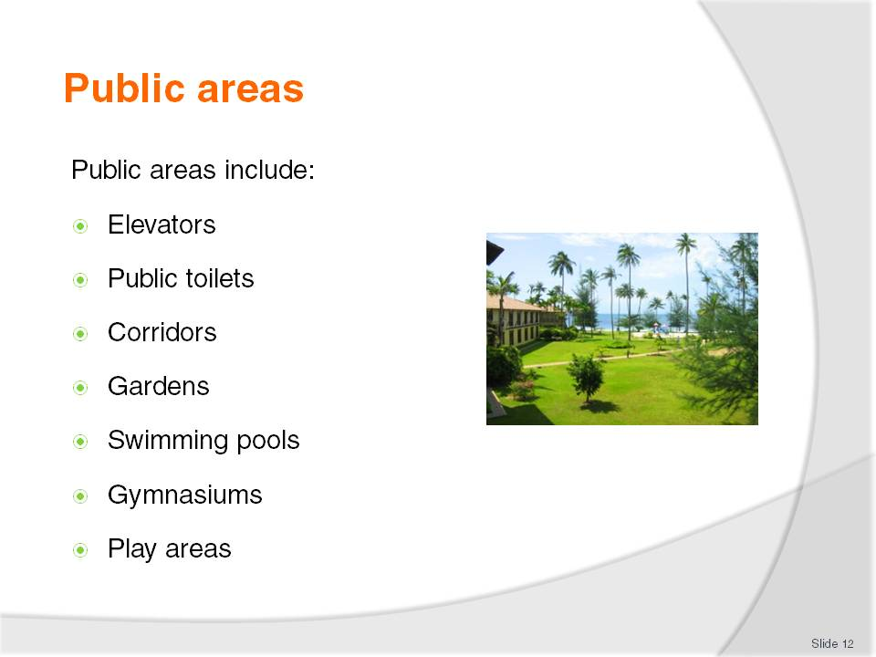
Slide No | Trainer Notes
Class Activity – Discussion
What makes the locations in this slide ‘public’ areas?
Discuss the types of cleaning and cleaning expectations to be undertaken in each of these locations.

Slide
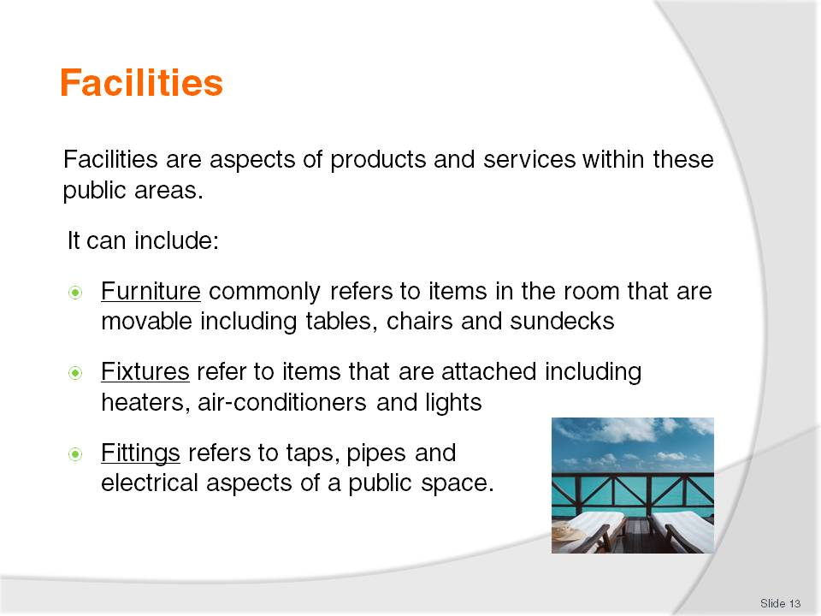
Slide No | Trainer Notes
Class Activity – Discussion
What cleaning activities need to be performed to keep facilities clean?

Slide
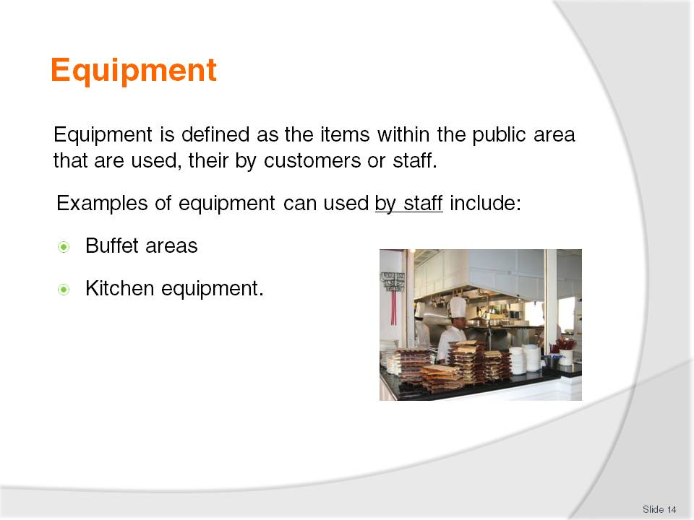
Slide No | Trainer Notes
Class Activity – Discussion
Think about a city hotel and a resort.
In each of these types of establishments:
How many of each would exist?
Where would they be located?
Are they indoors or outdoors?
Are they in public view?
Who is responsible for cleaning them?

Slide
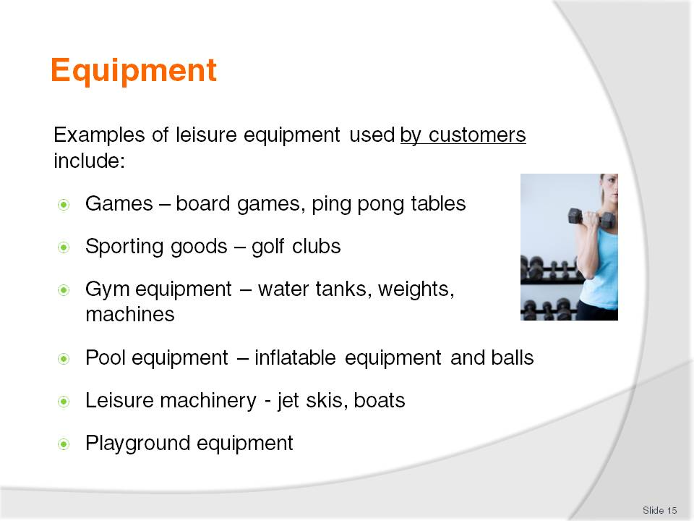
Slide No | Trainer Notes
Class Activity – Discussion
What other types of equipment do customers use?
How are they cleaned?
Who cleans them?
When should they be cleaned?

Slide
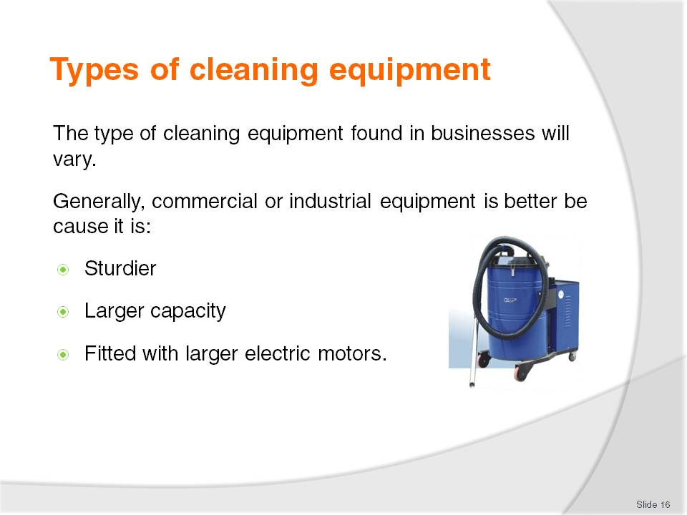
Slide No | Trainer Notes
Class Activity – Discussion
What types of cleaning equipment exist?
What is their purpose?
Where can you get these from?

Slide
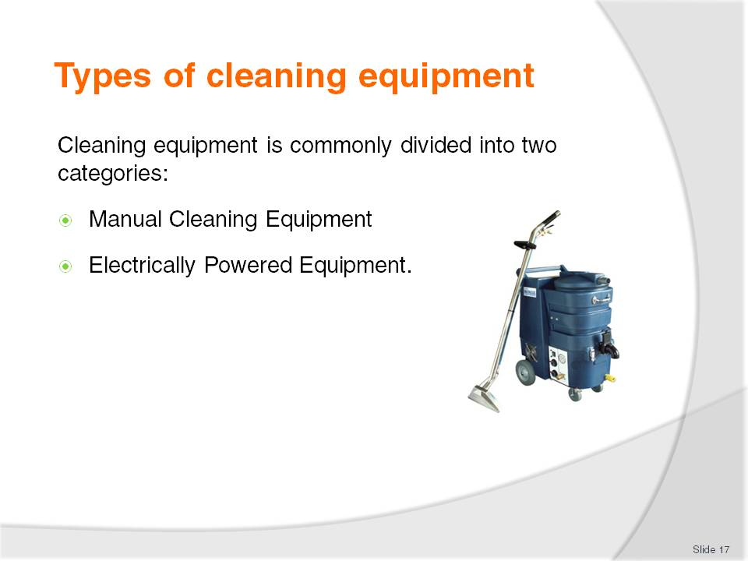
Slide No | Trainer Notes
Class Activity – Discussion
What are some examples of each?
What are the benefits of each?

Slide
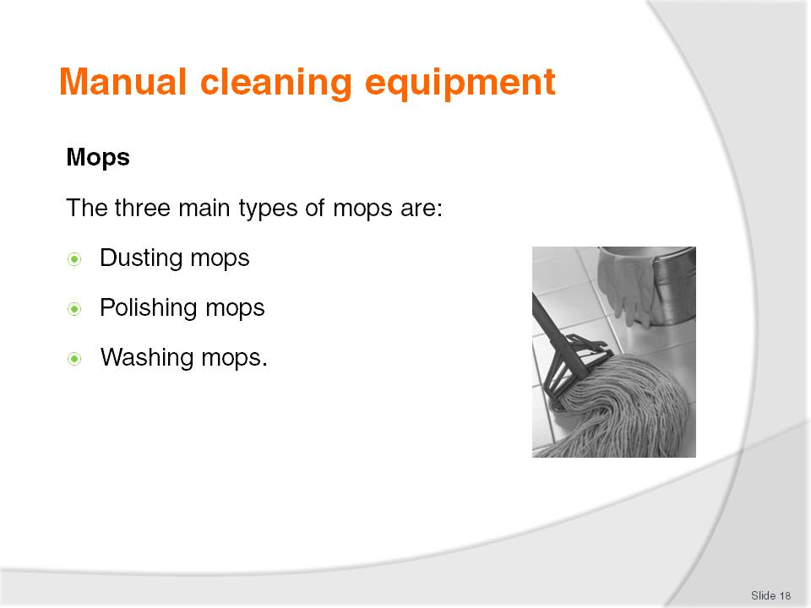
Slide No | Trainer Notes
Class Activity – Discussion
Dusting mops – to clean skirting boards and polished surfaces
Polishing mops – for buffing and polishing
Washing mops – to wash floor surfaces or apply sealant to floors that have been stripped and need to be re-sealed.

Slide
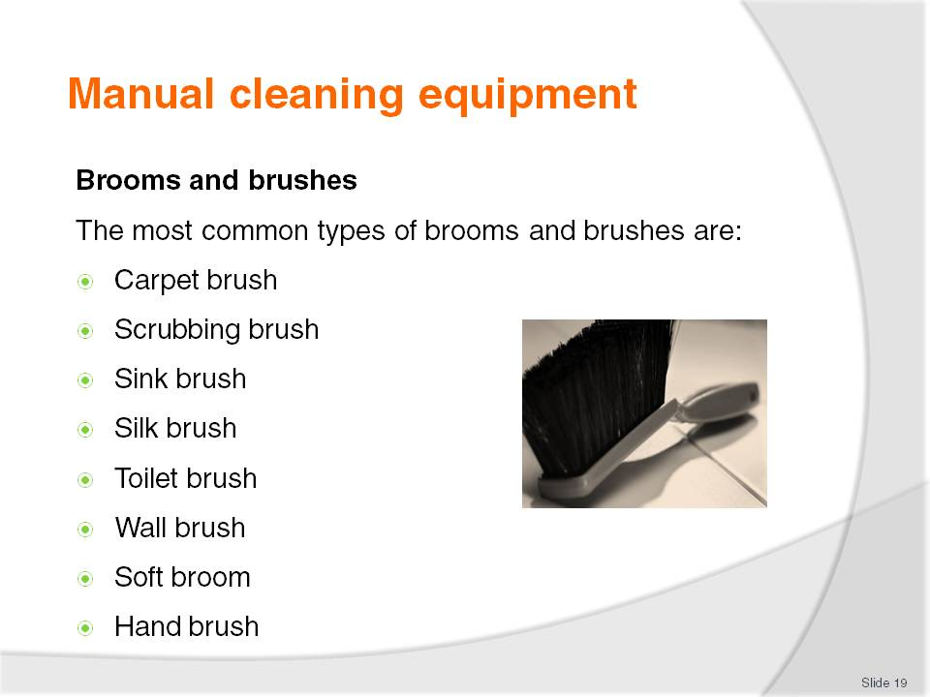
Slide No | Trainer Notes
Class Activity – Discussion
What is each type of brush used for?

Slide
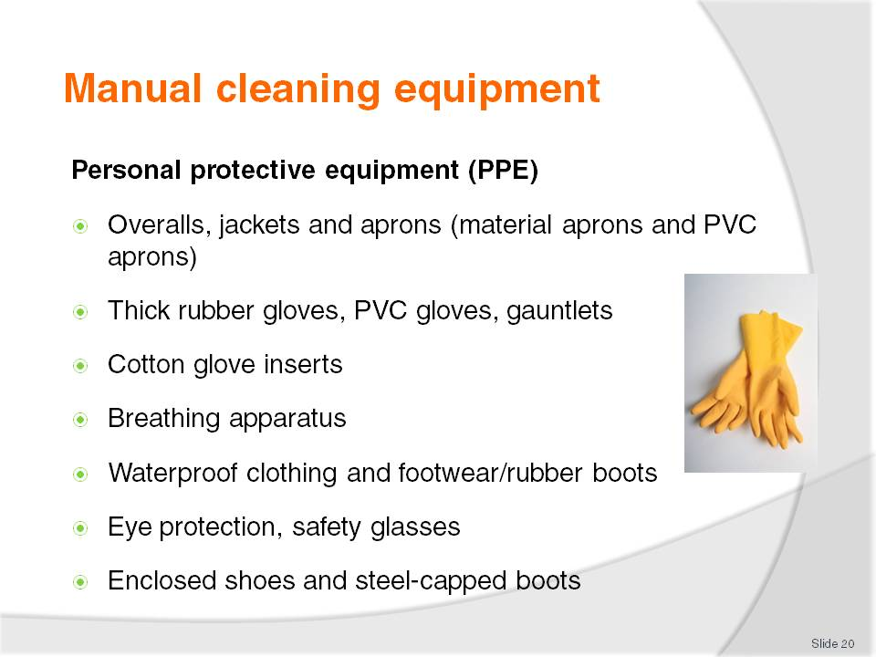
Slide No | Trainer Notes
Class Activity – Discussion
What is each type of PPE used for?

Slide
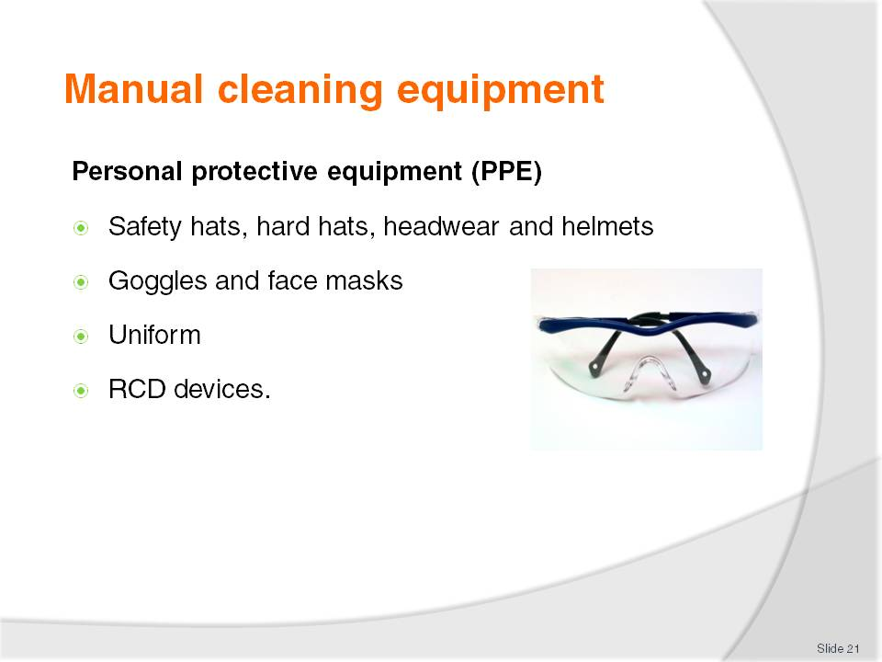
Slide No | Trainer Notes
Class Activity – Discussion
What is each type of PPE used for?

Slide
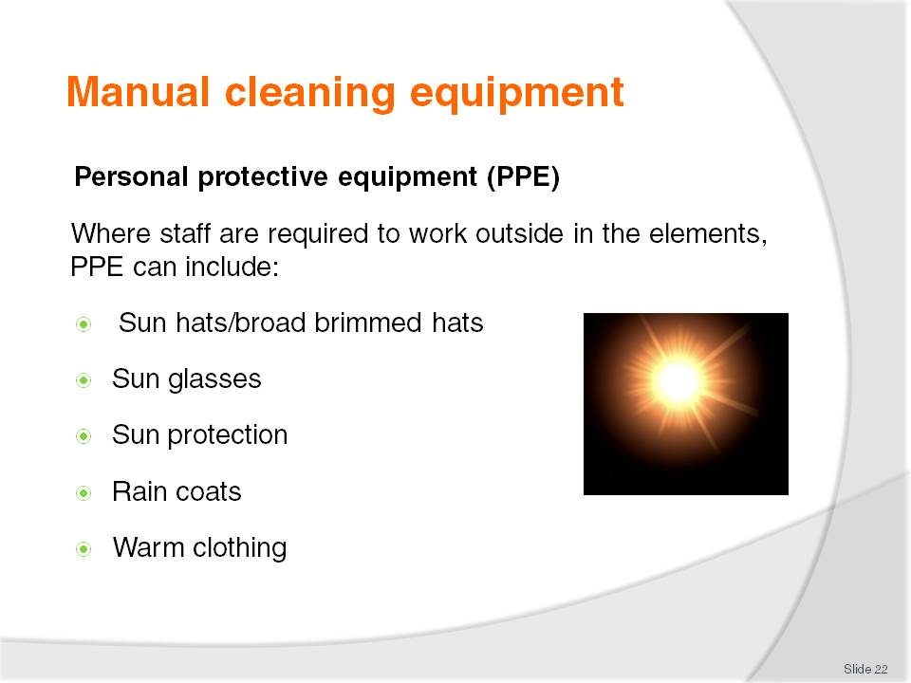
Slide No | Trainer Notes
Class Activity – Discussion
What is each type of PPE used for?

Slide
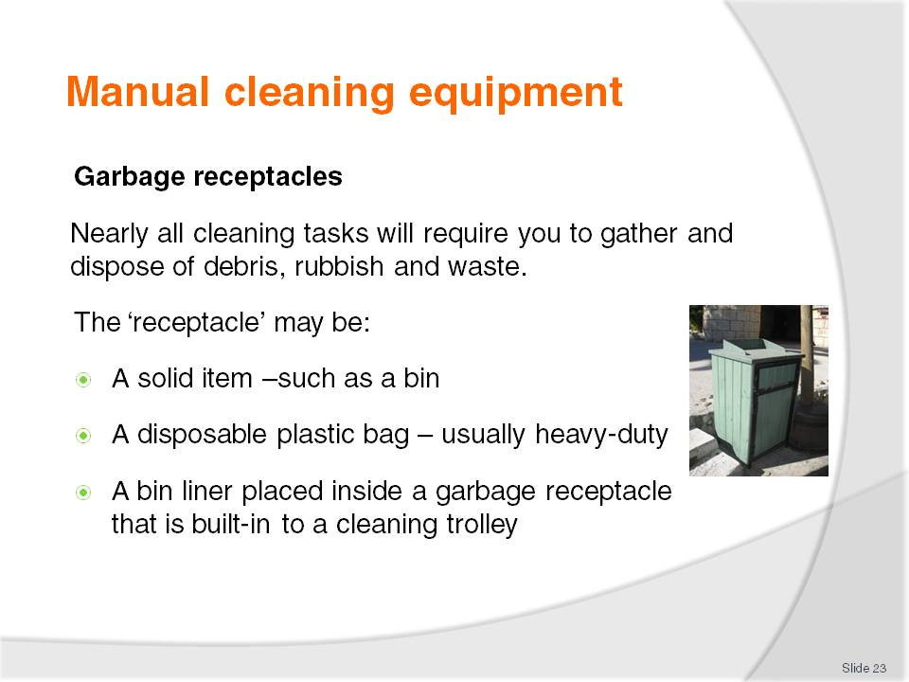
Slide No | Trainer Notes
Class Activity – Discussion
What is each type of garbage receptacles are there?
How often are they cleaned?
Who does this?
Is recycling options available?

Slide
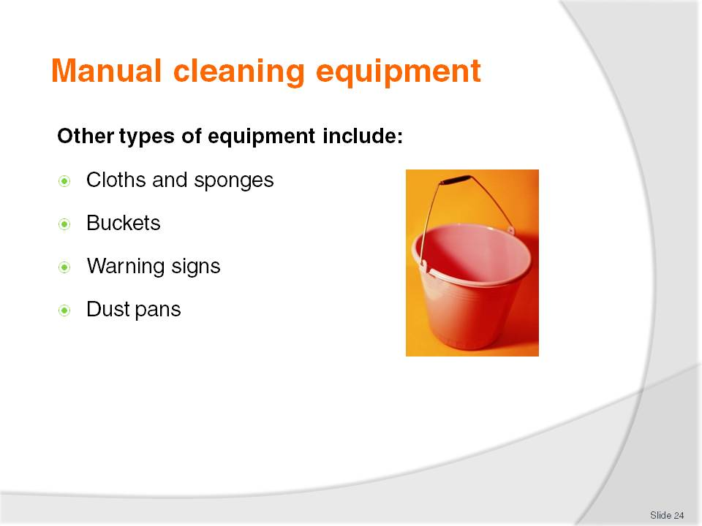
Slide No | Trainer Notes
Class Activity – Discussion
What is each type of equipment used for?

Slide
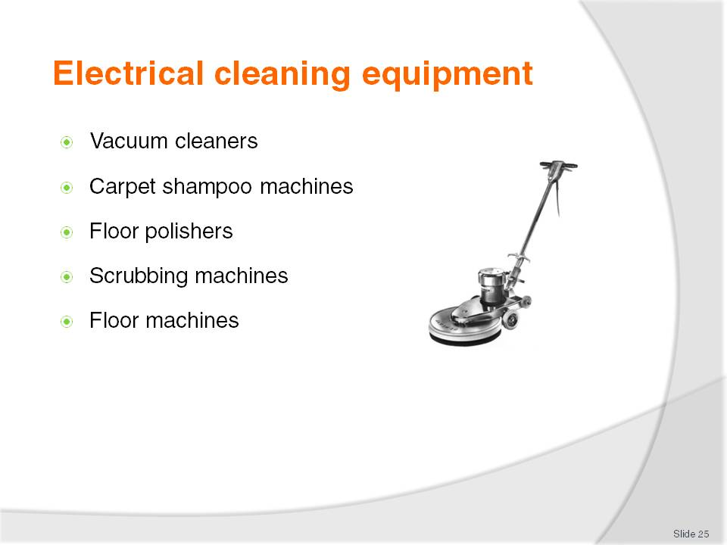
Slide No | Trainer Notes
Class Activity – Discussion
What is the purpose of each type of electrical equipment listed in this slide?
Trainer may get the audience to conduct a research exercise to:
Get a detailed description (also refer to the manual notes)
Identify the benefits
Identify the different types available
Identify where these can be obtained?
How much these cost?

Slide
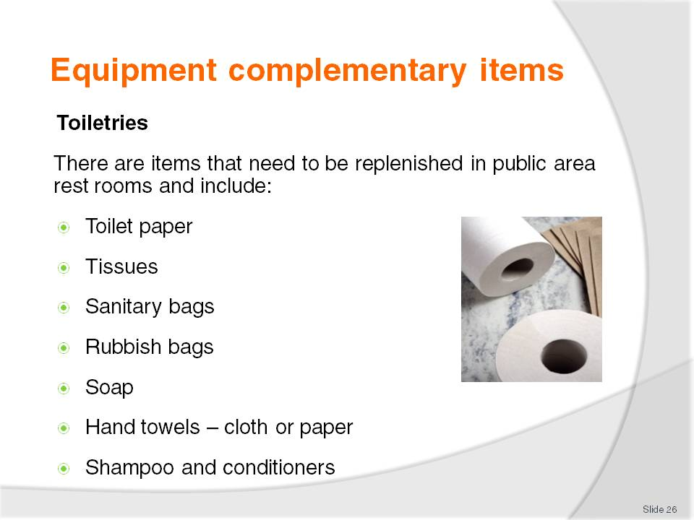
Slide No | Trainer Notes
Class Activity – Discussion
Not only is equipment needed in public areas, attendants must also replace essential toiletries as well
Where are these items required?

Slide
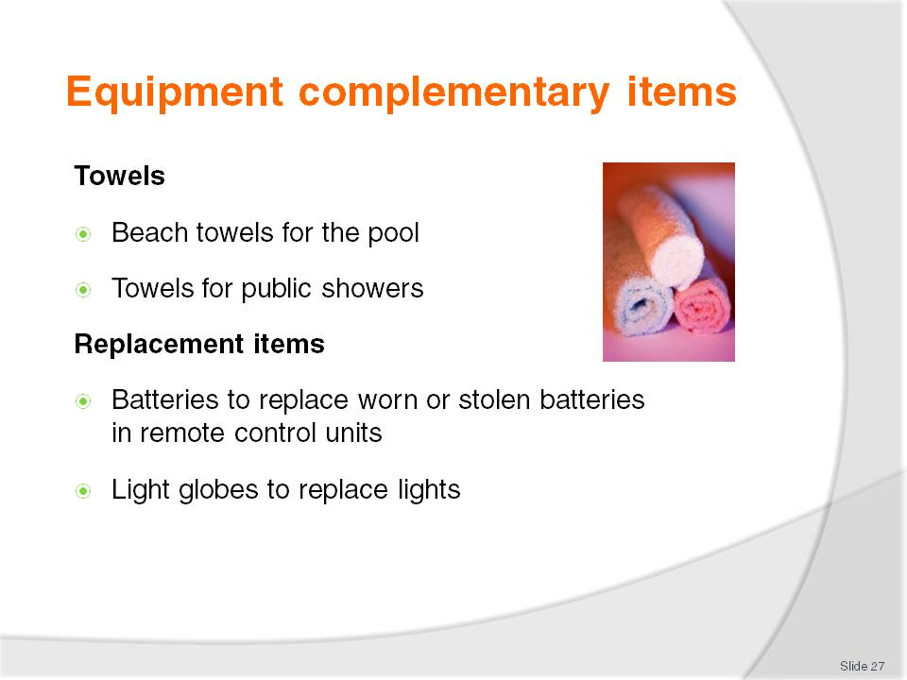
Slide No | Trainer Notes
Class Activity – Discussion
How do you control towels in public areas to ensure:
They are not stolen?
They are returned to the allocated collection point?

Slide
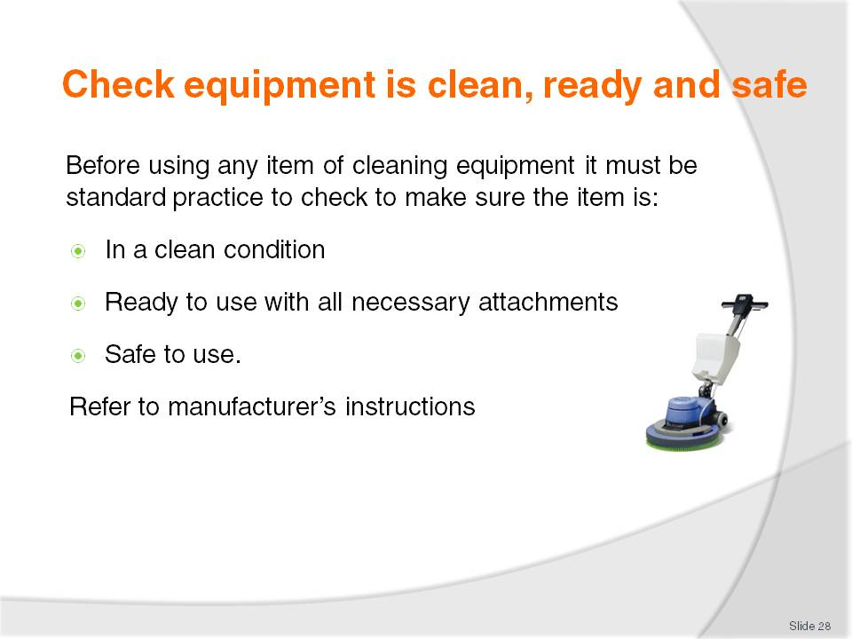
Slide No | Trainer Notes
Class Activity – Discussion & Demonstration
Why is it important to make sure items are clean, ready and safe to use?
Where can you access manufacturer’s instructions?
Trainer to demonstrate how to check an electrical item using manufacturer’s instructions.
Trainer may want to show how to access manufacturer’s instructions via the internet. (if no paper format is available)

Slide
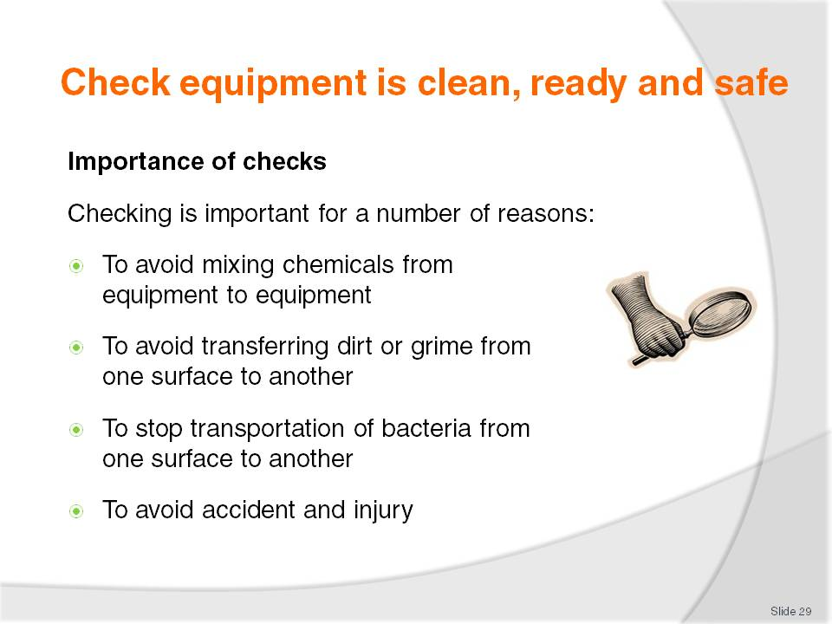
Slide No | Trainer Notes
Class Activity – Discussion & Demonstration
How can you do these checks?

Slide
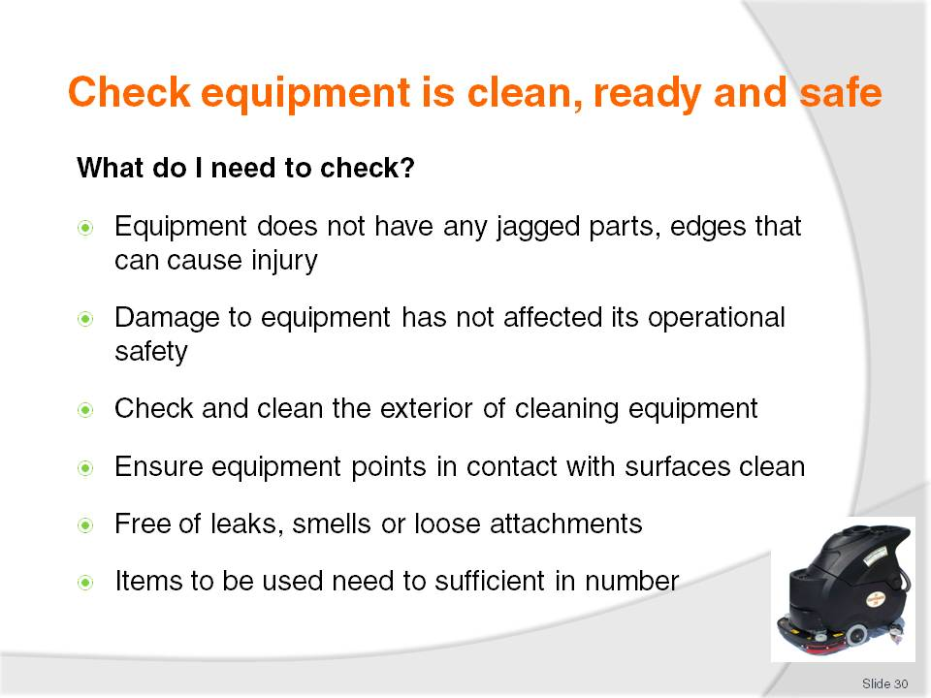
Slide No | Trainer Notes
Class Activity – Discussion & Demonstration
What else would you check?
Equipment does not have any jagged parts, edges that can cause injury.
Damage to equipment has not affected its operational safety.
Check and clean the exterior of cleaning equipment – to enhance presentation and project a positive image for the company when seen by patrons. Cleaning equipment must be clean itself.
Ensure mop head looks presentable - customers will be able to see these if you are working in public areas and may infer a lack of cleanliness in other parts of the establishment.
Buckets should be free of leaks, not smelly and have secure handles.
Check and clear around the rollers on mop buckets to avoid the build up of debris and fibres from the mop.
Items to be used need to sufficient in number – you need to have enough cleaning cloths, disposable gloves etc to get the job done.

Slide
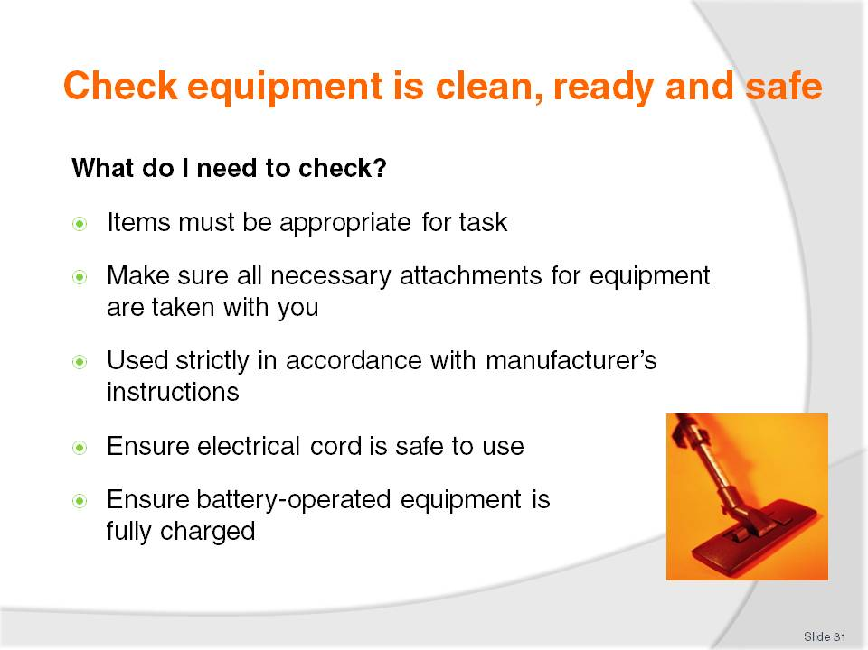
Slide No | Trainer Notes
Class Activity – Discussion & Demonstration
What else would you check?
Items must be appropriate for task – many instances of damage or injury have resulted from trying to complete a cleaning job without the right tools
Make sure all necessary attachments for vacuum cleaners, polishers and other equipment are taken with you before leaving the cleaning store to enable you to complete the intended task. This saves time and effort
All electrically-powered and battery-powered items must be used strictly in accordance with manufacturer’s instructions. If you don’t know how to use an item either read the instructions or ask an experienced staff member to show you what to do
A standard check with any piece of electrical equipment is to ensure the electrical cord is safe to use – not frayed or broken and with no wires exposed
Make sure any battery-operated equipment is adequately charged before using it. Low battery power can adversely affect cleaning performance and causes time loss when the job has to be interrupted to remedy the situation.

Slide
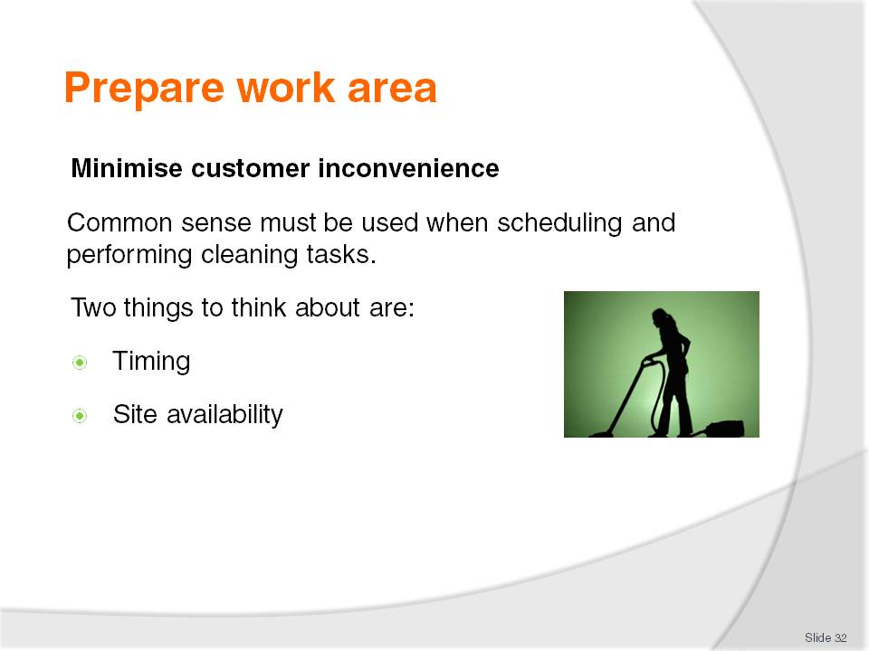
Slide No | Trainer Notes
Class Activity – Discussion
When is the best time to clean public areas to ensure minimal customer inconvenience?

Slide
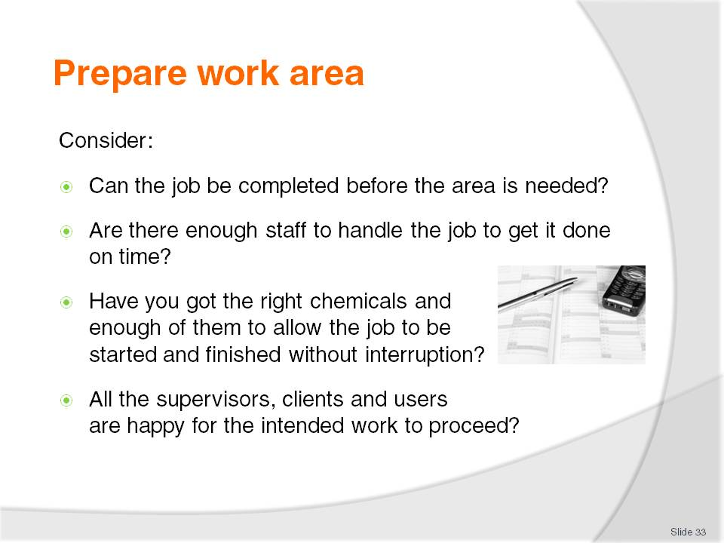
Slide No | Trainer Notes
Class Activity – Discussion
What else would you need to consider?

Slide
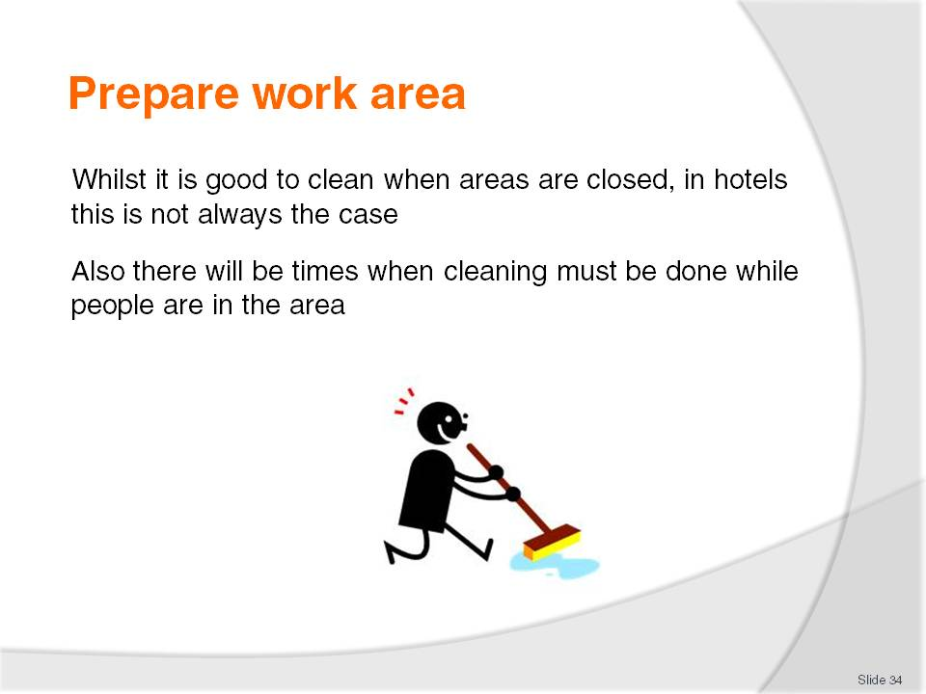
Slide No | Trainer Notes
Class Activity – Discussion
What areas of a hotel never close?
When is immediate cleaning required, regardless of how busy an area is?
How can you clean these areas keeping customer inconvenience to a minimum?

Slide
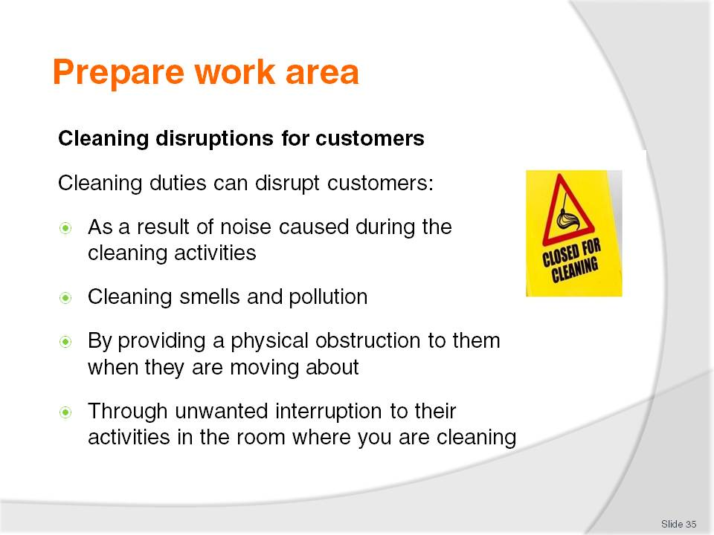
Slide No | Trainer Notes
Class Activity – Discussion
What types of cleaning are noisy? What can you do to reduce the noise?
What types of smells and pollution are created?
What can you do when you have to close an area for cleaning (toilet) which customers need to use?

Slide
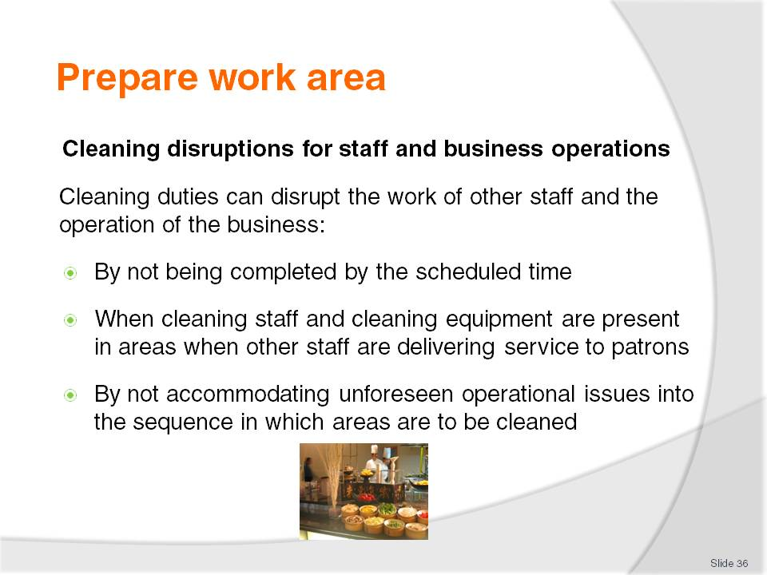
Slide No | Trainer Notes
Class Activity – Discussion
What are some examples in delays in cleaning can cause service to be delayed?
By not accommodating unforeseen operational issues into the sequence in which areas are to be cleaned, or into the extent of cleaning to be provided.
For example:
A dining room due to be cleaned at 9:30PM is still full of in-house guests who are dining there, spending well and enjoying themselves. Go ahead and do other cleaning duties now and return at 11:00PM to do the dining room
A lobby area due for a full clean is found to be teeming with 300 check-in guests who have just arrived with their luggage on several buses. Just do a spot clean, empty the bins and tidy things up. Leave the vacuum cleaning and scheduled cleaning of the drapes until tomorrow.

Slide
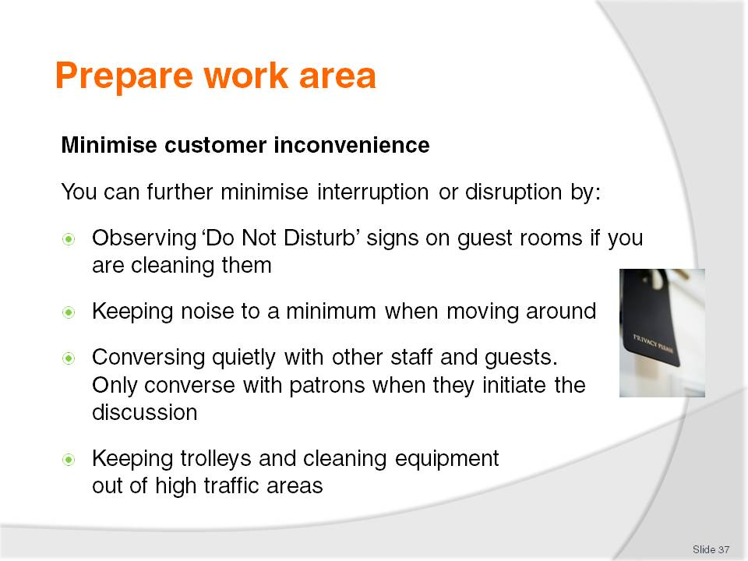
Slide No | Trainer Notes
Class Activity – Discussion
What other ways can you keep customer inconvenience to a minimum?
Think back to when you were a customer. What cleaning activities caused an inconvenience? What could be changed?

Slide
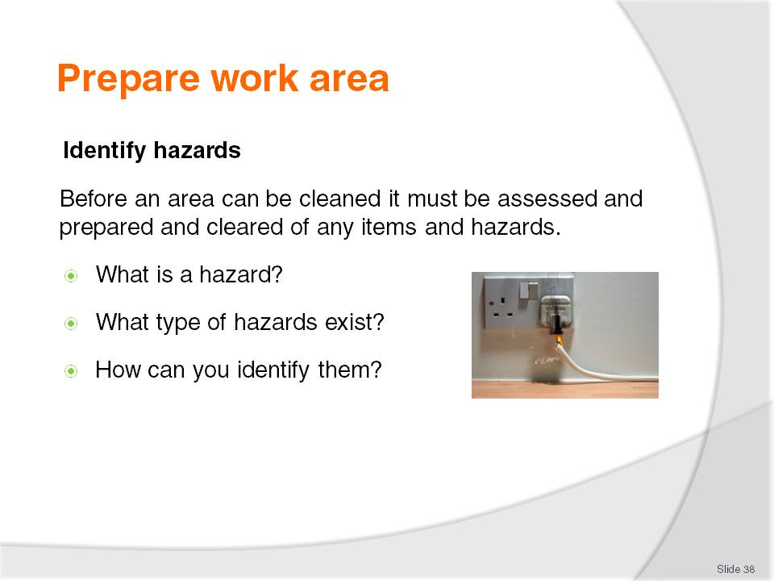
Slide No | Trainer Notes
Class Activity – Observation
Trainer to take the audience for a tour around the complex, especially in public areas, to identify types of hazards in the workplace or hospitality environment.

Slide
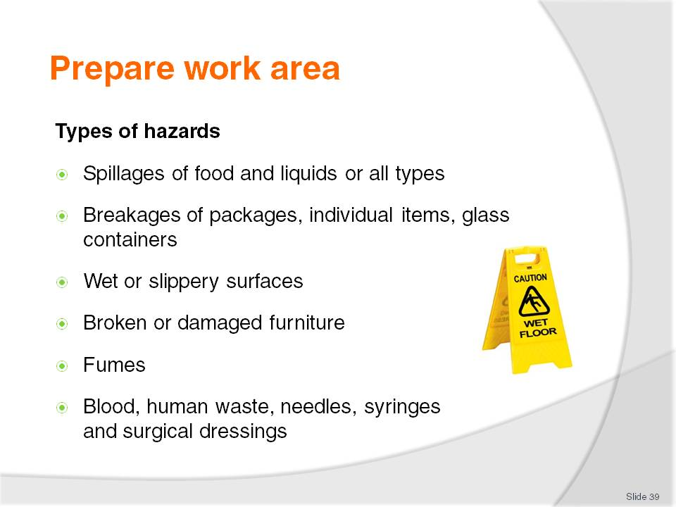
Slide No | Trainer Notes
Class Activity – Discussion
What is the cause of thee hazards?
Where are these hazards normally found?
How can they prevented?
As a cleaner, how can you remove these hazards?

Slide
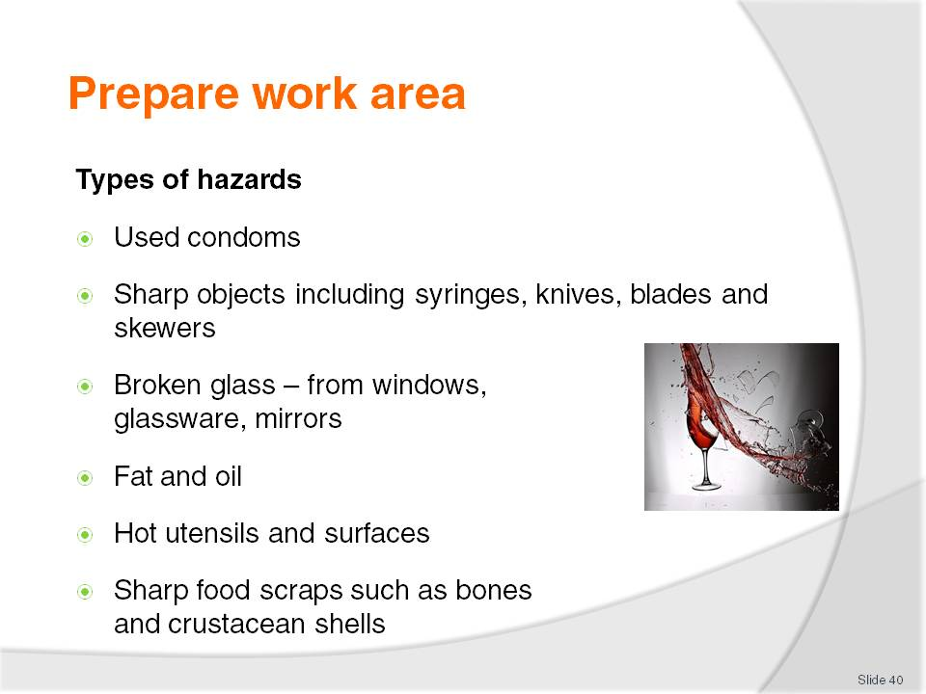
Slide No | Trainer Notes
Class Activity – Discussion
What is the cause of thee hazards?
Where are these hazards normally found?
How can they prevented?
As a cleaner, how can you remove these hazards?

Slide
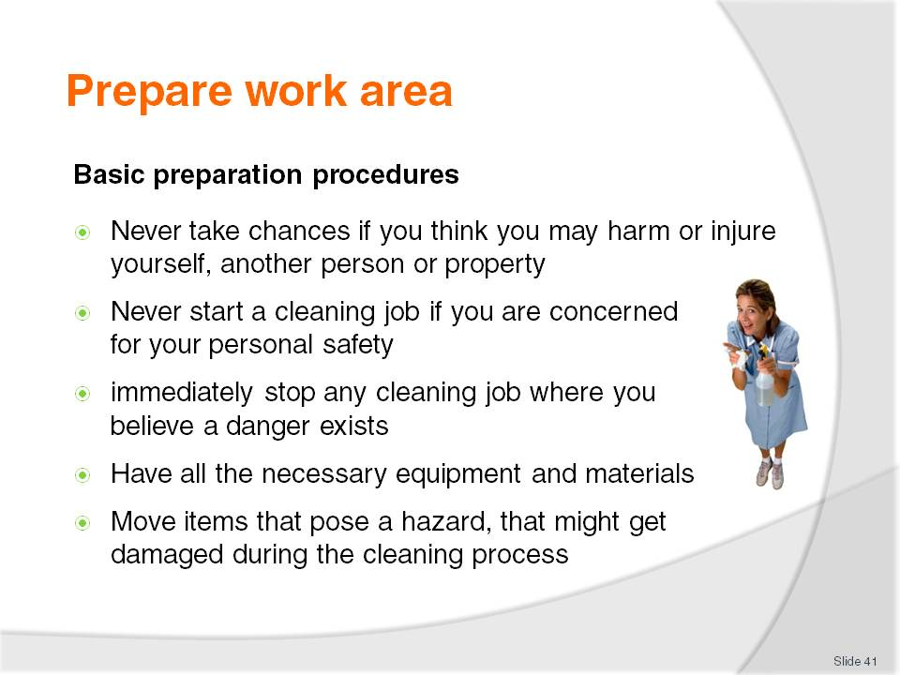
Slide No | Trainer Notes
Class Activity – Discussion
What activities are involved in each of the basic preparation procedures?
When preparing to clean an area the following should be applied where necessary:
Never take chances if you think you may harm or injure yourself, another person or property. Never start a cleaning job if you are concerned for your personal safety. You should also immediately stop any cleaning job where you believe a danger exists
Make sure you have all the necessary equipment and materials before you start to do the job properly and completely. Some jobs such as stripping and re-sealing a floor can’t be stopped and started
Move items that pose a hazard, that might get damaged during the cleaning process or get in the way of the cleaning process and slow the job down. Items that may need to be moved or removed may include guest property as well as enterprise assets.

Slide
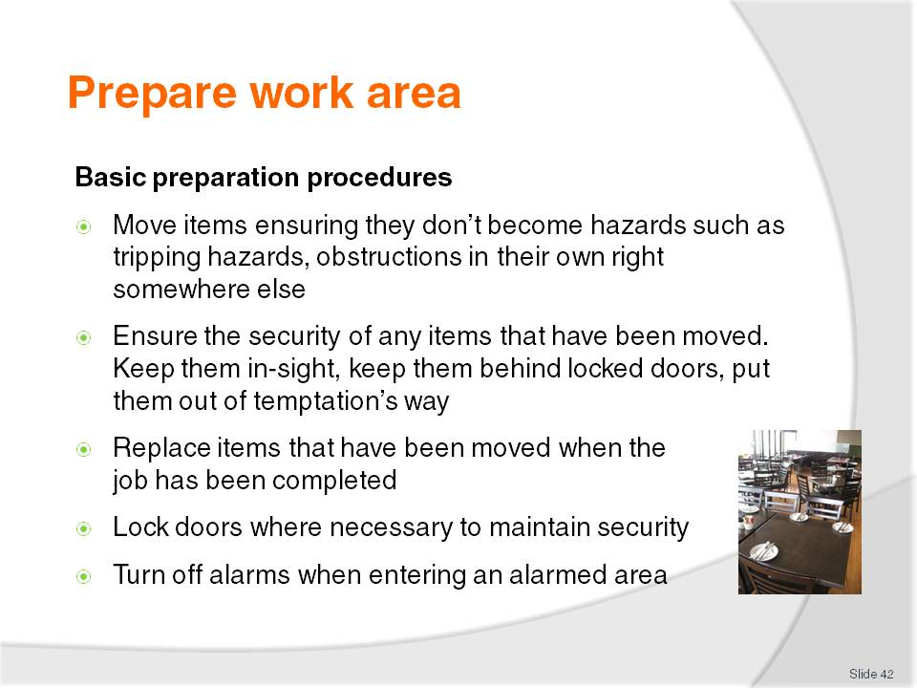
Slide No | Trainer Notes
Class Activity – Discussion
What activities are involved in each of the basic preparation procedures?
Where items have to be moved to allow the cleaning to be done, the items that have to be moved must be removed to a place that doesn’t cause them to become hazards such as tripping hazards, obstructions in their own right somewhere else
Ensure the security of any items that have been moved. Keep them in-sight, keep them behind locked doors, put them out of temptation’s way
Replace items that have been moved when the job has been completed
Lock doors where necessary to maintain security – if you had to unlock a door at night to enter a bar, a room then you should lock that door again once you are inside. This is not so much to lock yourself in, but to lock potential offenders, thieves, out
Turn off alarms when entering an alarmed area.

Slide
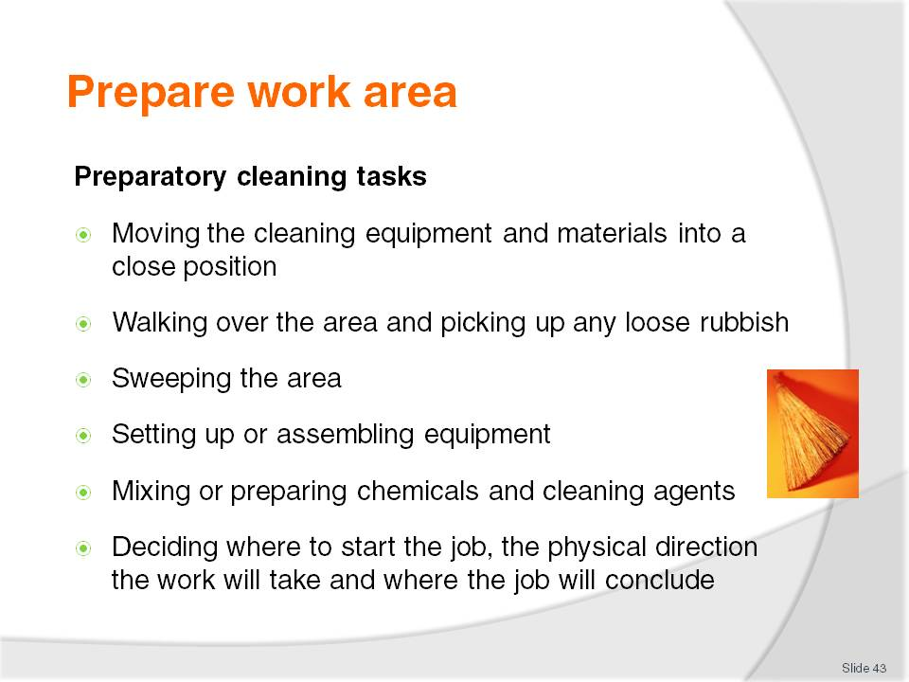
Slide No | Trainer Notes
Class Activity – Discussion
What activities are involved in each of the preparatory cleaning tasks?
Moving the cleaning equipment and materials into a position that will enable them to be readily used – close to the job but not interfering with the work that needs to be done
Walking over the area and picking up any loose rubbish – papers, discarded boxes, large items, by hand and putting them into a rubbish receptacle
Sweeping the area – to remove dust. In some cases ‘sweeping’ may be the entire cleaning job that needs to be done but in many cases, sweeping can be seen as a preparatory task for others jobs such as wet mopping, stripping etc
Setting up or assembling any equipment that needs to be put together
Mixing any chemicals or preparing chemicals and cleaning agents that will be needed
Deciding where to start the job, the physical direction the work will take and where the job will conclude. This is often vital with cleaning tasks because you often don’t want to walk over surfaces that have just been mopped, re-sealed and you have to make sure you don’t trap yourself into a corner. Working from the furthest point back to the entry door is a usual work direction.

Slide
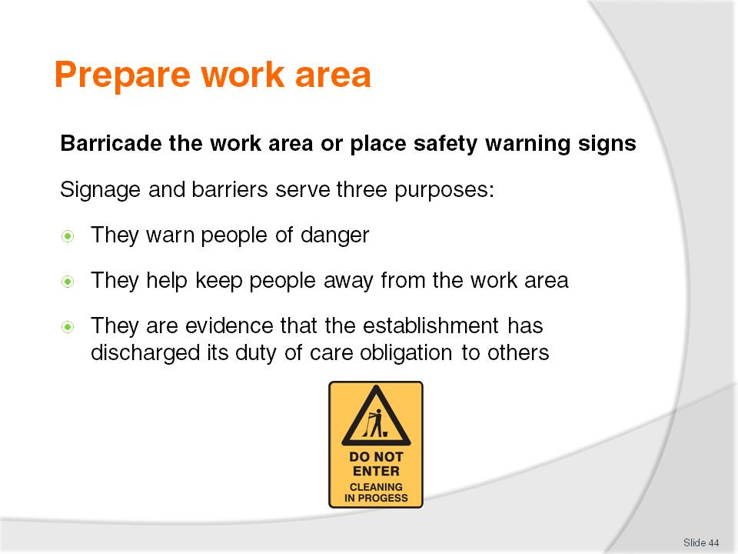
Slide No | Trainer Notes
Class Activity – Discussion
When should cleaning signs be used?
Where should they be placed?
Signage and barriers serve three purposes:
They warn people of danger – reducing the risk of injury due to slipping
They help keep people away from the work area – which allows us to work unimpeded and keeps their feet off surfaces that need to dry
They are evidence that the establishment has discharged its duty of care obligation to others.

Slide
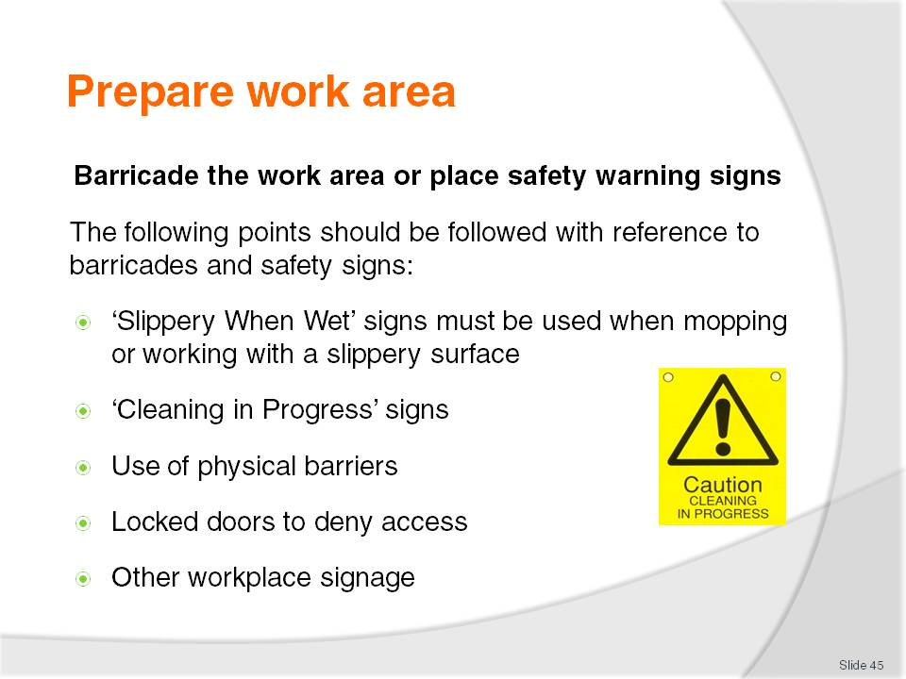
Slide No | Trainer Notes
Class Activity – Discussion
What physical barriers can be used?
What other workplace signage may be required?
The following points should be followed with reference to barricades and safety signs:
•‘Slippery When Wet’ signs must be used when mopping or working with a slippery surface – there must be sufficient of these signs to provide suitable and adequate warning to anyone who may enter the cleaning area from any direction. They must be sufficient to be ‘readily visible’
• During cleaning, ‘Cleaning in Progress’ signs should be posted as a warning to patrons and staff in the same way that Slippery When Wet signs are posted
• Physical barriers and physical restraints (purpose-built safety barriers) may be used to restrict access to a site
• Locked doors are another practical way of denying access to areas and rooms
• Your workplace may have other signage that they require you to erect when cleaning is being done – often the signs that are available will depend on the company from whom they were bought.

Slide
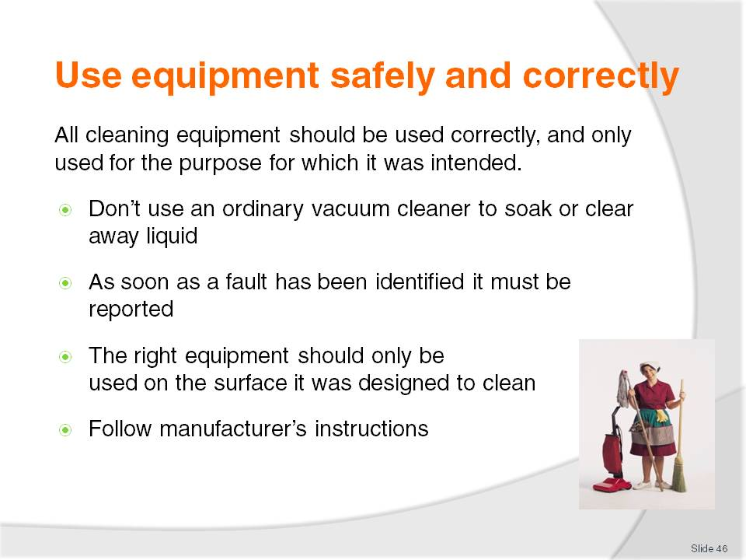
Slide No | Trainer Notes
Class Activity – Discussion
What are some common examples where people do NOT use equipment correctly?
Why do they do this?
How can you ensure staff use equipment correctly?
Don’t use an ordinary vacuum cleaner to soak or clear away liquid – you must use one that is classified as a wet vacuum cleaner
As soon as a fault has been identified it must be reported – not only is this a genuine safety concern, but it may also impact on the effectiveness of the item and render it less than totally efficient
The right equipment should only be used on the surface it was designed to clean, in accordance with the manufacturer’s instructions – avoid trying to ‘make do’ with what you’ve got: if you need a special item to clean a certain item/area then you should obtain what is needed and not ‘force’ what you have got to do the job
Follow manufacturer’s instructions.

Slide
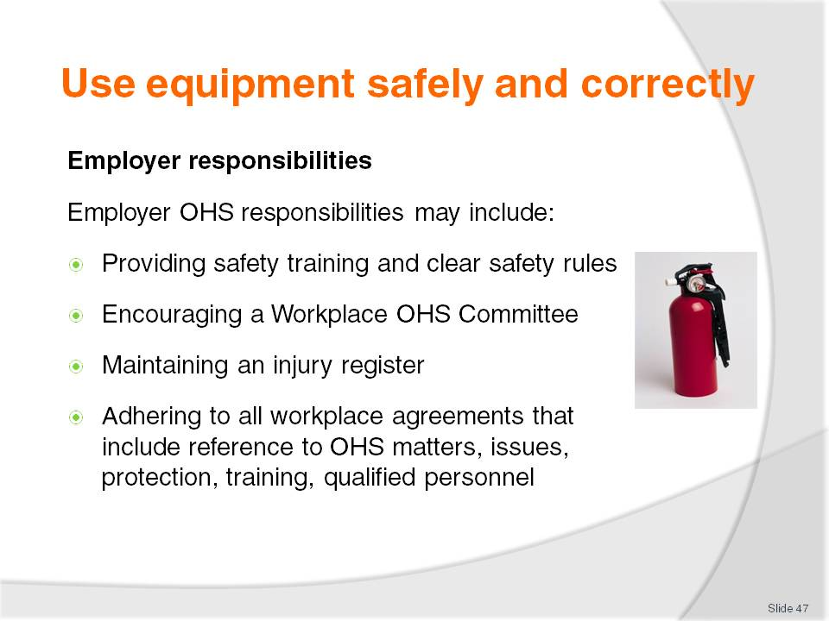
Slide No | Trainer Notes
Employer responsibilities
Employer OHS responsibilities may include:
Providing safety training and clear safety rules
Encouraging a Workplace OHS Committee – the aim of the committee is to identify areas in the workplace where changes should be made so as to create a safer working environment: this may include upgrading equipment, equipment training and safety matters
Maintaining an injury register - so that accidents are logged for insurance and monitoring purposes
Adhering to all workplace agreements that include reference to OHS matters, issues, protection, training, qualified personnel etc.

Slide
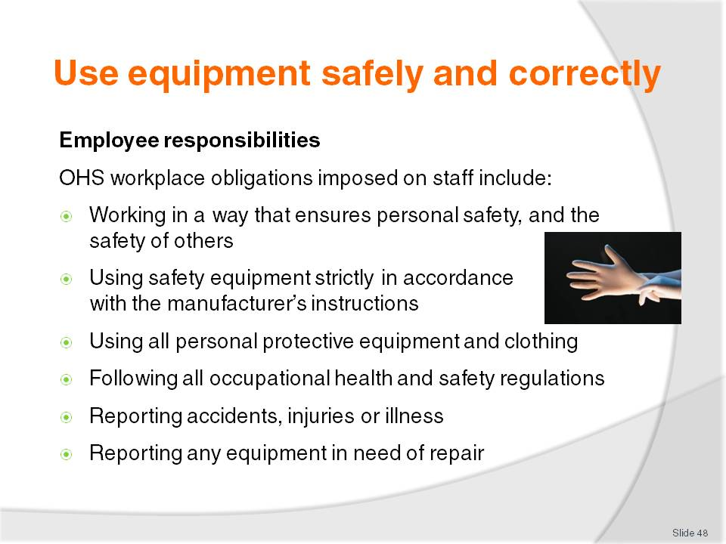
Slide No | Trainer Notes
Employee responsibilities
OHS workplace obligations imposed on staff include:
Working in a way that ensures personal safety, and the safety of others including colleagues and customers – this is a legal responsibility to look after your personal welfare and includes the requirement to avoid engaging in activities that can compromise or jeopardise the safety of others including playing around in the workplace
Using safety equipment strictly in accordance with the manufacturer’s instructions – which means avoiding taking short-cuts and avoiding the belief that you have found a better way to do things
Using all personal protective equipment and clothing when and where required and in a correct manner – this means using items such as goggles, masks, gloves, guards every time they are required, no exceptions
Following all occupational safety and health regulations in-line with establishment requirements. A fundamental for doing this is to know what these requirements are: if you don’t know or aren’t told. Ask!
Reporting accidents, injuries or illness to the appropriate person – so that help can be provided where needed or appropriate action taken to prevent an accident from occurring where a hazard has been reported, prevent a repeat event occurring, minimise damage, loss or injury
Reporting any equipment in need of repair.
Slide
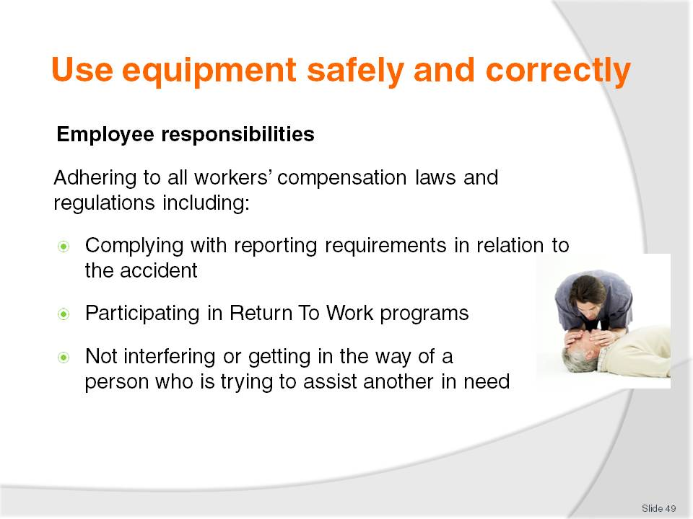
Slide No | Trainer Notes
Class Activity – Discussion
What legal requirements must staff follow?
What organisational responsibilities do staff have in relation to safety in the workplace?

Slide
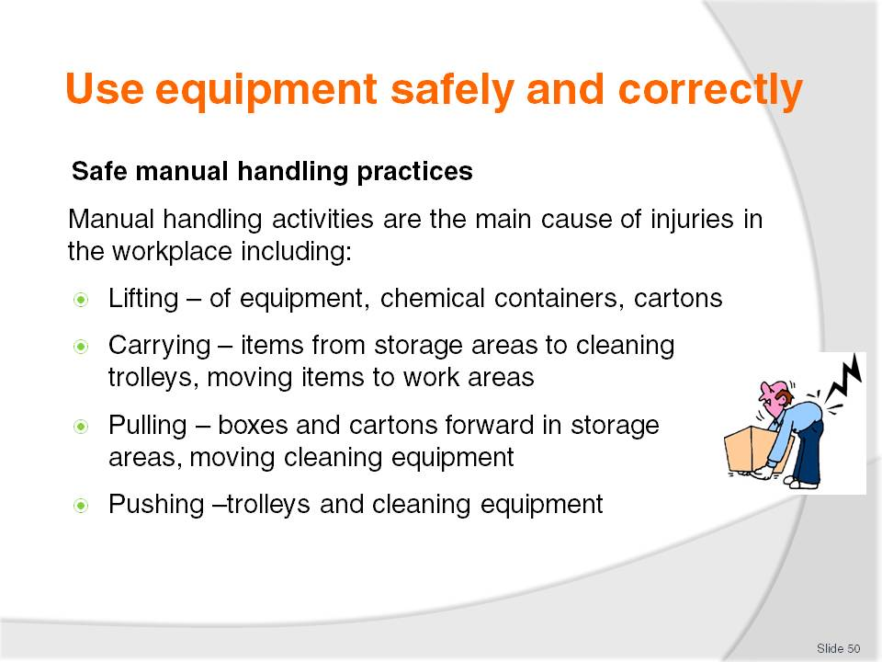
Slide No | Trainer Notes
Class Activity – Questions and Demonstration
What equipment can help assist with manual handling?
What techniques should be used to correctly handle items?
Trainer to demonstrate correct manual handling techniques.

Slide
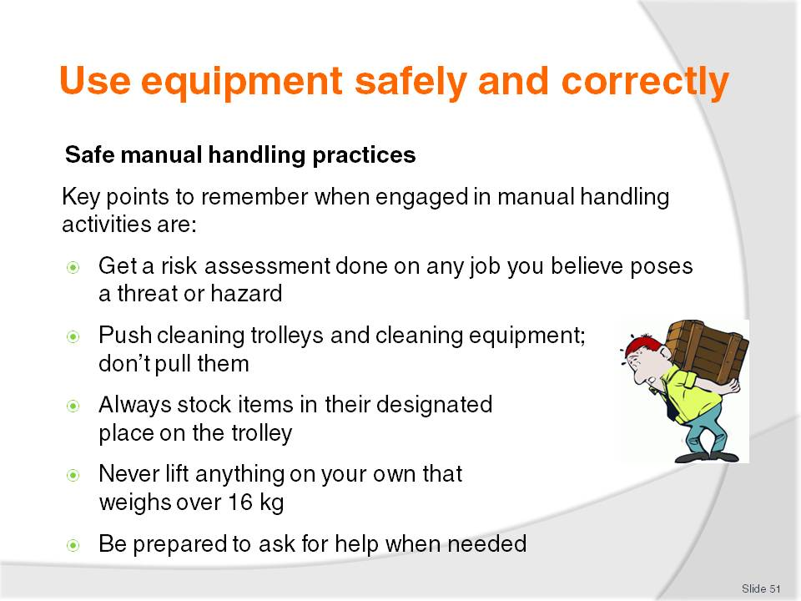
Slide No | Trainer Notes
Key points to remember when engaged in manual handling activities are:
Get a risk assessment done on any job you believe poses a threat or hazard – involve your Occupational Safety and Health representatives and Committee. (where applicable)
Push cleaning trolleys and cleaning equipment; don’t pull it. It is important for you to see where you are going
Always stock items in their designated place on the trolley - it is best to position heavy items on the bottom to prevent the trolley from overturning. If you are not sure where things go – ask!
Never lift anything on your own that weighs over 16 kg – this is a recommendation from OHS authorities. There are no maximum weight restrictions as the current approach to workplace safety is to assess every lifting need on an individual basis and use the most appropriate technique depending on the type of load, how far it has to be moved, the size of the load etc. Chemicals can be delivered in drums of 25 litres and 20 kg
Be prepared to ask for help when needed – this may be a request for help such as to do a ‘team lift’ or a request for information. You must also be prepared to provide help when required.

Slide
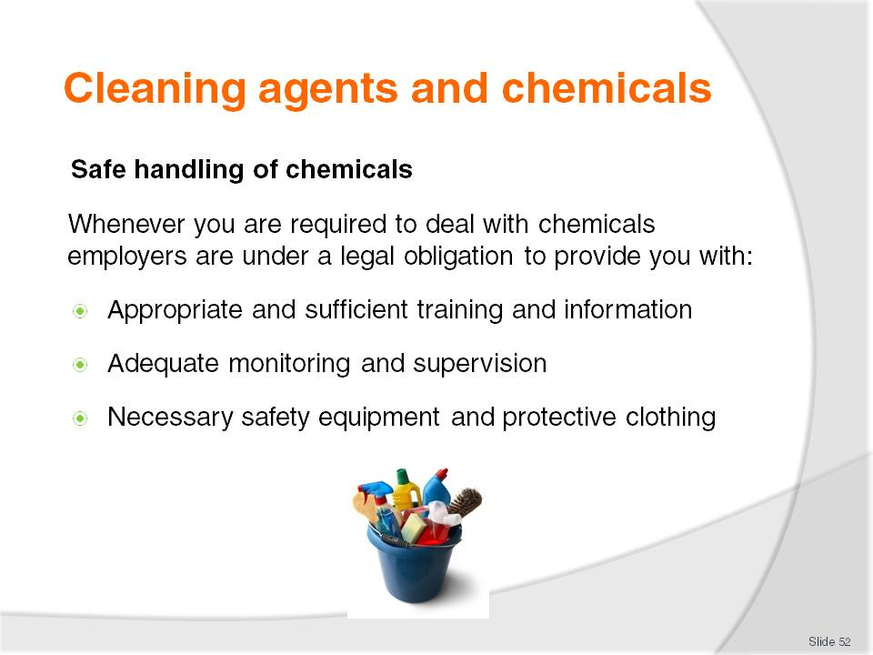
Slide No | Trainer Notes
Class Activity – Questions
What types of chemical training is needed?
Who should provide this training?
What safety equipment is needed when handling chemicals?
What protective equipment is helpful when handling chemicals?

Slide
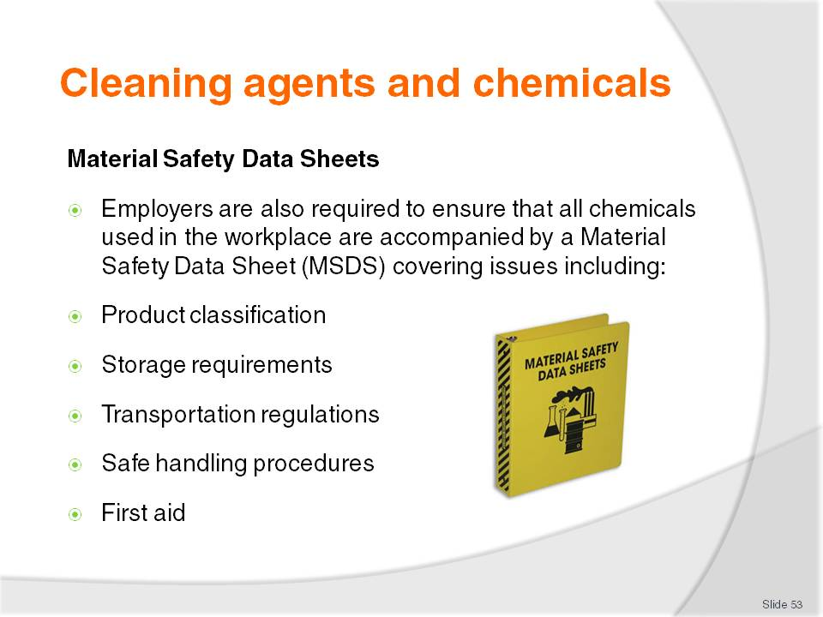
Slide No | Trainer Notes
Class Activity – Demonstration
Trainer to show and explain contents of Material Safety Data Sheets.

Slide
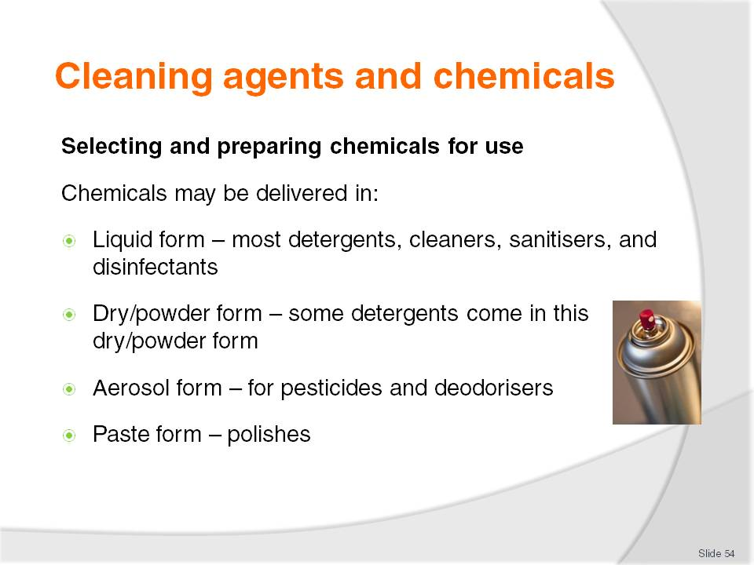
Slide No | Trainer Notes
Class Activity – Questions & internet research
Trainer to get trainees to:
Conduct internet research on major chemical suppliers
Identify types of chemicals they provide
Prepare a list of chemicals and cleaning agents under each of these headings.

Slide
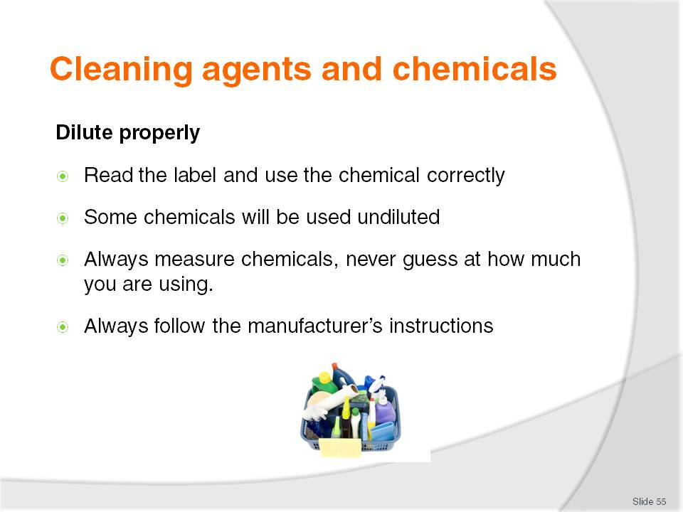
Slide No | Trainer Notes
Class Activity – Questions
Which chemicals are usually diluted?
What is the ratio of chemical to water?
How do you measure ratios?

Slide
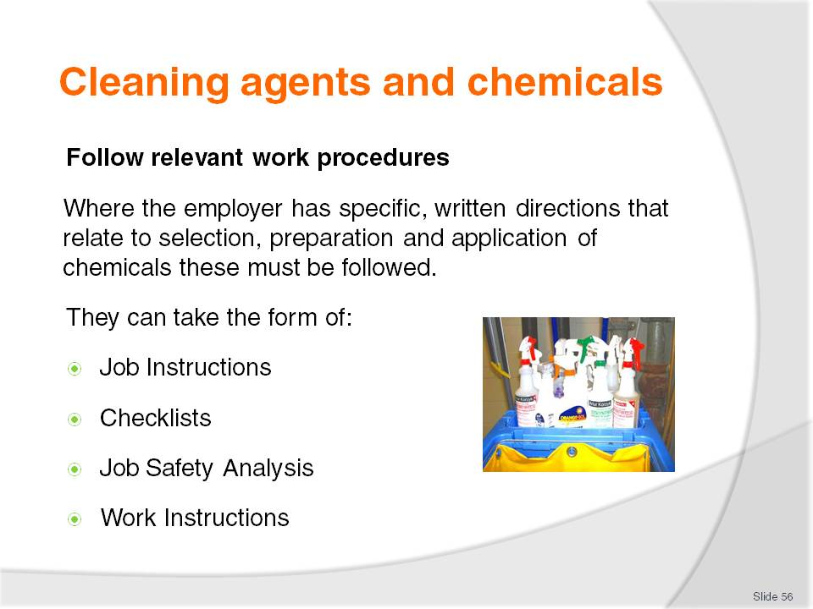
Slide No | Trainer Notes
Class Activity – Demonstration
Trainer to show and explain workplace procedures used in hotels in relation to using chemicals.

Slide
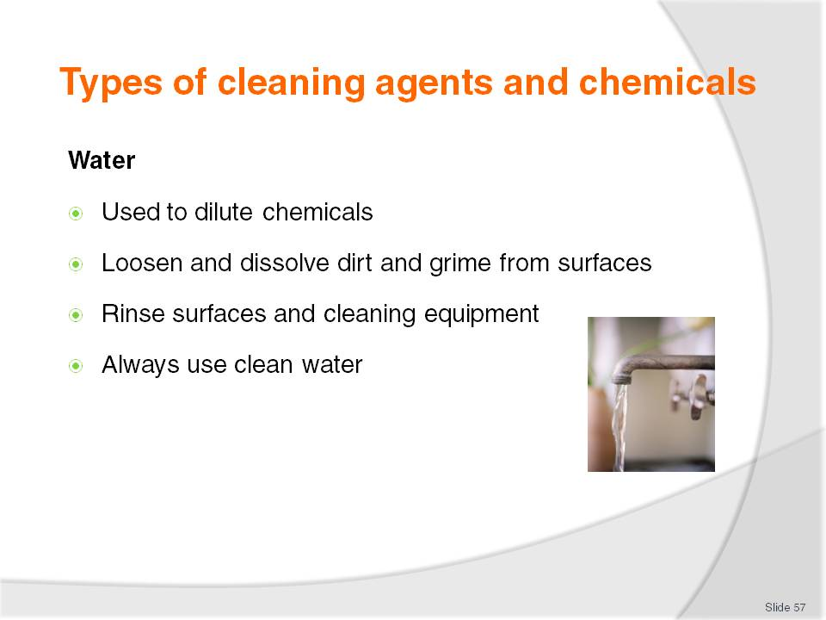
Slide No | Trainer Notes
Class Activity – Questions
What are the benefits of using water as a cleaning agent?

Slide
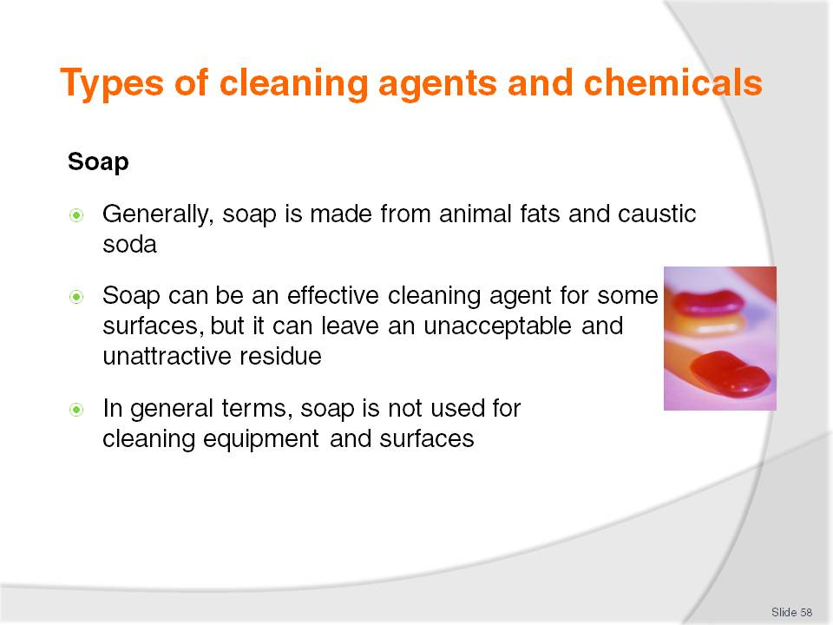
Slide No | Trainer Notes
Class Activity – Questions
What are the benefits of using soap as a cleaning agent?
What do you need to do to remove soap from surfaces?

Slide
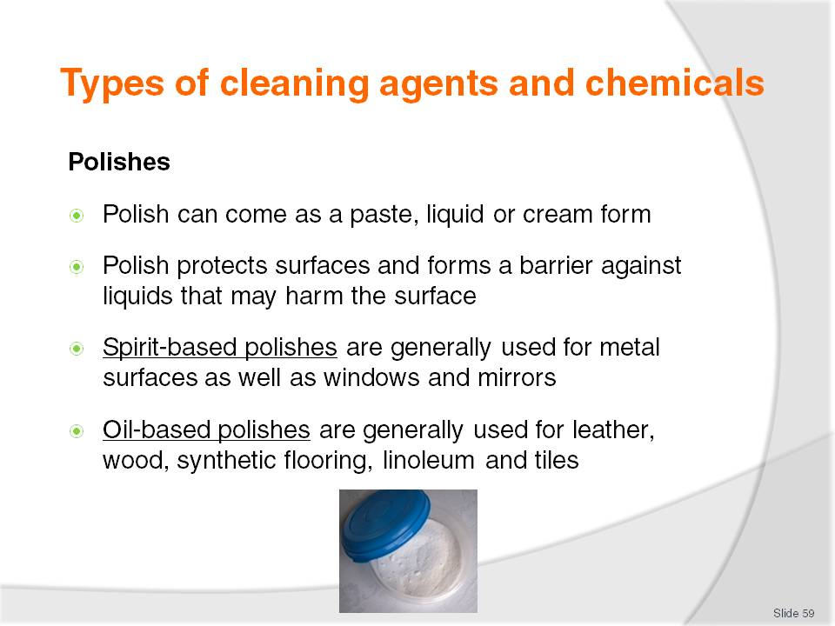
Slide No | Trainer Notes
Class Activity – Questions
What are some polishes you use in your everyday life?
What polishes do you use in the workplace?
What are the benefits of polishes?

Slide
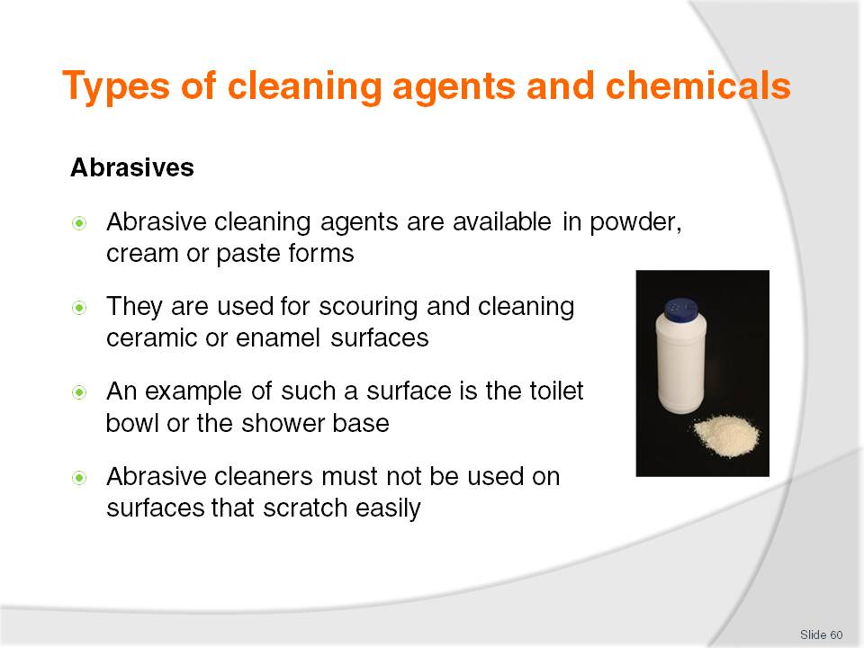
Slide No | Trainer Notes
Class Activity – Questions
What are some abrasives you use in your everyday life?
What abrasives do you use in the workplace?
What are the benefits of abrasives?

Slide
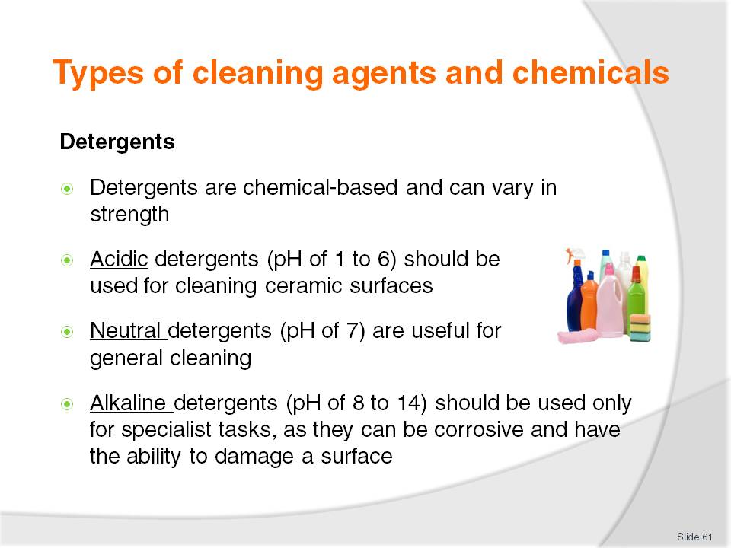
Slide No | Trainer Notes
Class Activity – Questions & Demonstration
What are some abrasives you use in your everyday life?
What abrasives do you use in the workplace?
What are the benefits of abrasives?
Trainer to provide examples of each type of detergent as identified in this slide.

Slide
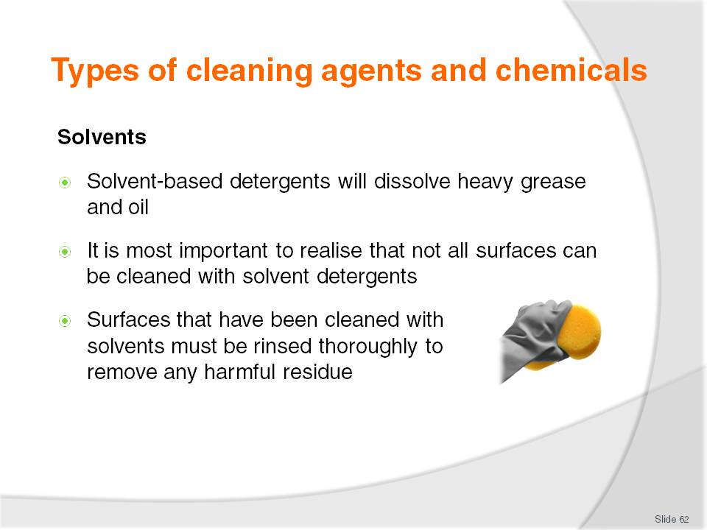
Slide No | Trainer Notes
Class Activity – Questions & Demonstration
- What are some solvents you use in your everyday life?
- What solvents do you use in the workplace?
- What are the benefits of solvents?
Trainer to provide examples of solvents explaining their purpose.

Slide
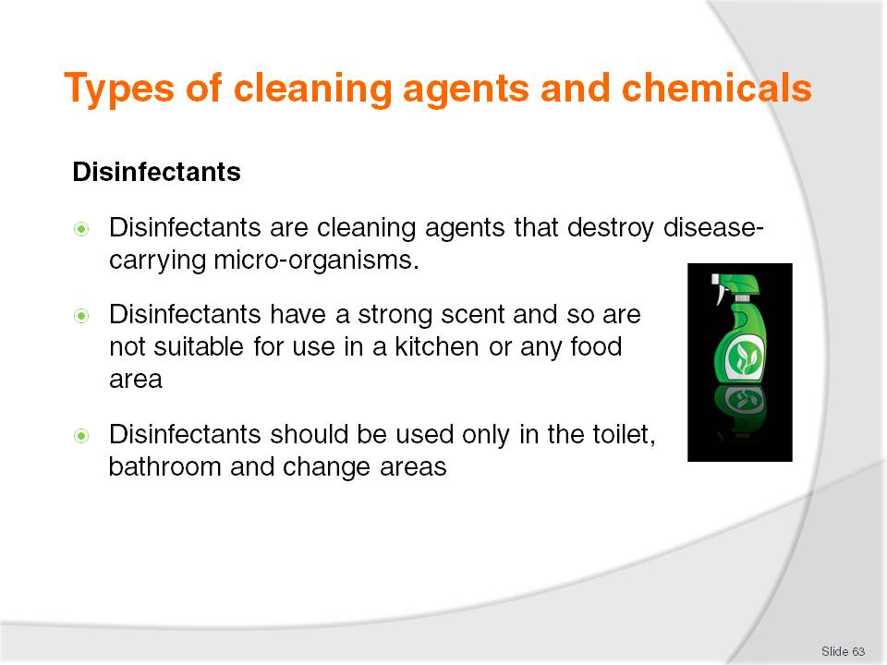
Slide No | Trainer Notes
Class Activity – Questions & Demonstration
- What are some disinfectants you use in your everyday life?
- What disinfectants do you use in the workplace?
- What are the benefits of disinfectants?
Trainer to provide examples of disinfectants explaining their purpose.

Slide
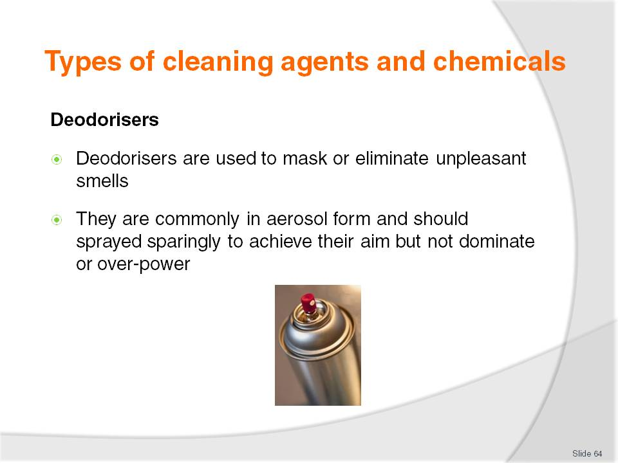
Slide No | Trainer Notes
Class Activity – Questions & Demonstration
What are some deodorisers you use in your everyday life?
What deodorisers do you use in the workplace?
What are the benefits of deodorisers?
Trainer to provide examples of deodorisers explaining their purpose.

Slide
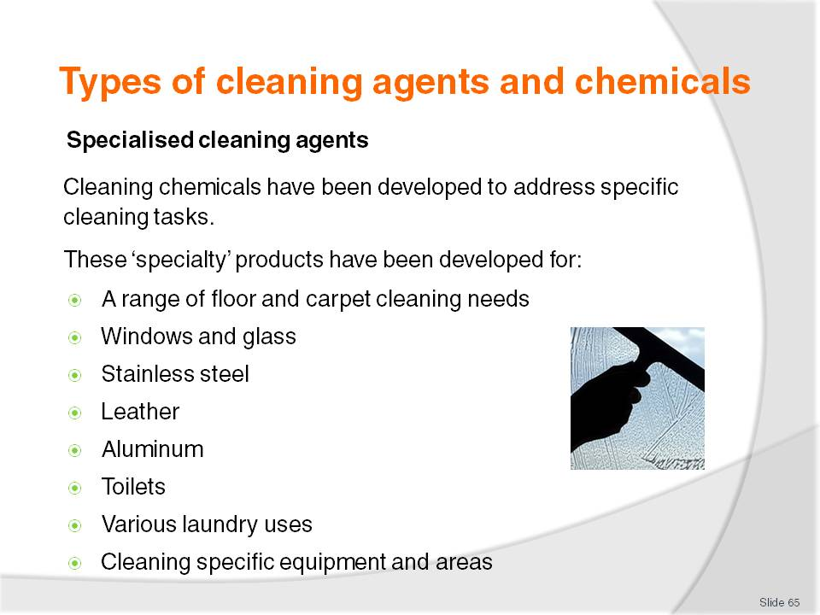
Slide No | Trainer Notes
Class Activity – Questions & Demonstration
What are some specialised cleaning agents you use in your everyday life?
What specialised cleaning agents do you use in the workplace?
What are the benefits of specialised cleaning agents?
Trainer to provide examples of specialised cleaning agents explaining their purpose.

Slide
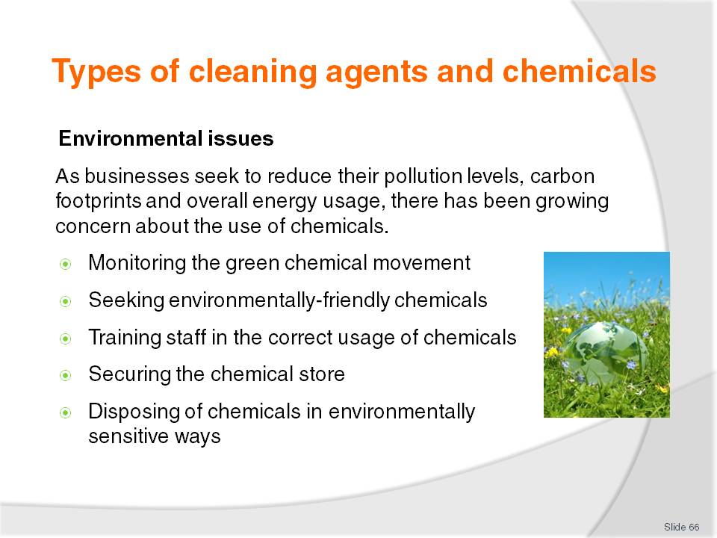
Slide No | Trainer Notes
Class Activity – Questions and research
What are other ways a company can be environmentally friendly?
The trainer may wish to get the audience to research other environmental trends and make a presentation to the class.

Slide
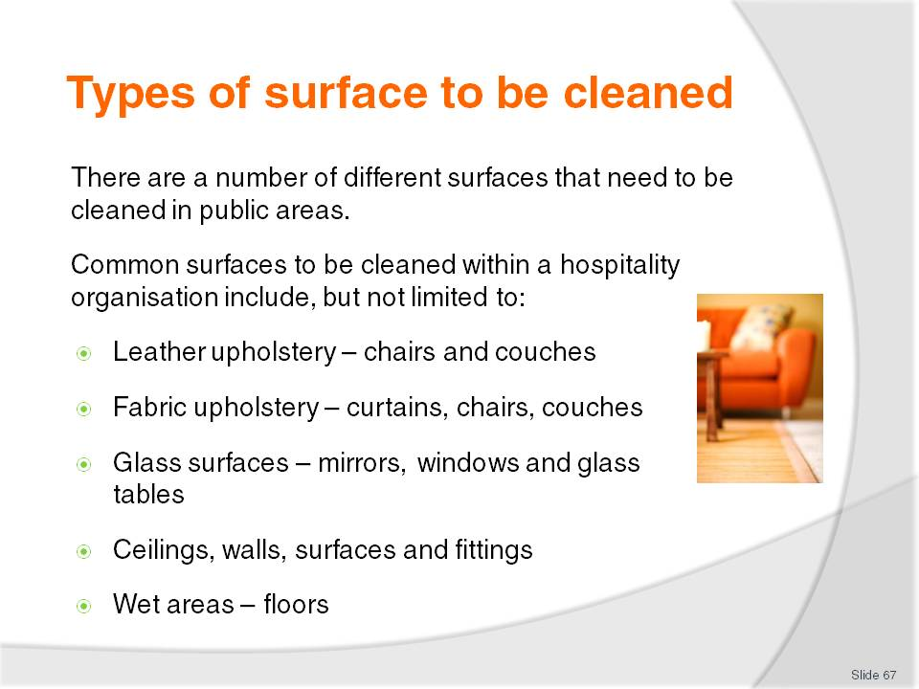
Slide No | Trainer Notes
Class Activity – Question and Explanation
What equipment and cleaning agents are used to clean each of these surfaces?
The Trainer does not need to go into too much detail. Let the audience know, the specific techniques for cleaning each of these surfaces will be explained in each of the Elements of Competency.

Slide
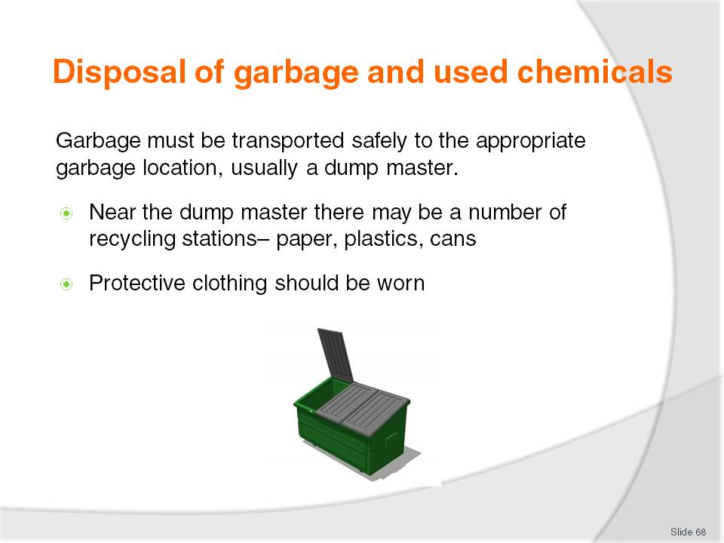
Slide No | Trainer Notes
Class Activity – Question
What is the normal procedure for disposing of garbage?
What are common items for recycling and how is this done?

Slide
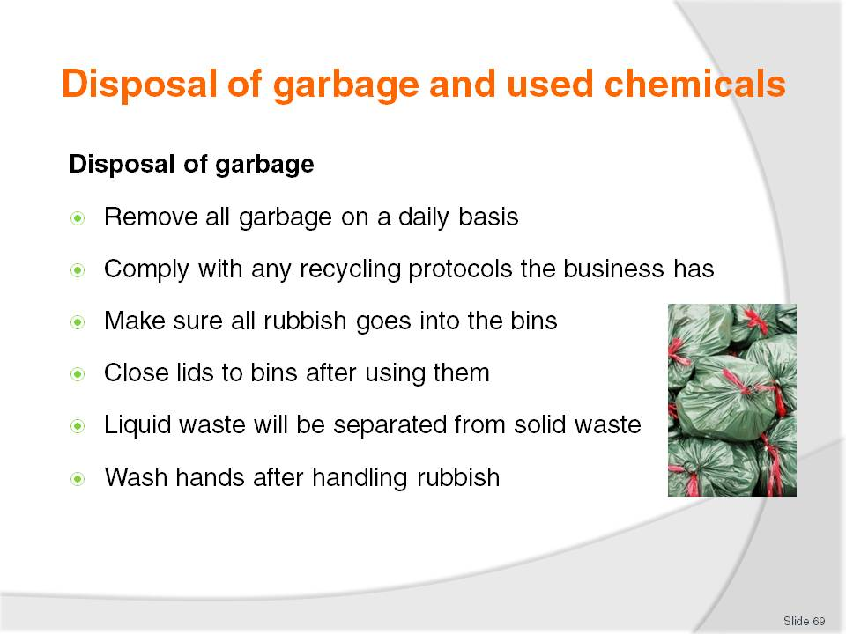
Slide No | Trainer Notes
Class Activity – Question
What are types of liquid garbage?
How do you dispose of liquid garbage?

Slide
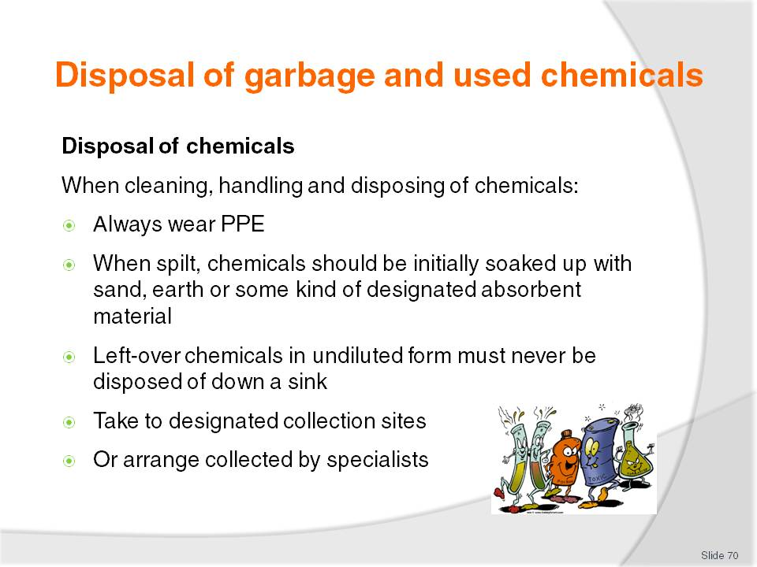
Slide No | Trainer Notes
Class Activity – Question
What are the procedures for disposing of chemicals in most hospitality businesses?

Slide
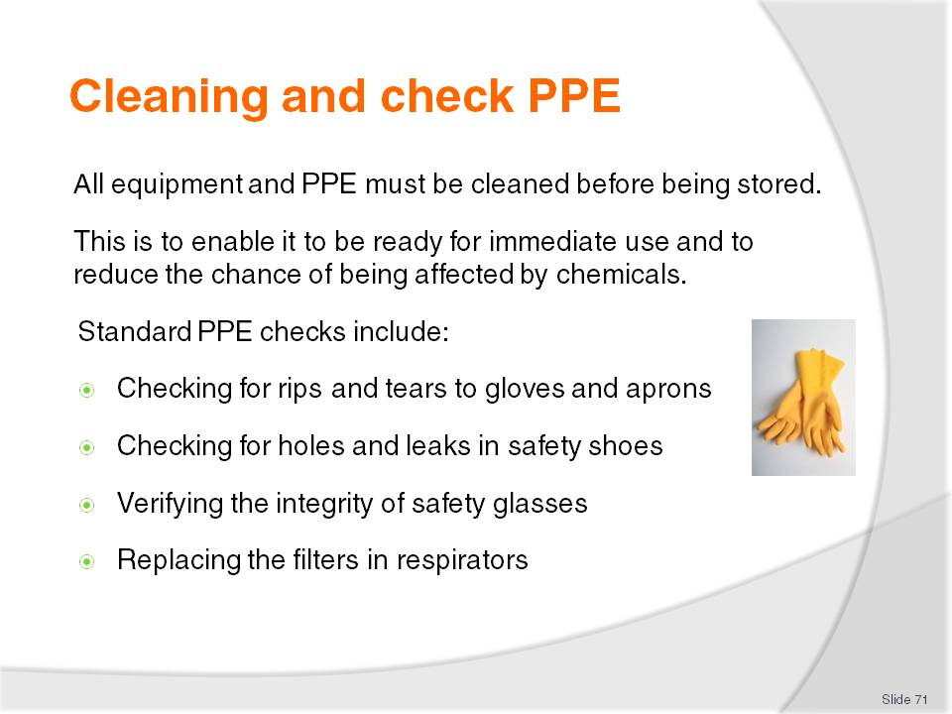
Slide No | Trainer Notes
Class Activity – Question
What happens if PPE equipment is damaged?

Slide
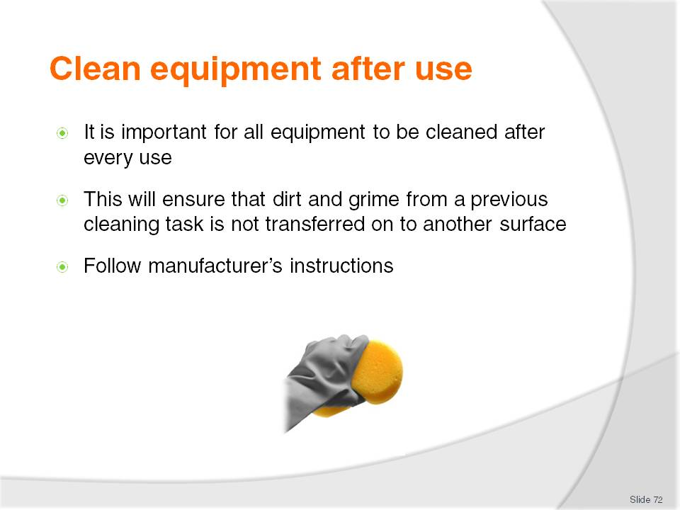
Slide No | Trainer Notes
Class Activity – Questions
What equipment needs to be cleaned?
Who does it?
What are the procedures for cleaning equipment after use?

Slide
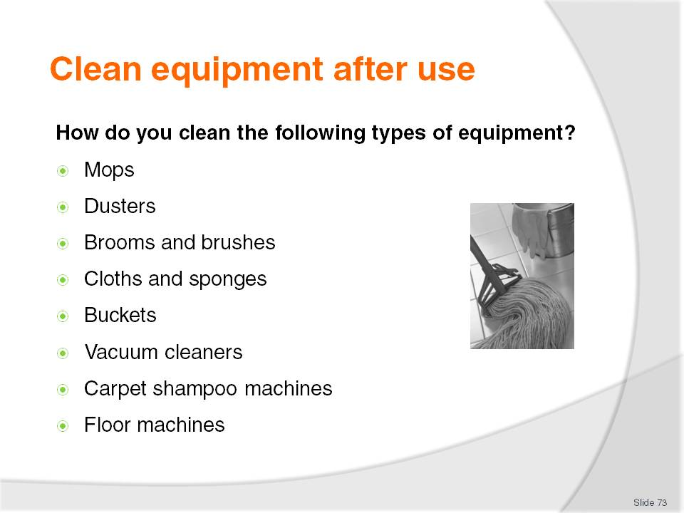
Slide No | Trainer Notes
Class Activity – Questions
How do you clean each type of equipment?
What else do you need to do to get it ready for the next shift?
Please refer to the Training manual which identifies how to clean each type of equipment.

Slide
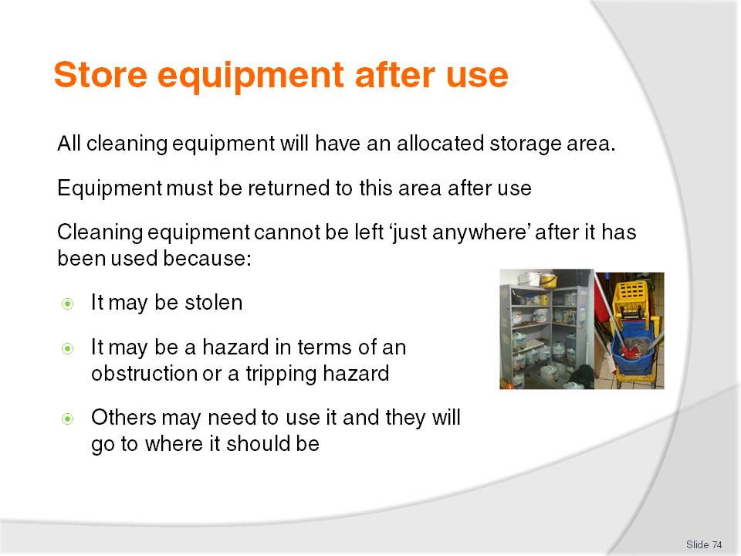
Slide No | Trainer Notes
Class Activity – Questions
Where is equipment normally stored?
Who has access to this area?

Slide
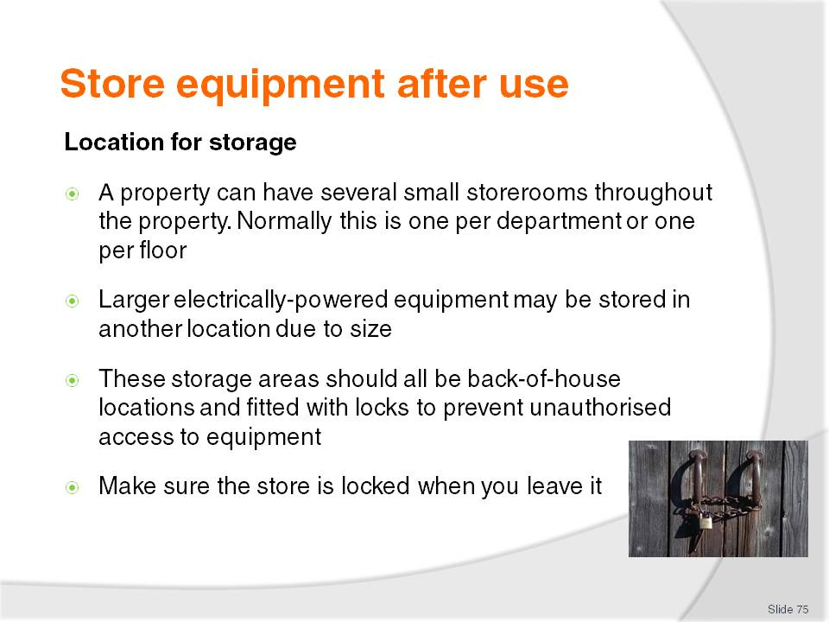
Slide No | Trainer Notes
Class Activity – Questions
Where is equipment normally stored?
Who has access to this area?

Slide
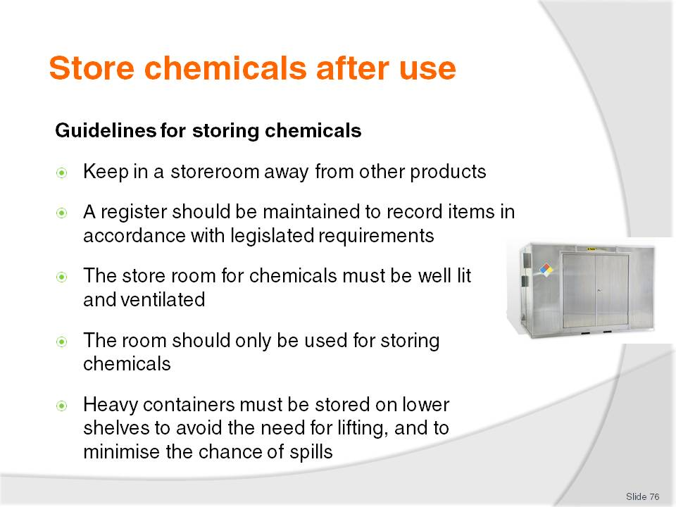
Slide No | Trainer Notes
Class Activity – Questions
What is the important of each of these guidelines when storing chemicals?

Slide
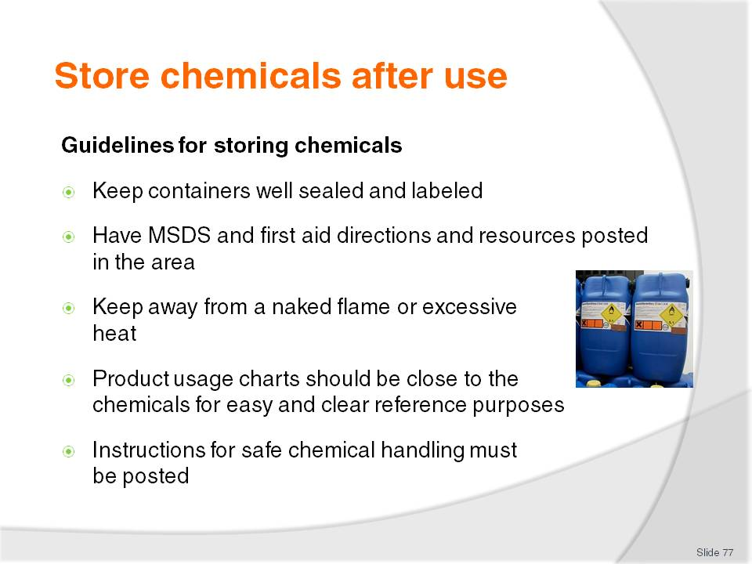
Slide No | Trainer Notes
Class Activity – Questions
What is the important of each of these guidelines when storing chemicals?

Slide
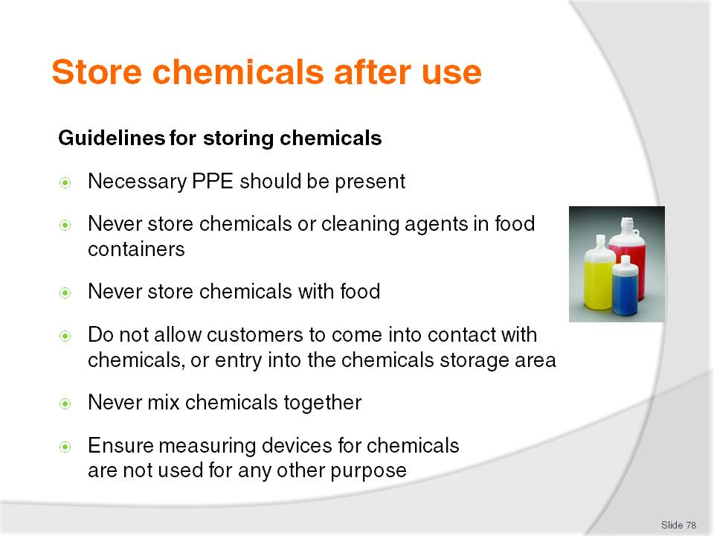
Slide No | Trainer Notes
Class Activity – Questions
What is the important of each of these guidelines when storing chemicals?

Slide
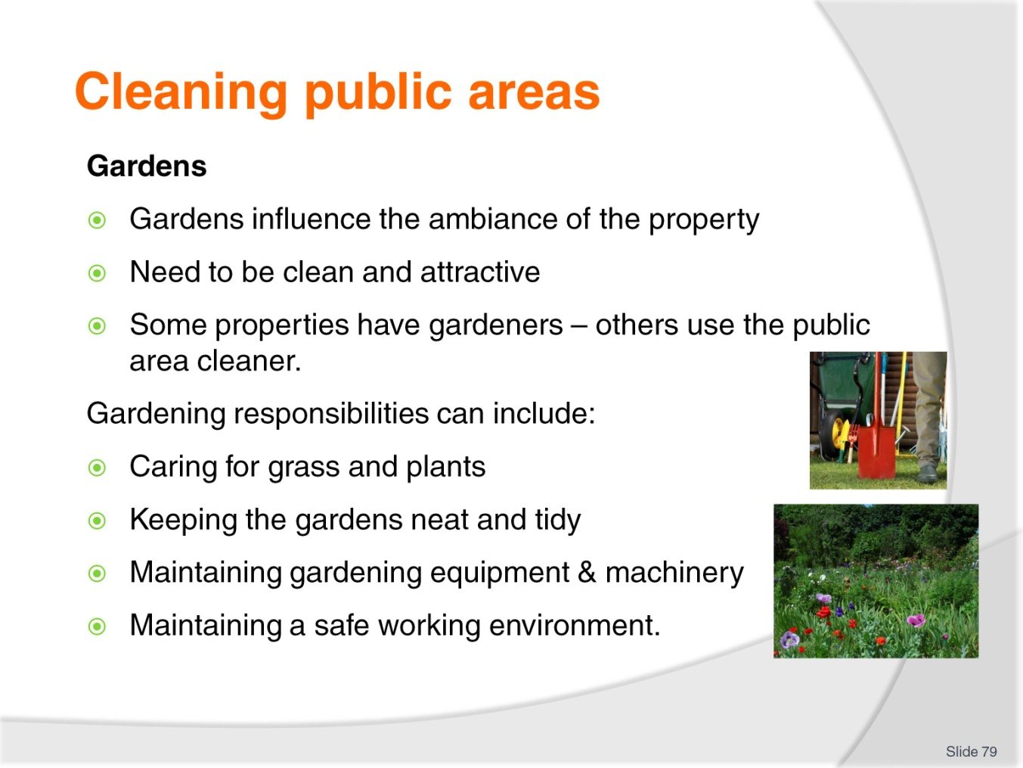
Slide No | Trainer Notes
Class Activity – Questions
- Make a list of some of the things a public area cleaner would be expected to do in the gardens.
- Which of these tasks would be better done by a gardener?

Slide
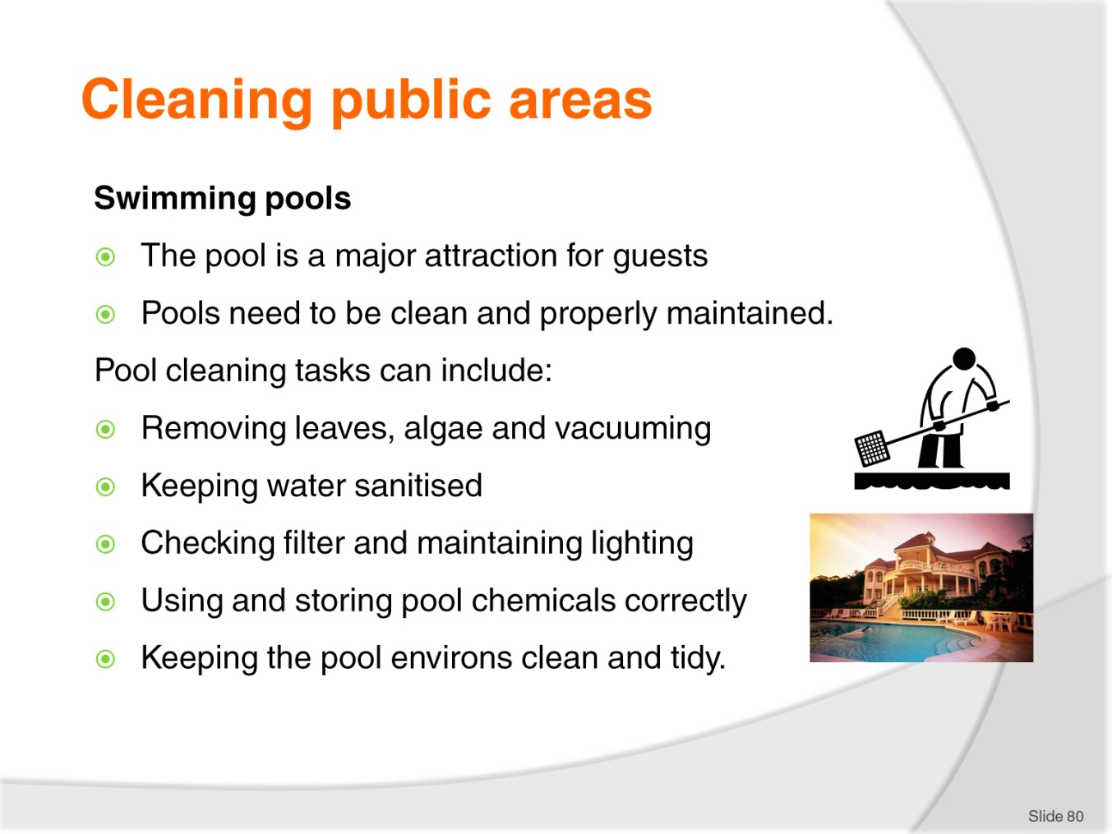
Slide No | Trainer Notes
Class Activity – Questions
- Make a list of some of the things a public area cleaner would be expected to do in the pool area.
- Which of these tasks would be better done by a pool cleaning contractor?

Slide
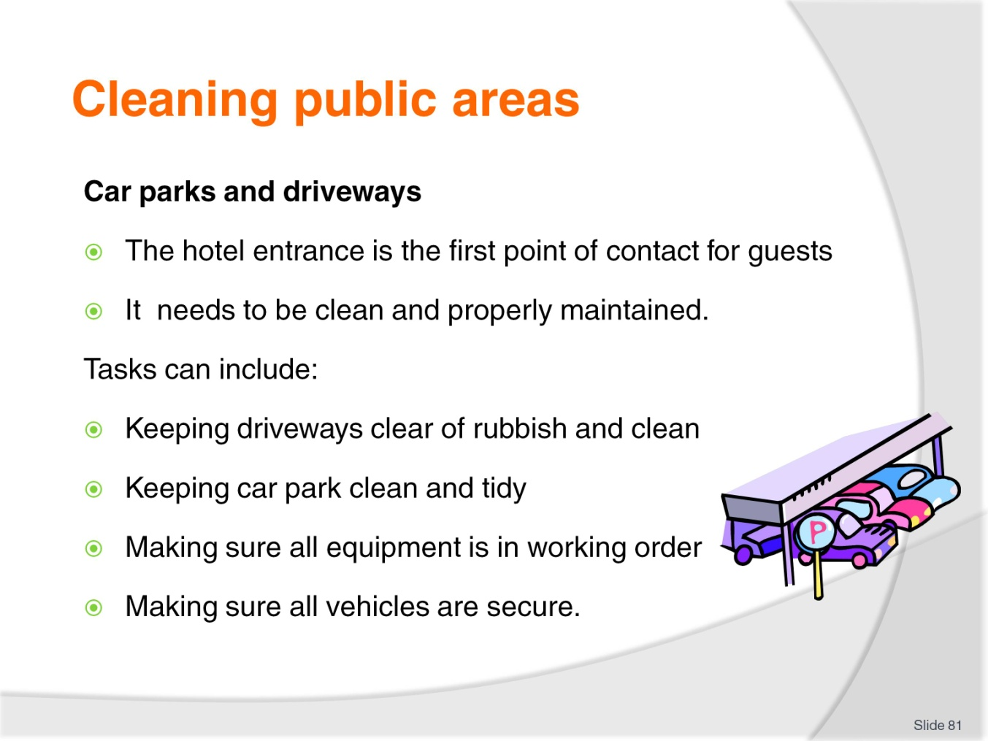
Slide No | Trainer Notes
Class Activity – Questions
Make a list of some of the things a public area cleaner would be expected to do in the car park and driveways areas.

Slide
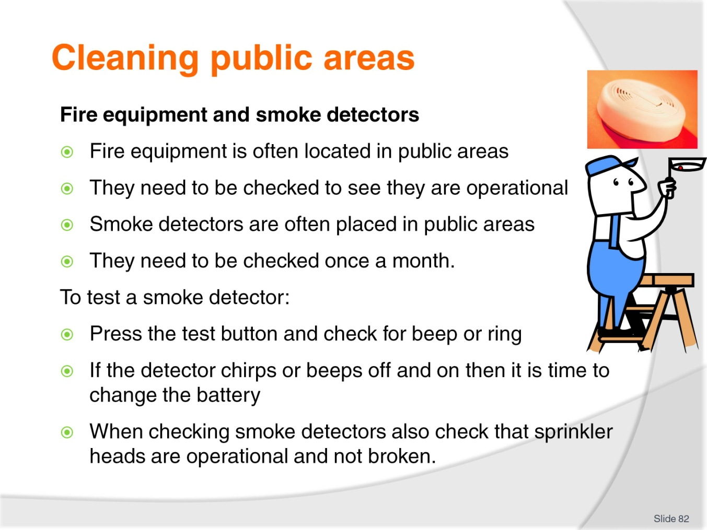
Slide No | Trainer Notes
Class Activity – Questions
Observe the presence of fire equipment and smoke detectors in the public areas or your workplace or a local hotel. How many did you see?

Slide
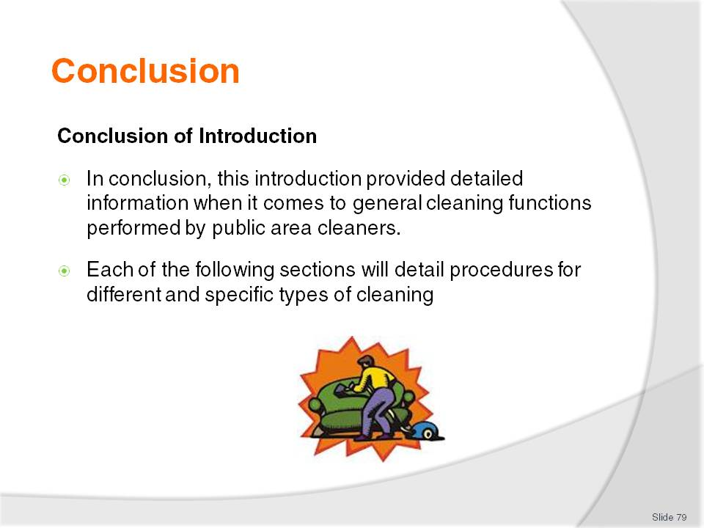
Slide No | Trainer Notes
Class Activity – Recap
The trainer may wise to conduct a recap of the topics covered in this introduction including:
Understanding public areas, facilities and equipment
Types of cleaning equipment
Preparing the work area
Using equipment correctly and safely
Types of cleaning agents and chemicals
Types of surfaces to be cleaned
Disposal of garbage and used chemicals
Cleaning and maintaining PPE
Cleaning equipment after use
Storing equipment and chemicals safely.

Slide
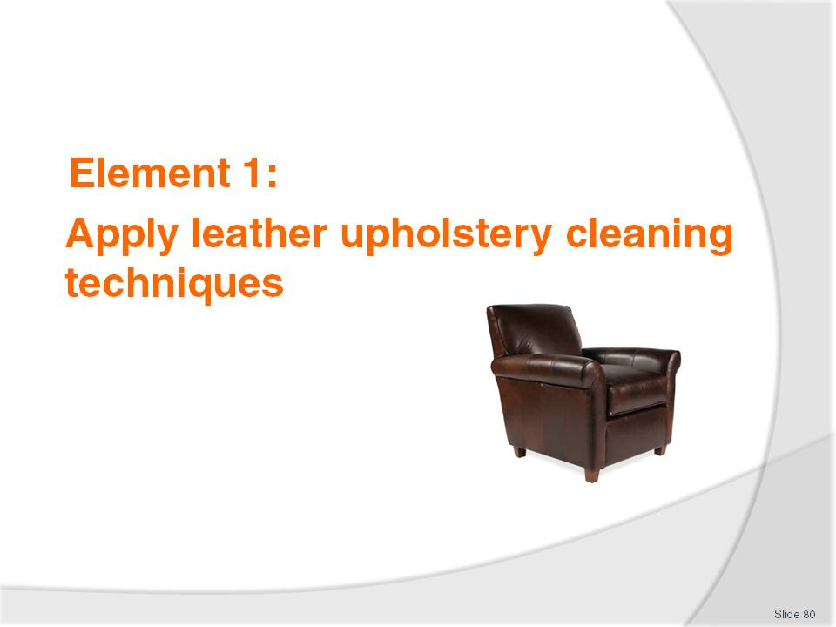
Slide No | Trainer Notes
Introduce topic.
Class Activity – General Discussion
Ask general questions:
What leather items are located in public areas?
How do you clean them?

Slide
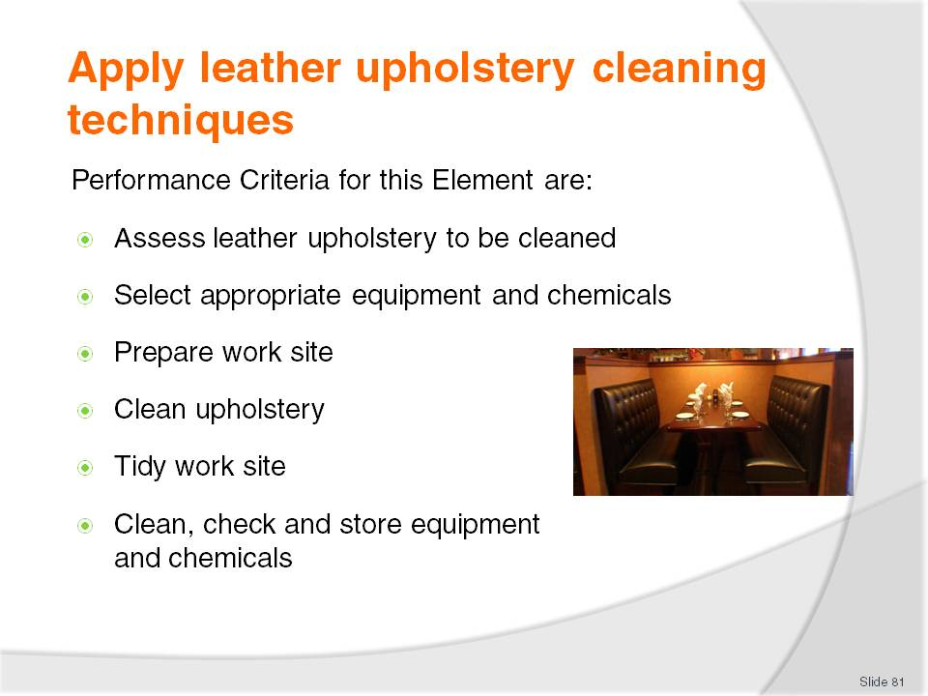
Slide No | Trainer Notes
 | Trainer identifies the Performance Criteria for this Element, as listed on the slide.

Slide
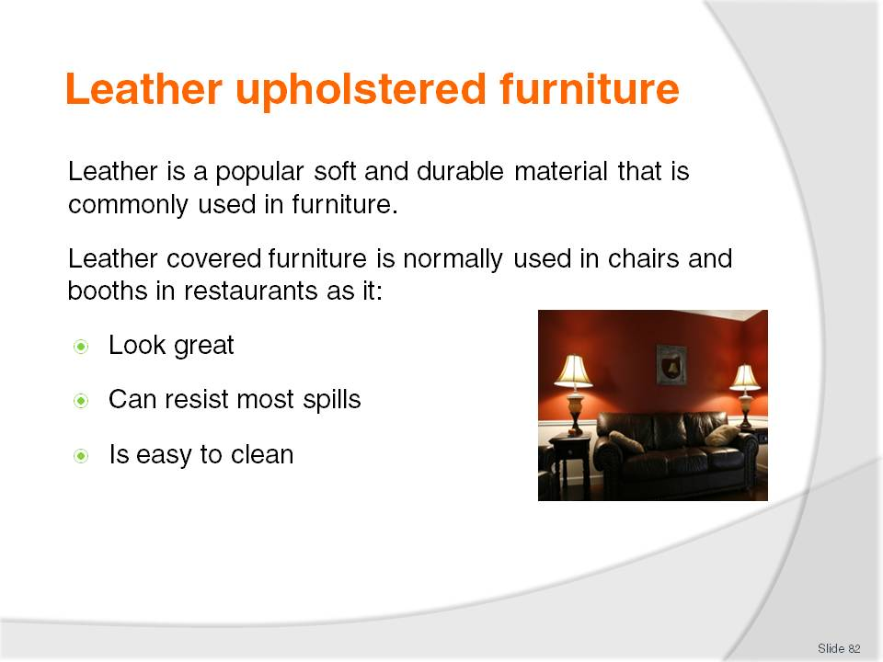
Slide No | Trainer Notes
Class Activity – Questions
How do you keep leather clean?

Slide
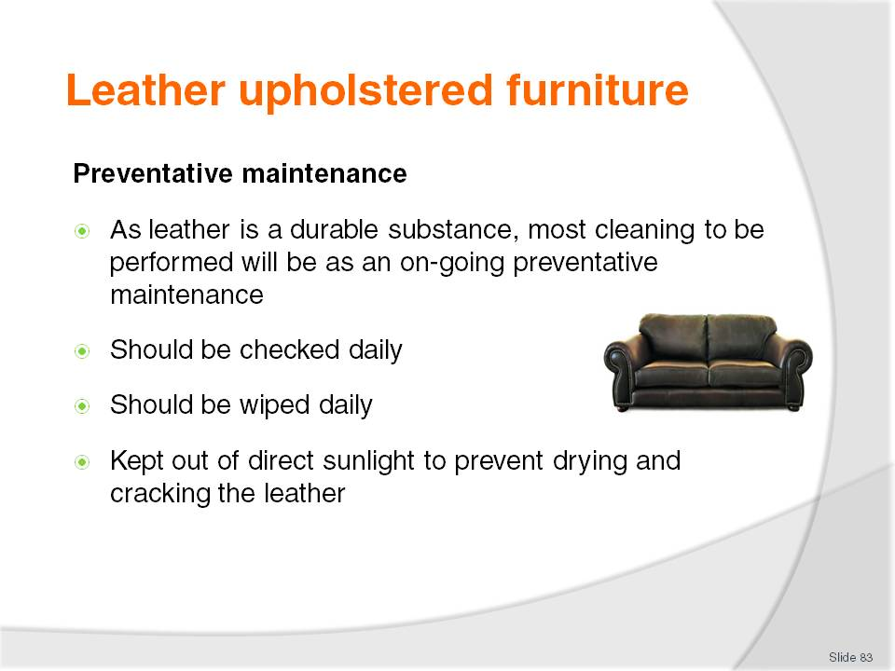
Slide No | Trainer Notes
Class Activity – Questions
What other preventative maintenance can you perform?

Slide
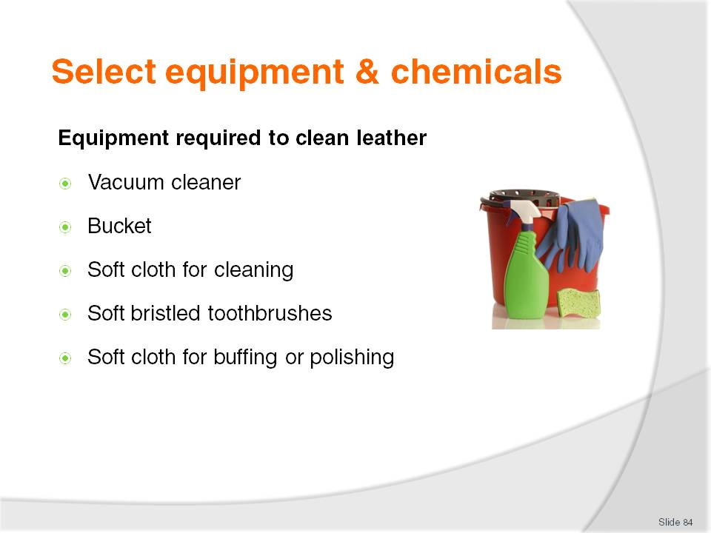
Slide No | Trainer Notes
Class Activity – Questions
What is each of the equipment items identified used for?

Slide
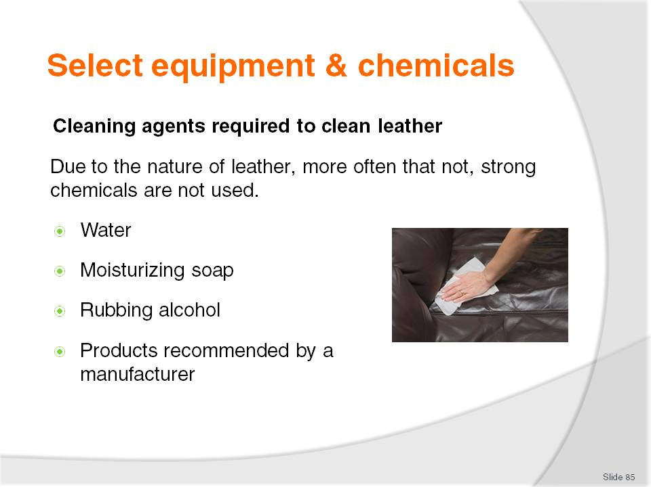
Slide No | Trainer Notes
Class Activity – Questions
What is each of the cleaning agents identified used for?
Leather Protection Cream - is a leather conditioner is used to protect leather that repels stains and protects the surface from wear and tear. It feeds, protects and re-instates the smell into old and new leather items.

Slide
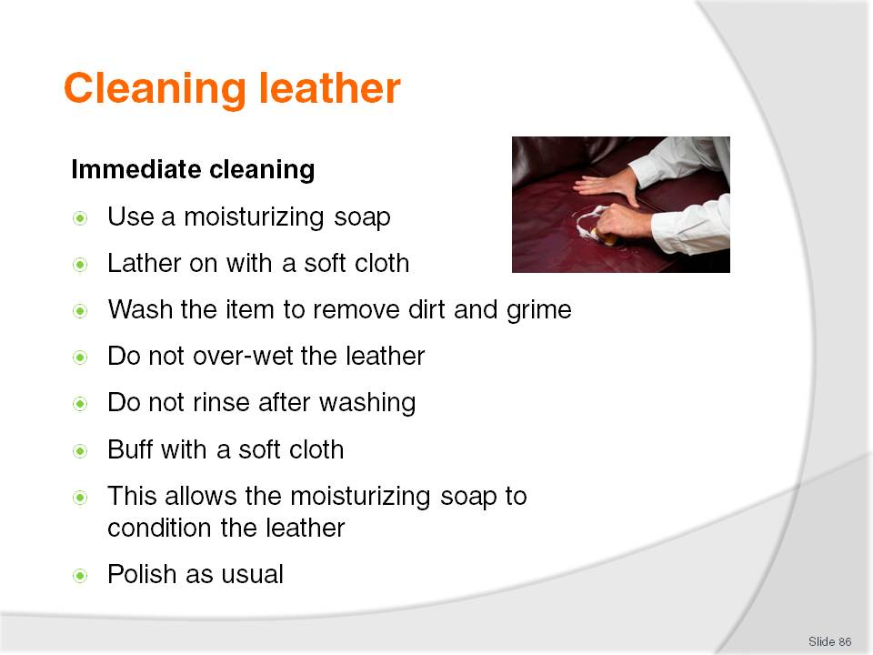
Slide No | Trainer Notes
Class Activity – Discuss steps and/or demonstration
Trainer to discuss steps and/or provide a demonstration.

Slide
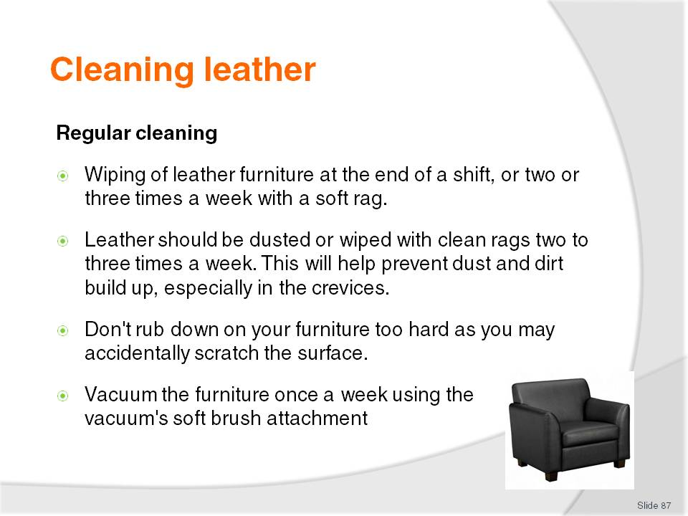
Slide No | Trainer Notes
Class Activity – Discuss steps and/or demonstration
Trainer to discuss steps and/or provide a demonstration.

Slide
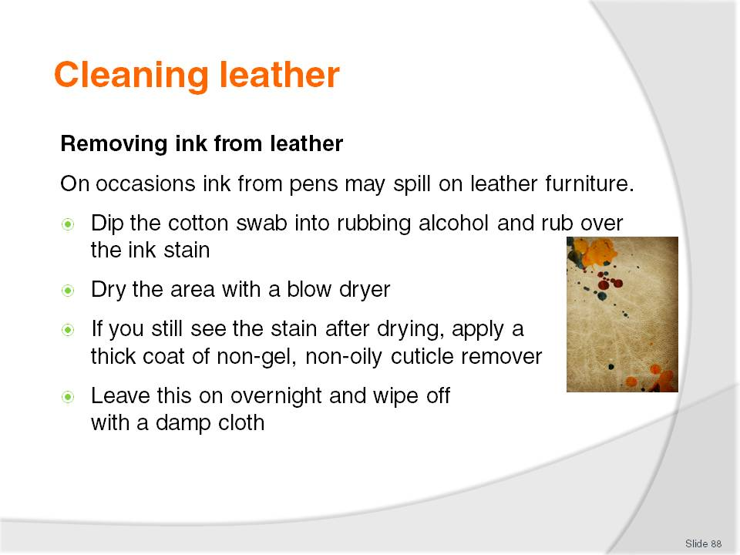
Slide No | Trainer Notes
Class Activity – Discuss steps and/or demonstration
Trainer to discuss steps and/or provide a demonstration.

Slide
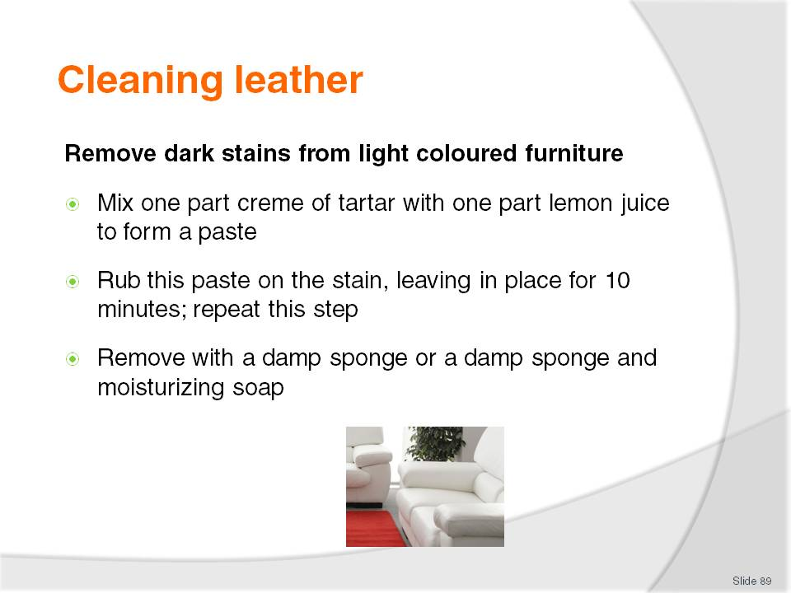
Slide No | Trainer Notes
Class Activity – Discuss steps and/or demonstration
Trainer to discuss steps and/or provide a demonstration.

Slide
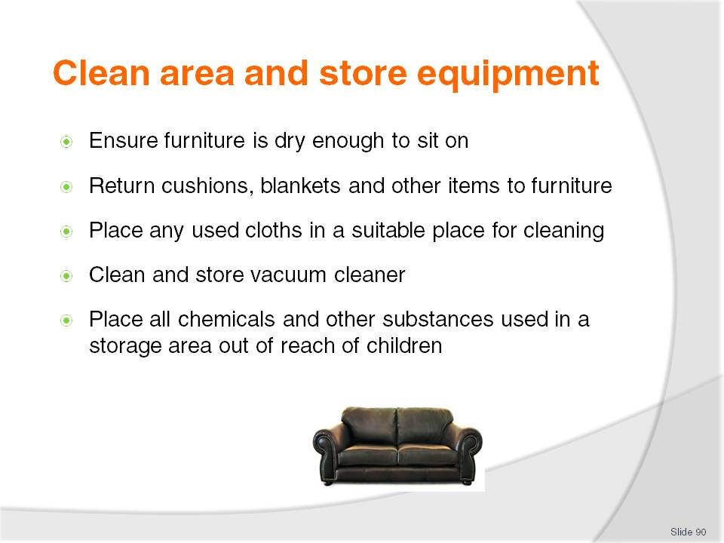
Slide No | Trainer Notes
Class Activity – Discuss steps
Why is each of the steps mentioned important?

Slide

Slide No | Trainer Notes
Introduce topic.
Class Activity – General Discussion
Ask general questions:
What fabric items are located in public areas?
How do you clean them?

Slide
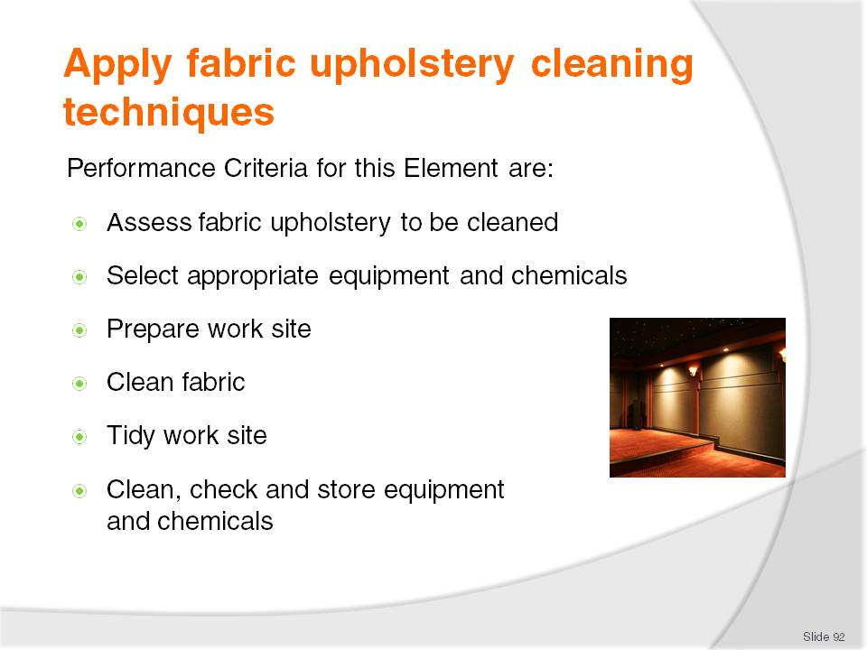
Slide No | Trainer Notes
 | Trainer identifies the Performance Criteria for this Element, as listed on the slide.

Slide
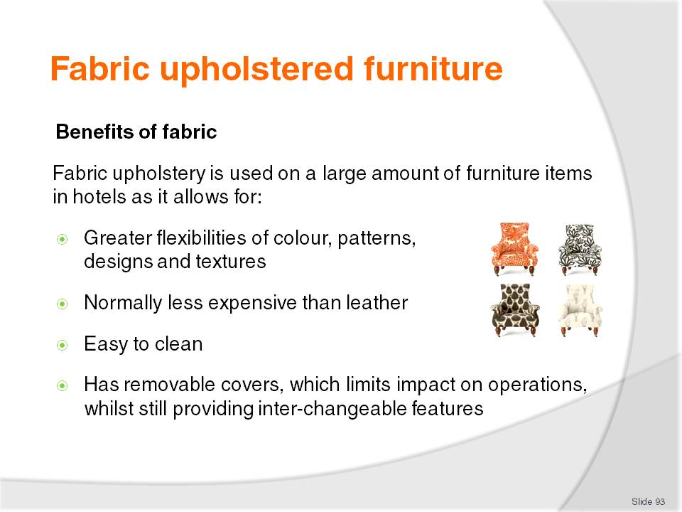
Slide No | Trainer Notes
Class Activity – Questions
How do you keep fabric clean?

Slide
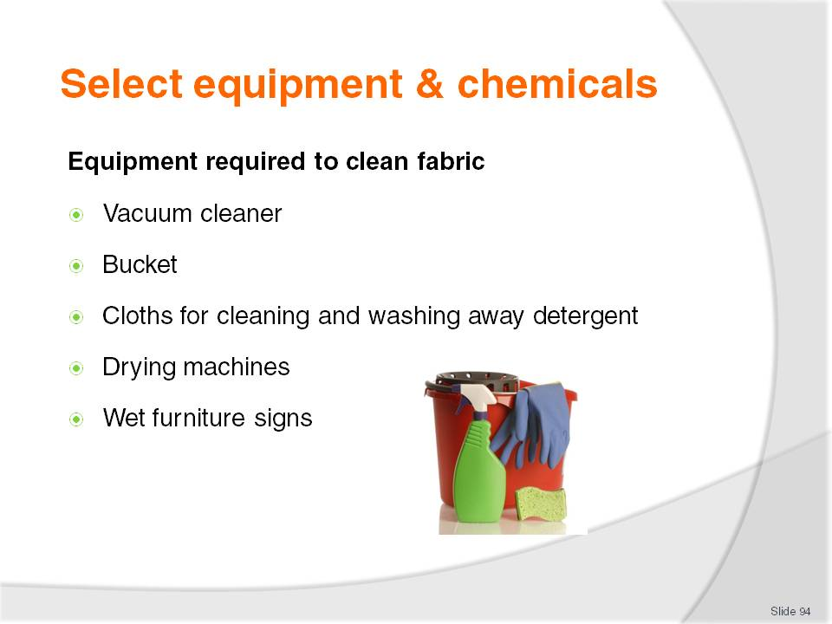
Slide No | Trainer Notes
Class Activity – Questions
What is each of the equipment items identified used for?

Slide
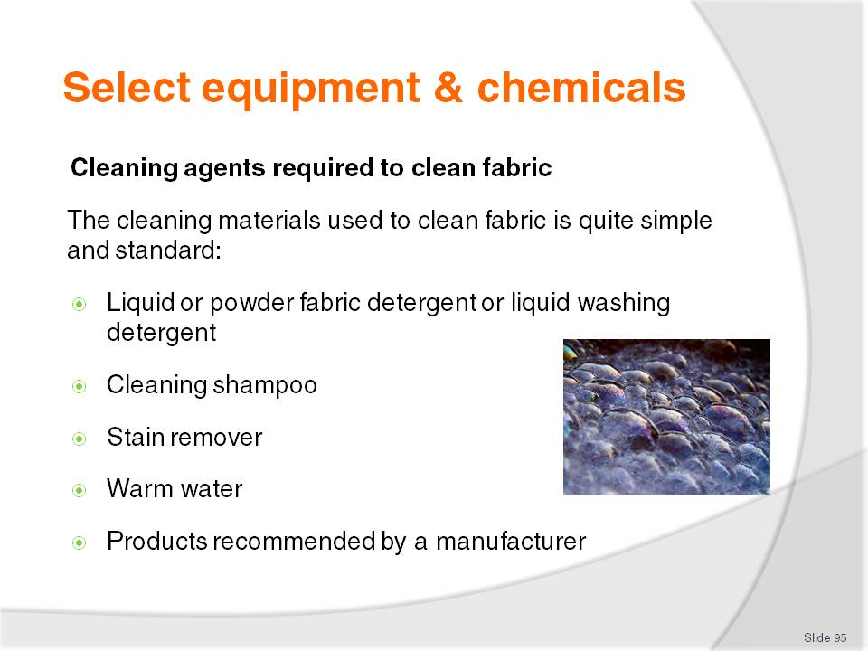
Slide No | Trainer Notes
Class Activity – Questions
What is each of the cleaning agents identified used for?

Slide
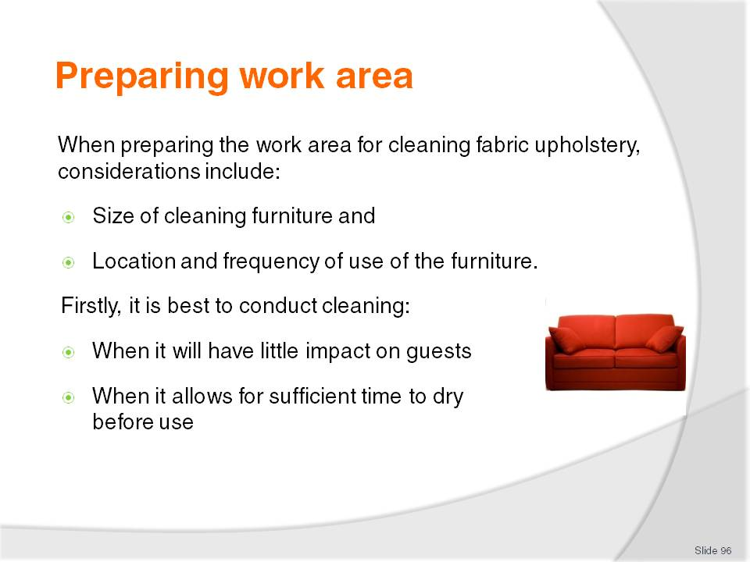
Slide No | Trainer Notes
Class Activity – Question
What activities need to be done when preparing the work area?

Slide
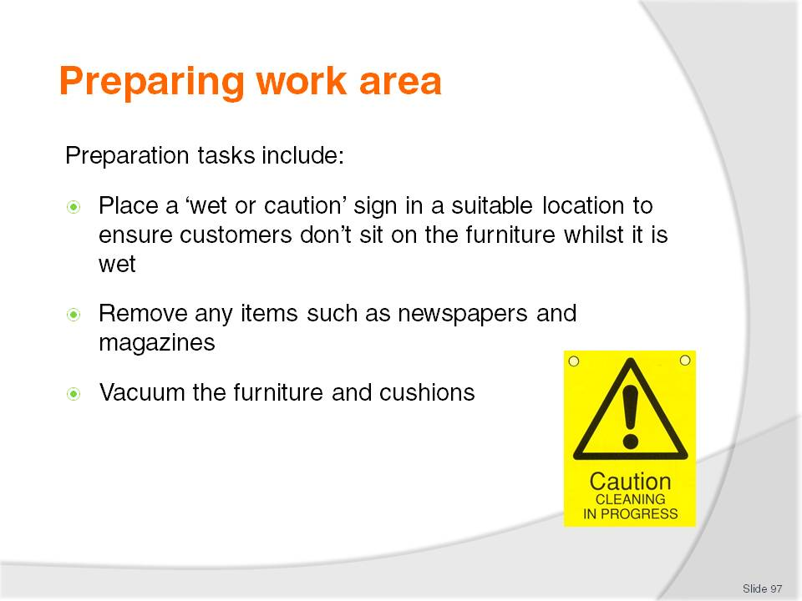
Slide No | Trainer Notes
Class Activity – Question
Where should cushions be placed to ensure they don’t go missing or get dirty themselves?

Slide
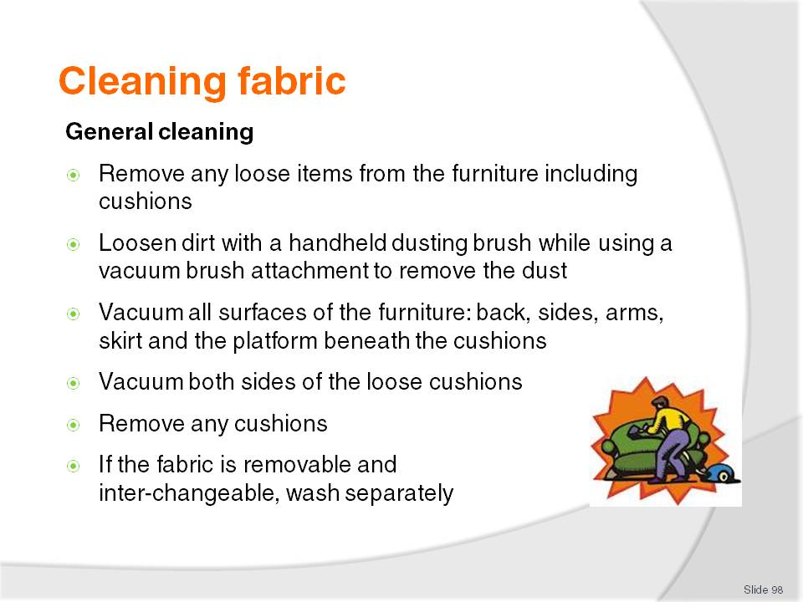
Slide No | Trainer Notes
Class Activity – Discuss steps and/or demonstration
Trainer to discuss steps and/or provide a demonstration.

Slide
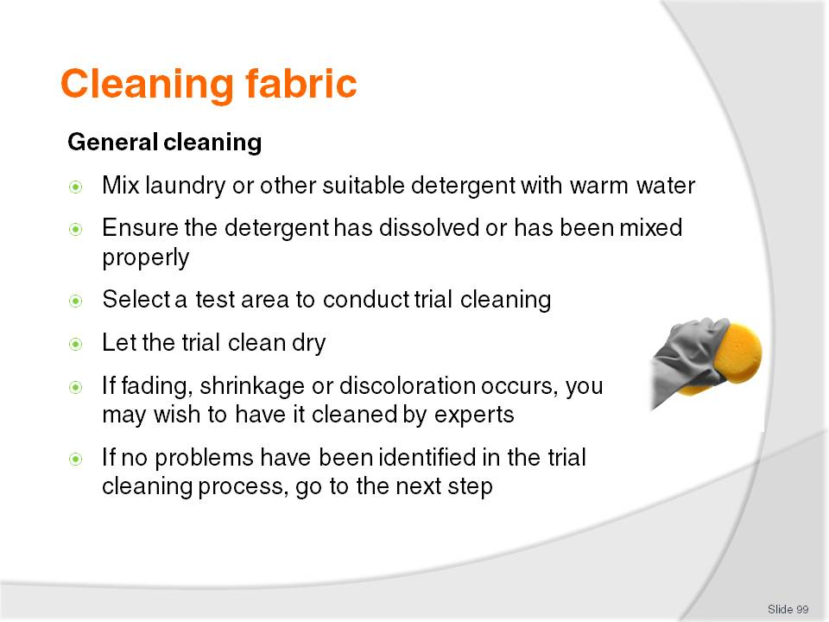
Slide No | Trainer Notes
Class Activity – Discuss steps and/or demonstration
Trainer to discuss steps and/or provide a demonstration.

Slide
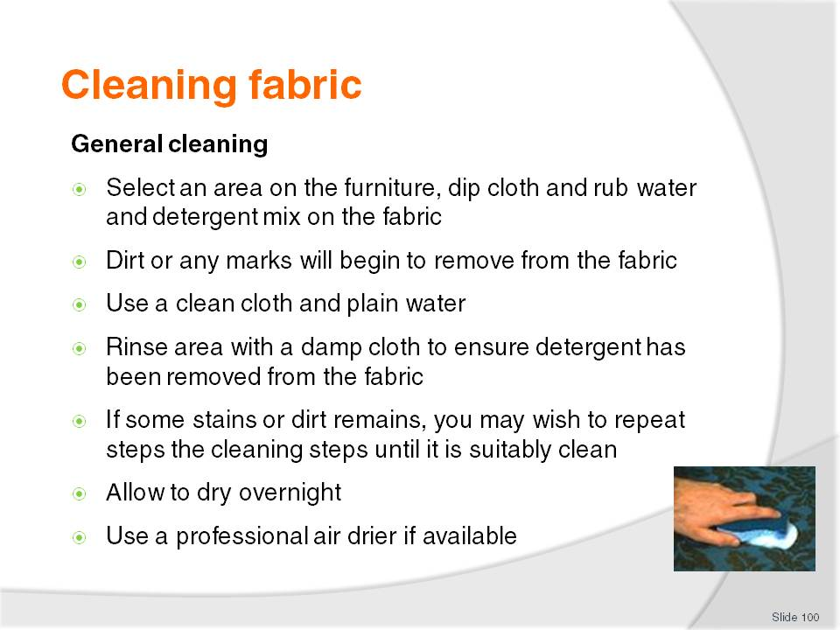
Slide No | Trainer Notes
Class Activity – Discuss steps and/or demonstration
Trainer to discuss steps and/or provide a demonstration.

Slide
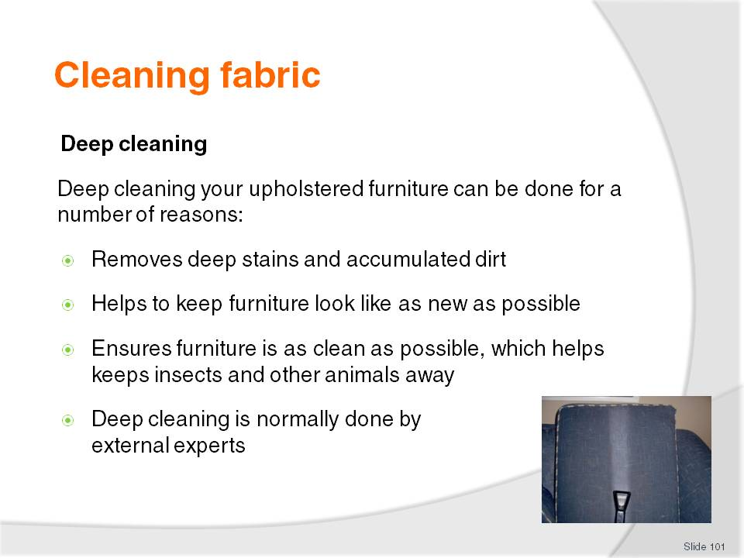
Slide No | Trainer Notes
Class Activity – Internet research
Trainer to get audience to identify:
Local companies that deep clean fabric upholstery
How much it costs?
Where is it done? (at hotel or at their location)

Slide
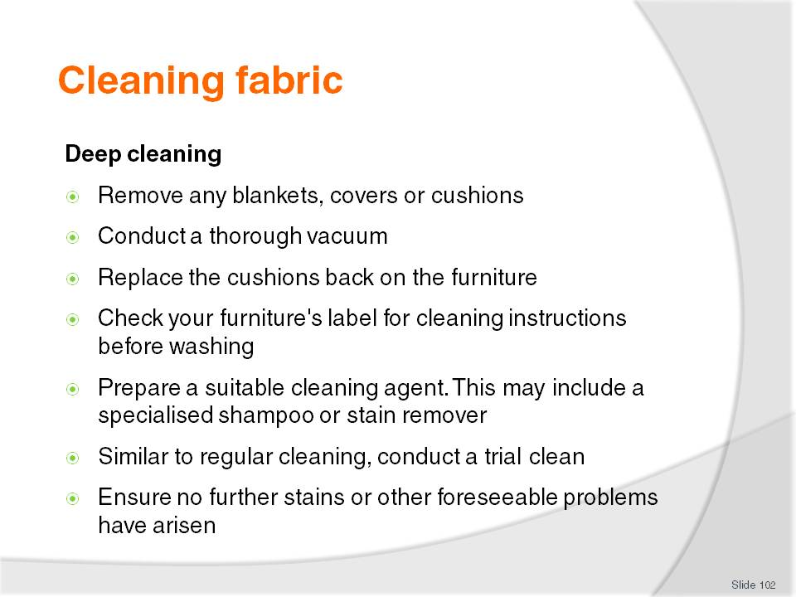
Slide No | Trainer Notes
Class Activity – Discuss steps and/or demonstration
Trainer to discuss steps and/or provide a demonstration.

Slide
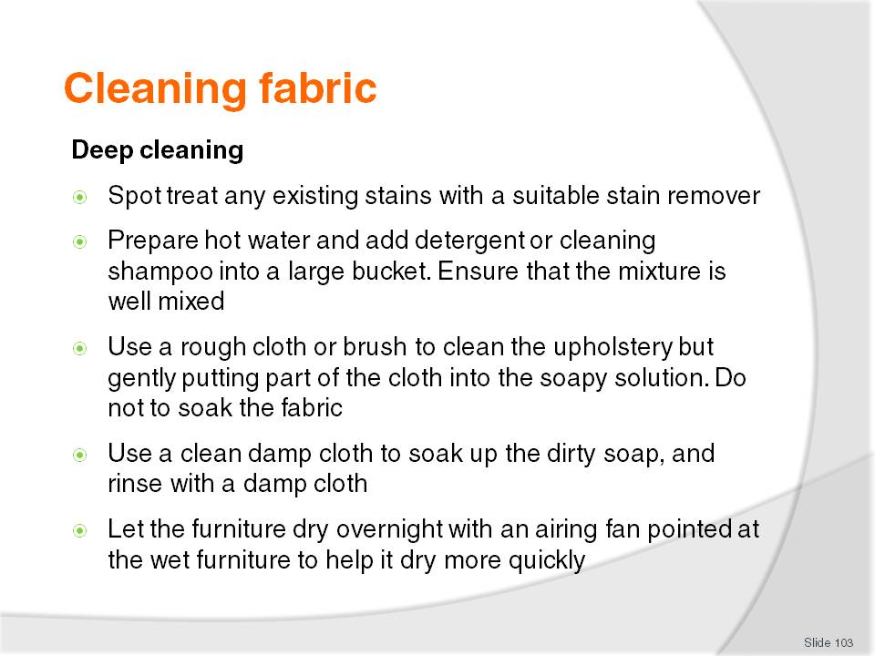
Slide No | Trainer Notes
Class Activity – Discuss steps and/or demonstration
Trainer to discuss steps and/or provide a demonstration.

Slide
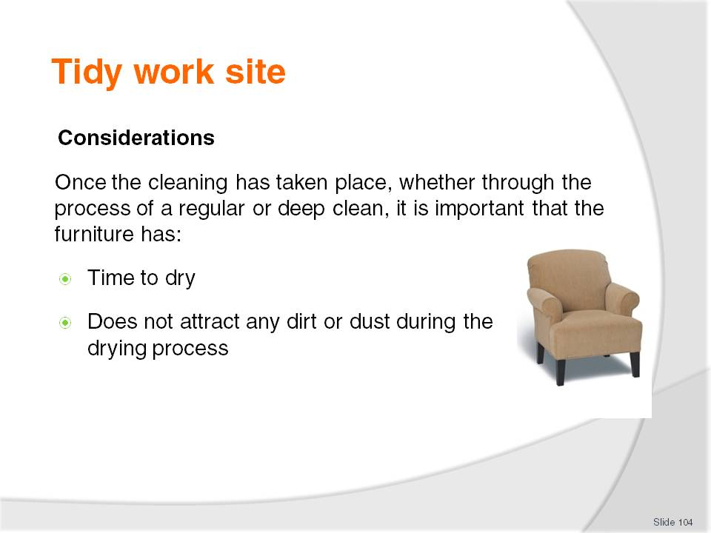
Slide No | Trainer Notes
Class Activity – Discuss steps
Why is each of the considerations mentioned important?

Slide
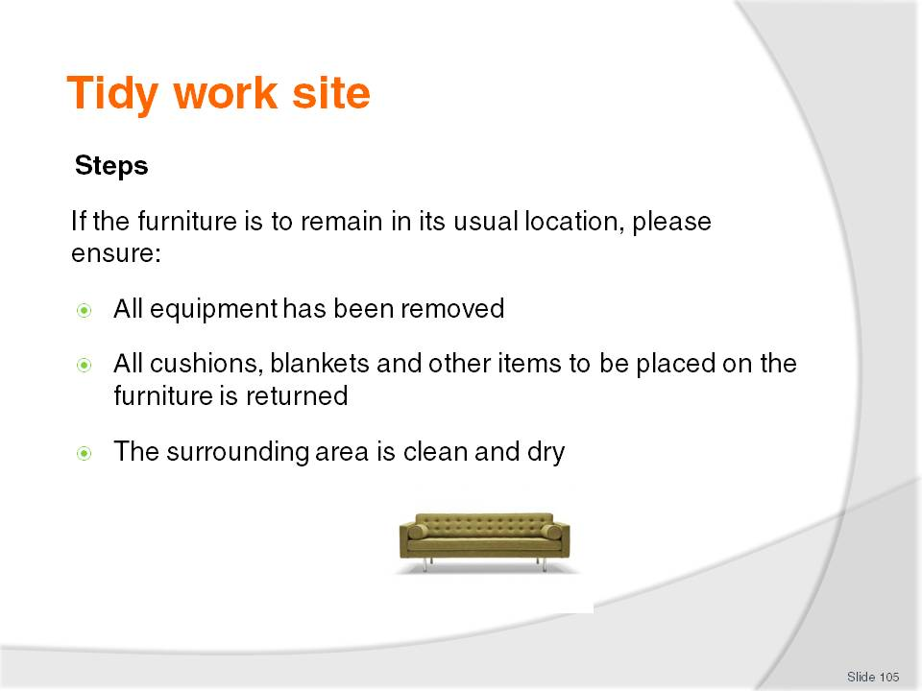
Slide No | Trainer Notes
Class Activity – Discuss steps
Why is each of the steps mentioned important?

Slide
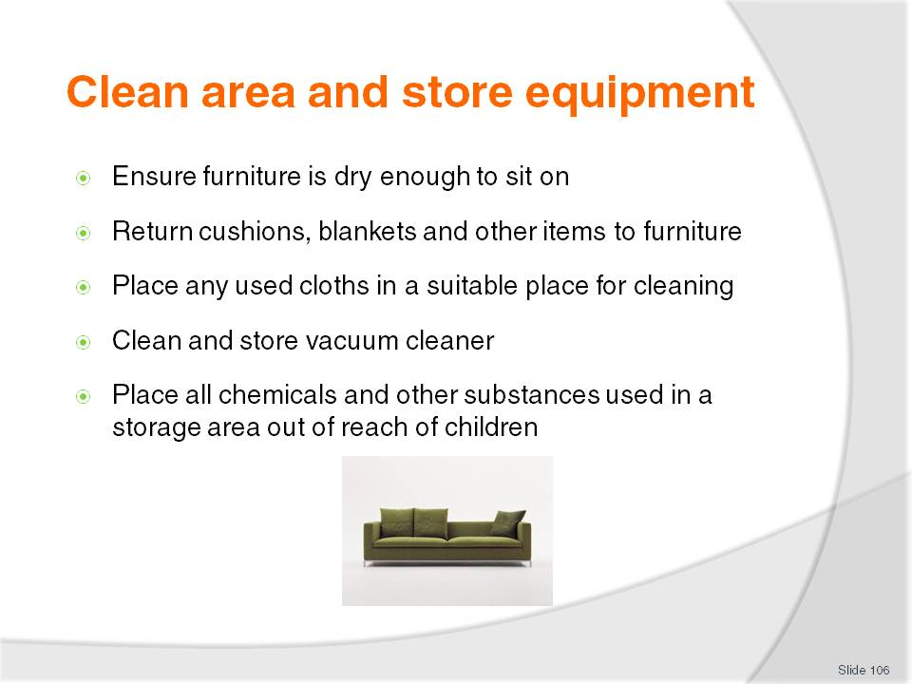
Slide No | Trainer Notes
Class Activity – Discuss steps
Why is each of the steps mentioned important?

Slide
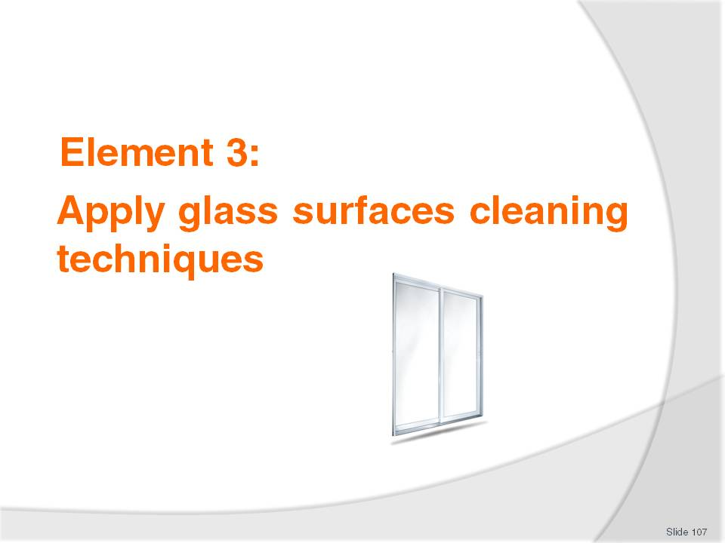
Slide No | Trainer Notes
Introduce topic.
Class Activity – General Discussion
Ask general questions:
What glass surfaces are located in public areas?
How do you clean them?

Slide
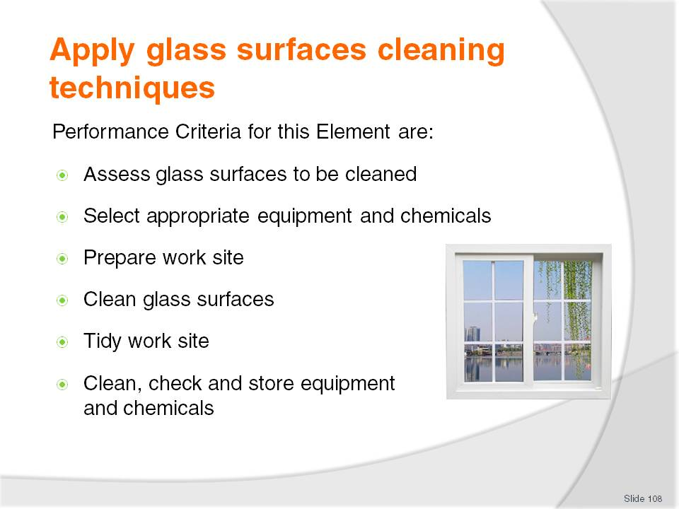
Slide No | Trainer Notes
 | Trainer identifies the Performance Criteria for this Element, as listed on the slide.

Slide
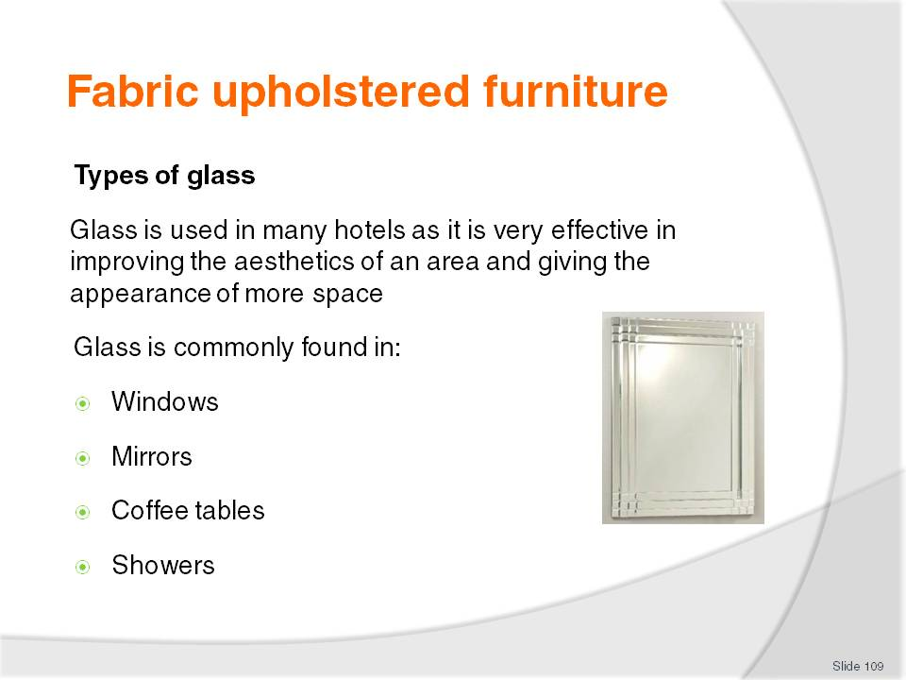
Slide No | Trainer Notes
Class Activity – Questions
What different types of glass items are located in a hotel?
How do you keep glass clean?

Slide
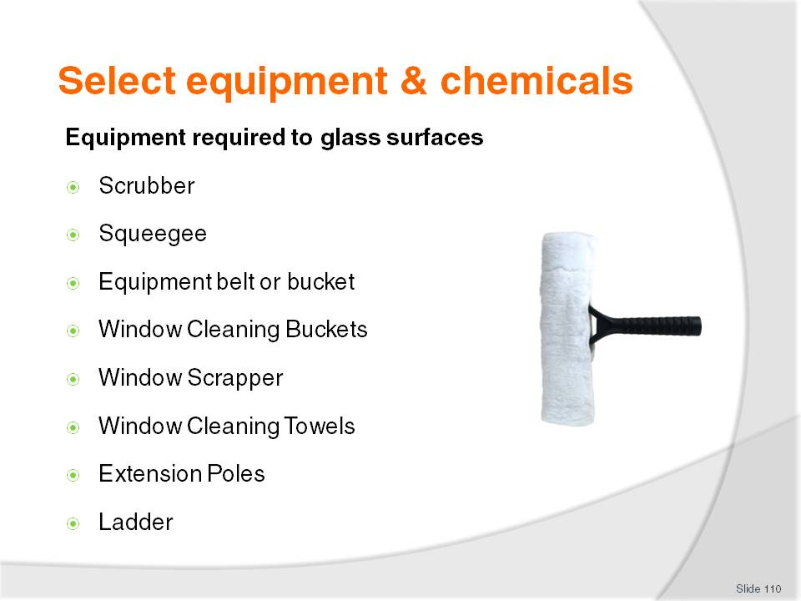
Slide No | Trainer Notes
Class Activity – Questions
What is each of the equipment items identified used for?
Please refer to the manual for detailed comment relating to each piece of equipment.

Slide
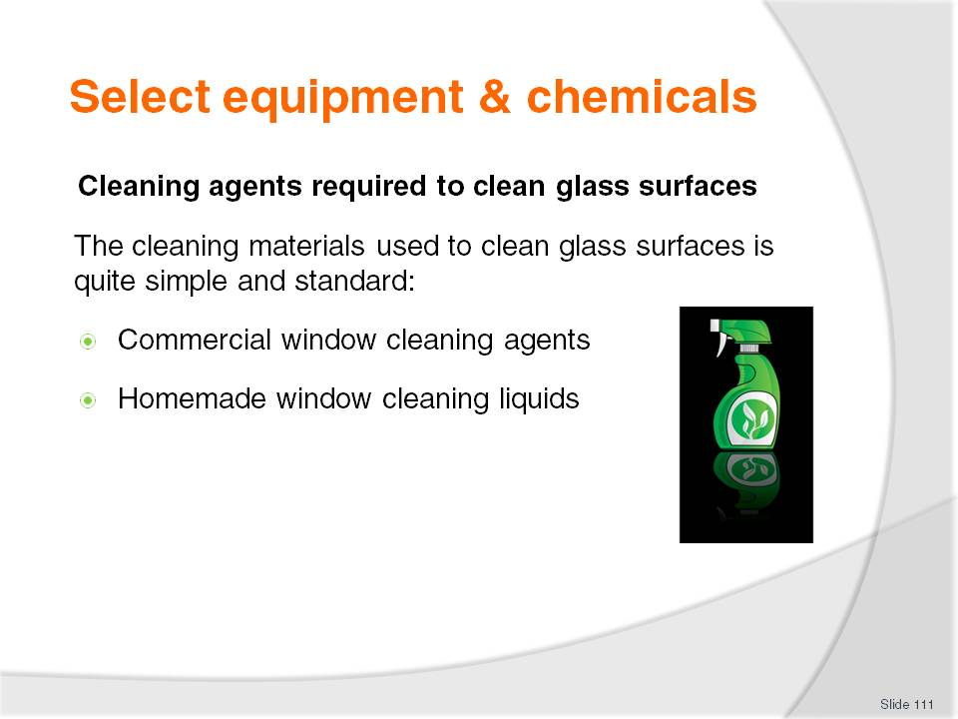
Slide No | Trainer Notes
Class Activity – Questions & Internet research
What are common types of commercial window cleaners?
How can you make your own window cleaner? What ingredients are in it? (This may be a good internet research session)
What is each of the cleaning agents identified used for?

Slide
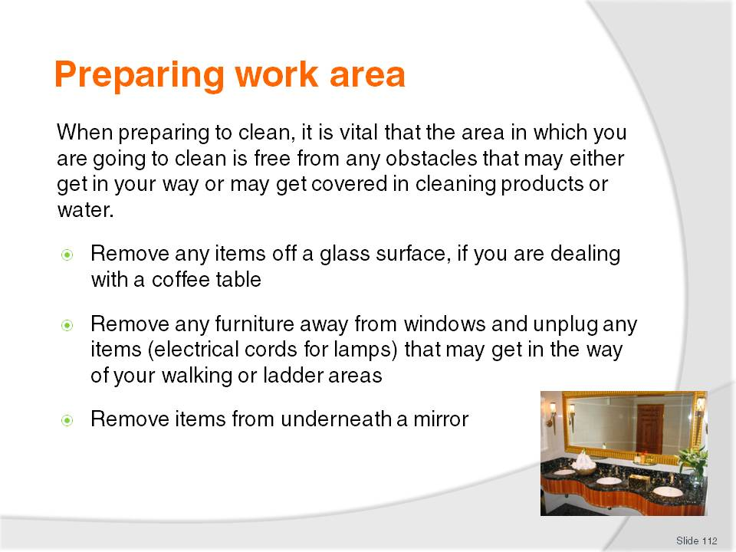
Slide No | Trainer Notes
 | No discussion required.

Slide
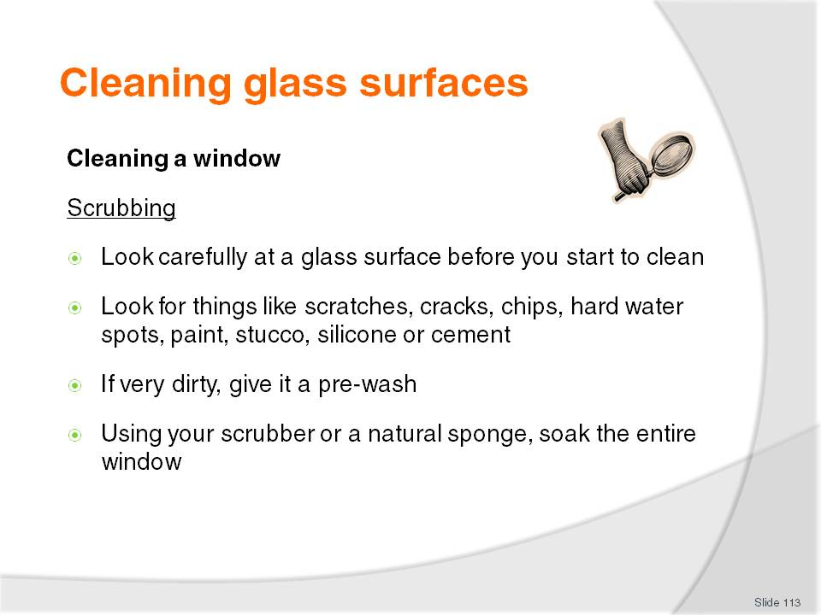
Slide No | Trainer Notes
Class Activity – Discuss steps and/or demonstration
Trainer to discuss steps and/or provide a demonstration.

Slide
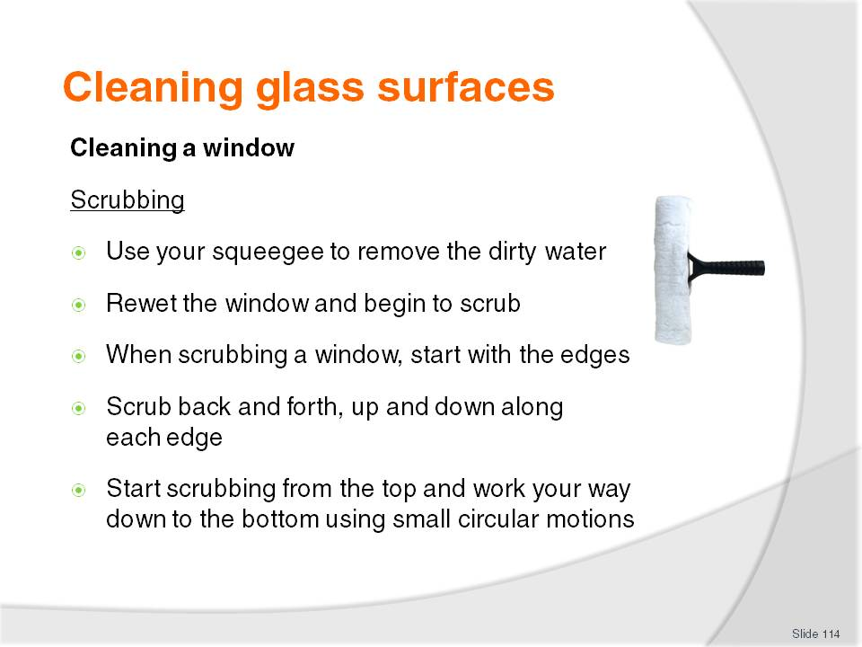
Slide No | Trainer Notes
Class Activity – Discuss steps and/or demonstration
Trainer to discuss steps and/or provide a demonstration.

Slide
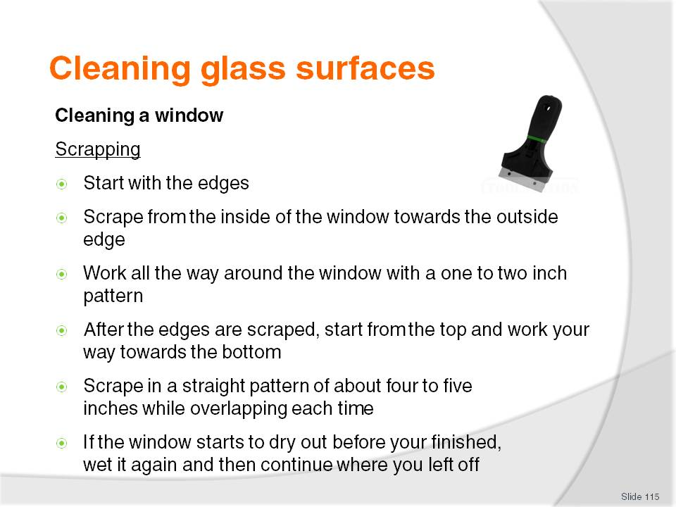
Slide No | Trainer Notes
Class Activity – Discuss steps and/or demonstration
Trainer to discuss steps and/or provide a demonstration.

Slide
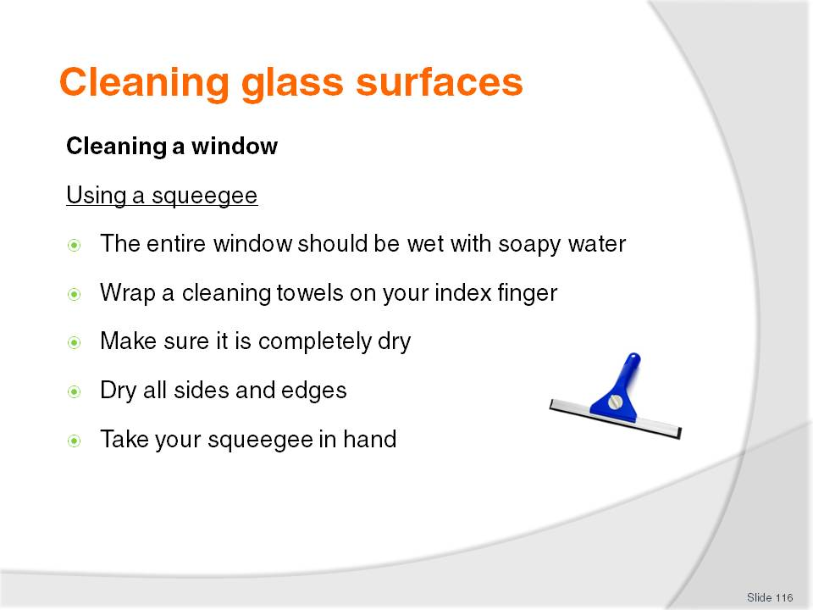
Slide No | Trainer Notes
Class Activity – Discuss steps and/or demonstration
Trainer to discuss steps and/or provide a demonstration.

Slide
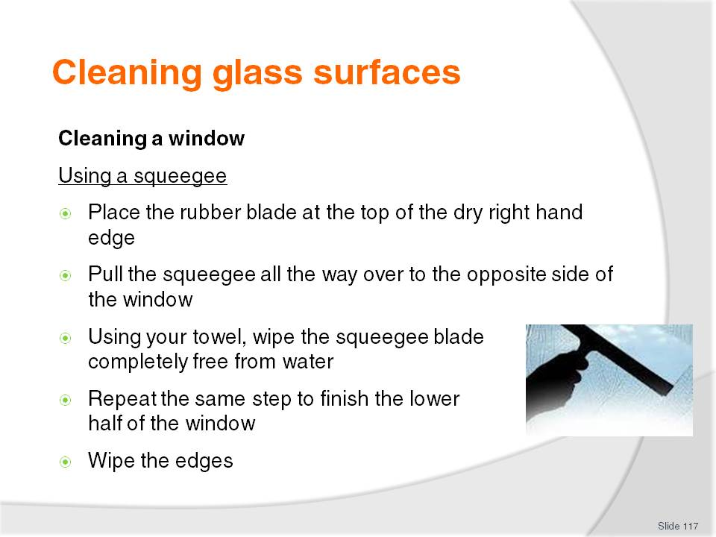
Slide No | Trainer Notes
Class Activity – Discuss steps and/or demonstration
Trainer to discuss steps and/or provide a demonstration.

Slide
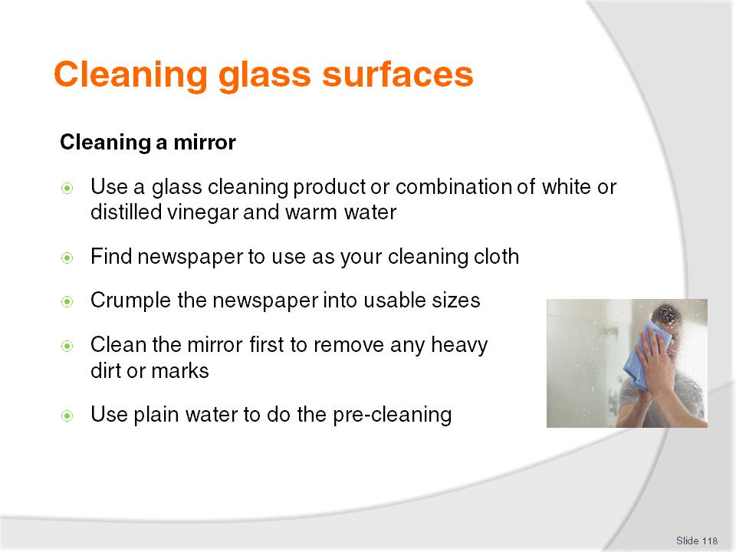
Slide No | Trainer Notes
Class Activity – Discuss steps and/or demonstration
Trainer to discuss steps and/or provide a demonstration.

Slide
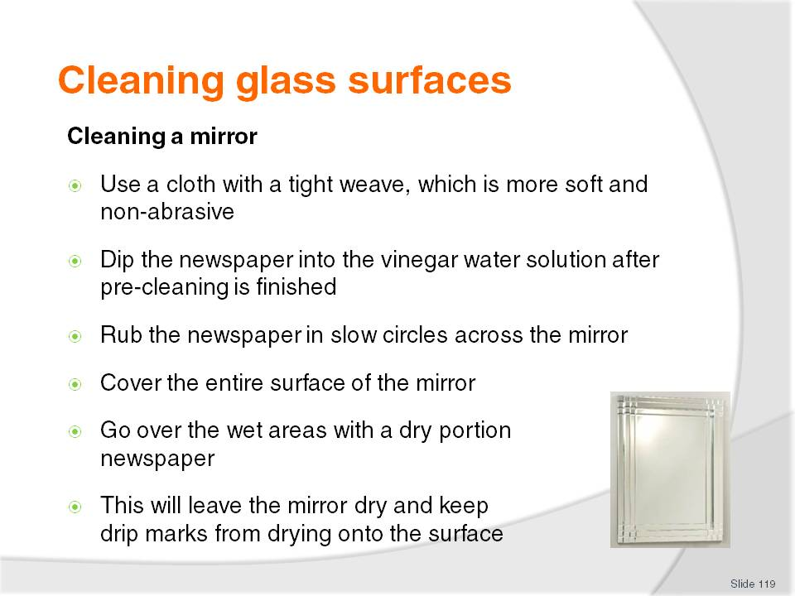
Slide No | Trainer Notes
Class Activity – Discuss steps and/or demonstration
Trainer to discuss steps and/or provide a demonstration.

Slide
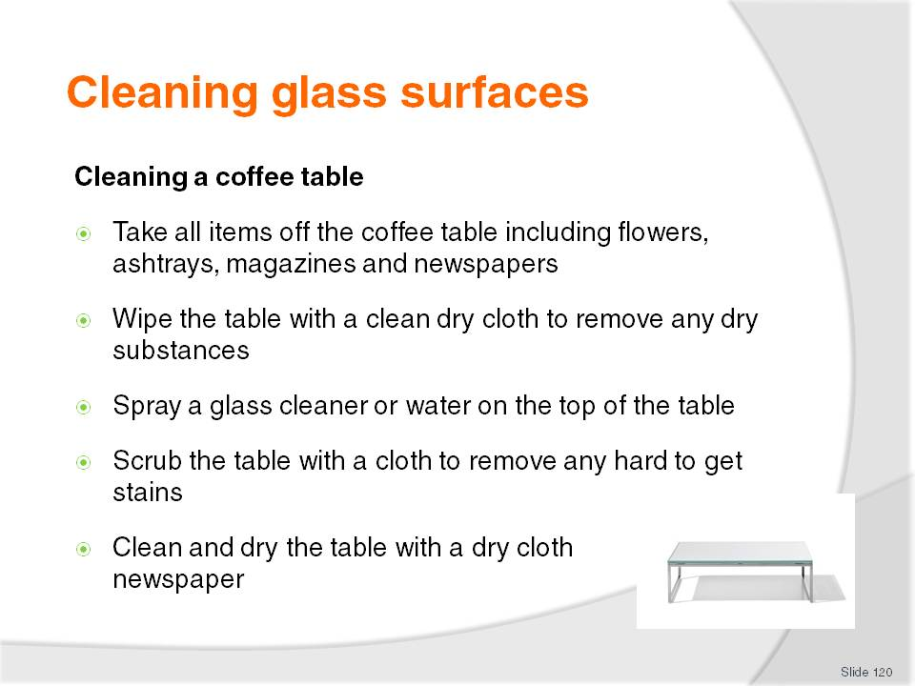
Slide No | Trainer Notes
Class Activity – Discuss steps and/or demonstration
Trainer to discuss steps and/or provide a demonstration.

Slide
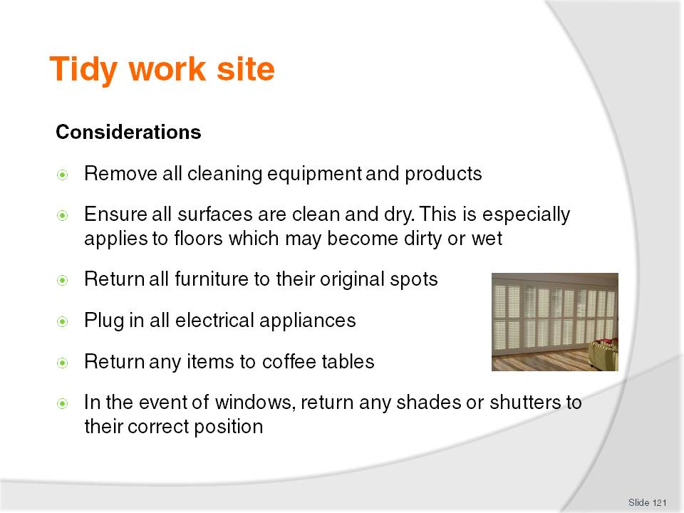
Slide No | Trainer Notes
Class Activity – Discuss steps
Why is each of the considerations mentioned important?

Slide
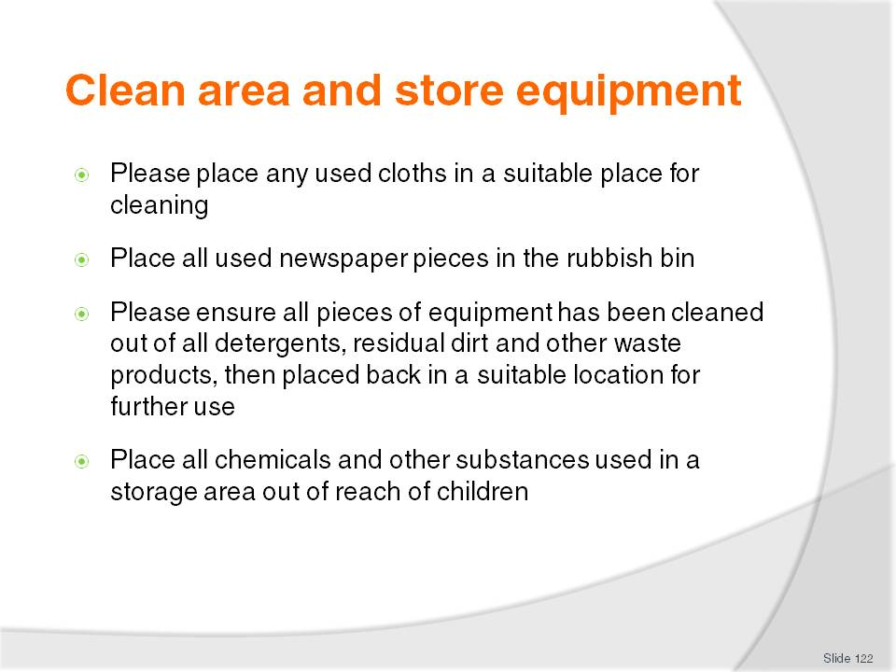
Slide No | Trainer Notes
Class Activity – Discuss steps
Why is each of the steps mentioned important?

Slide
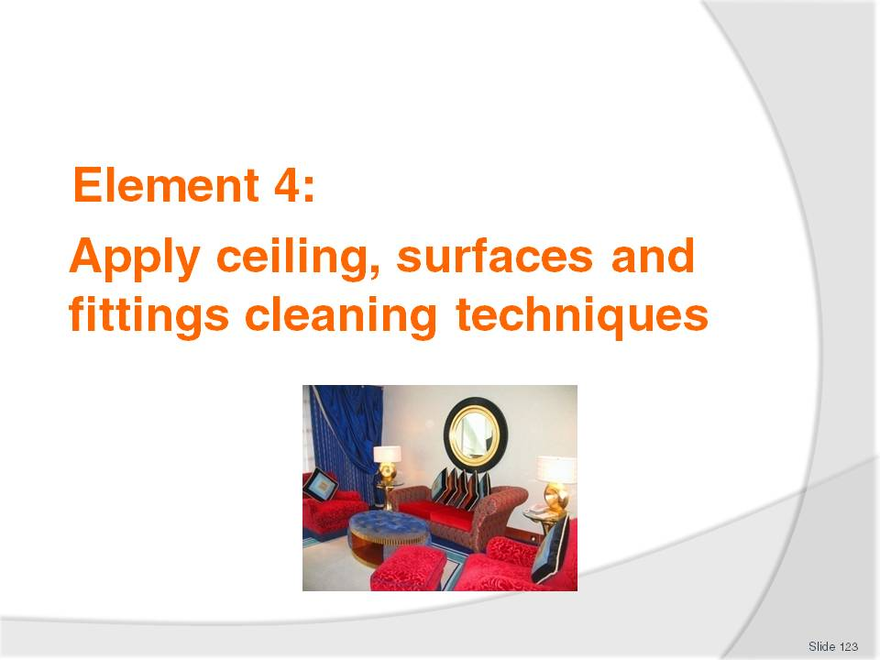
Slide No | Trainer Notes
Introduce topic.
Class Activity – General Discussion
Ask general questions:
What ceiling, surfaces and fittings are located in public areas?
How do you clean them?

Slide
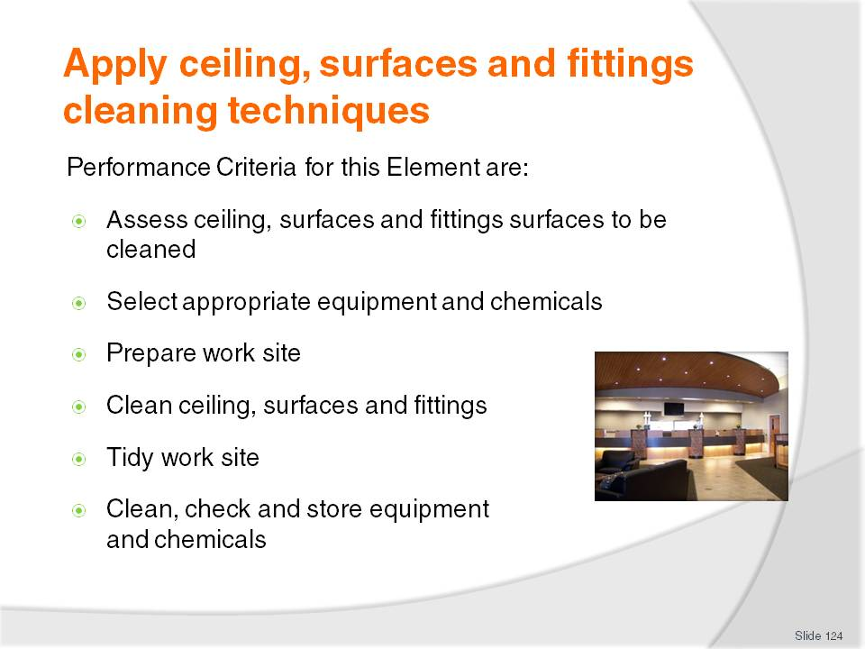
Slide No | Trainer Notes
 | Trainer identifies the Performance Criteria for this Element, as listed on the slide.

Slide
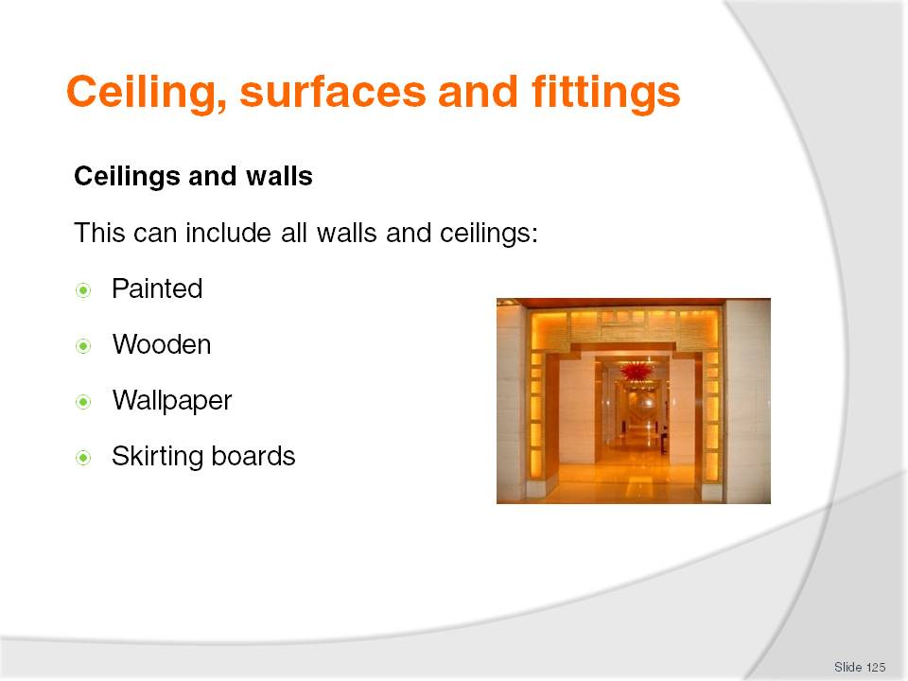
Slide No | Trainer Notes
Class Activity – Questions
How do you keep ceilings and walls clean?

Slide
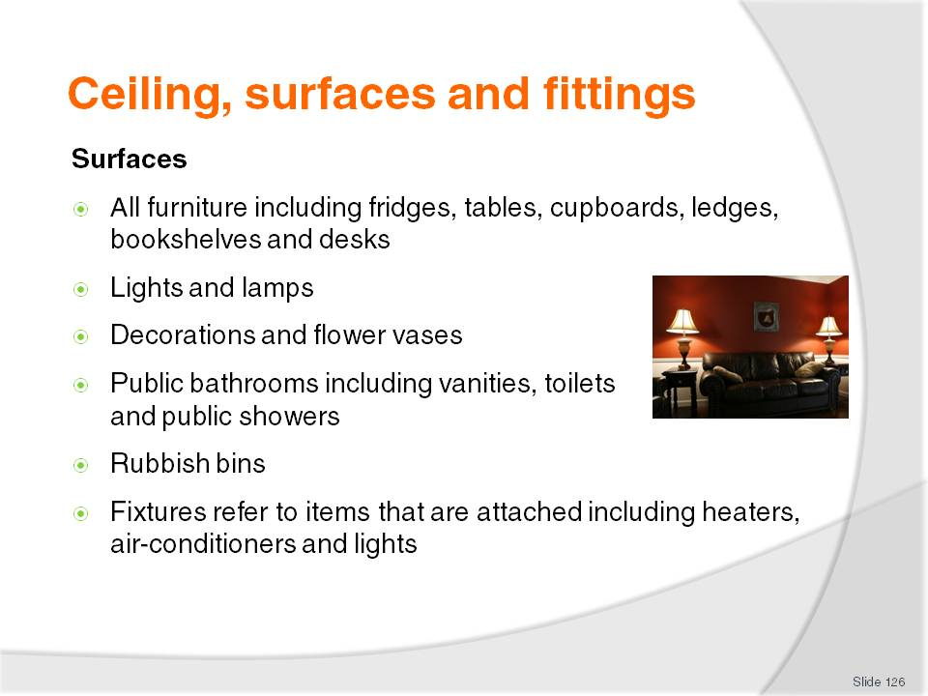
Slide No | Trainer Notes
Class Activity – Questions
How do you keep each of these surface types clean?

Slide
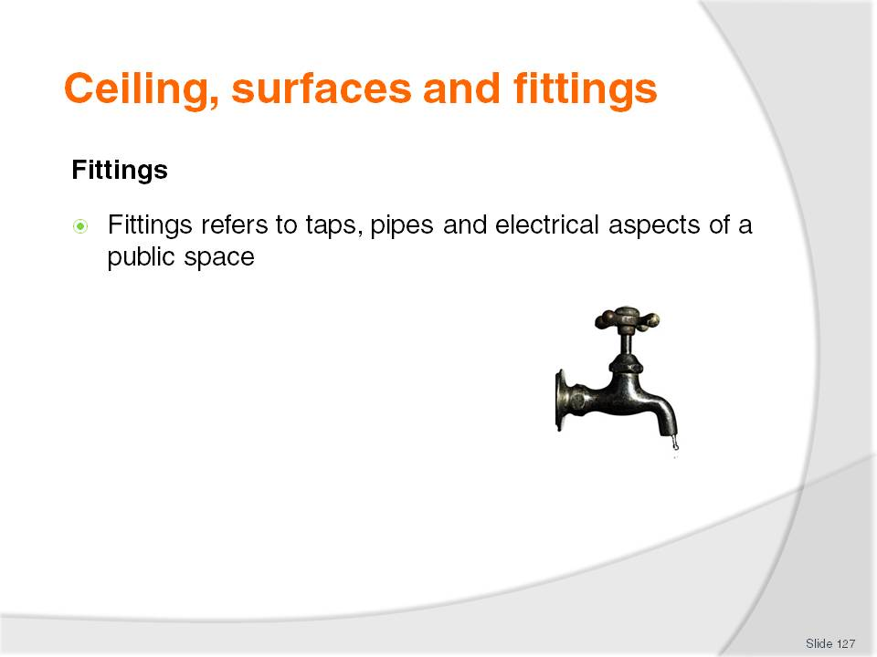
Slide No | Trainer Notes
Class Activity – Questions
How do you keep fittings clean?

Slide
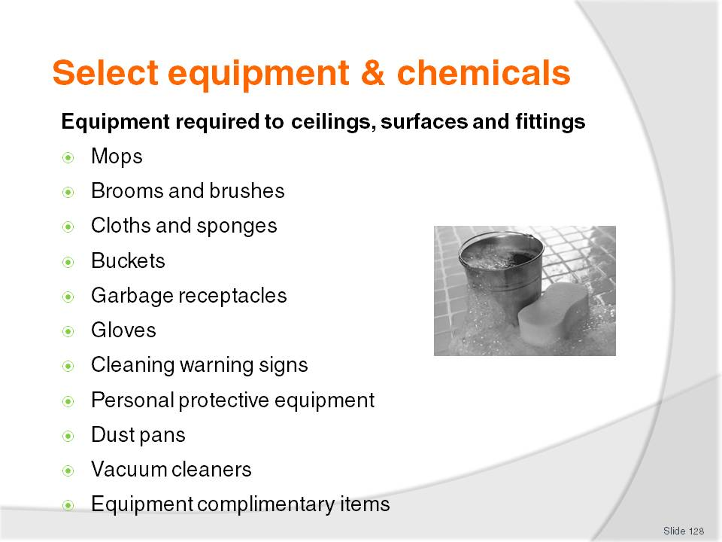
Slide No | Trainer Notes
Class Activity – Questions
What is each of the equipment items identified used for?
Please refer to the manual for detailed comment relating to each piece of equipment.

Slide
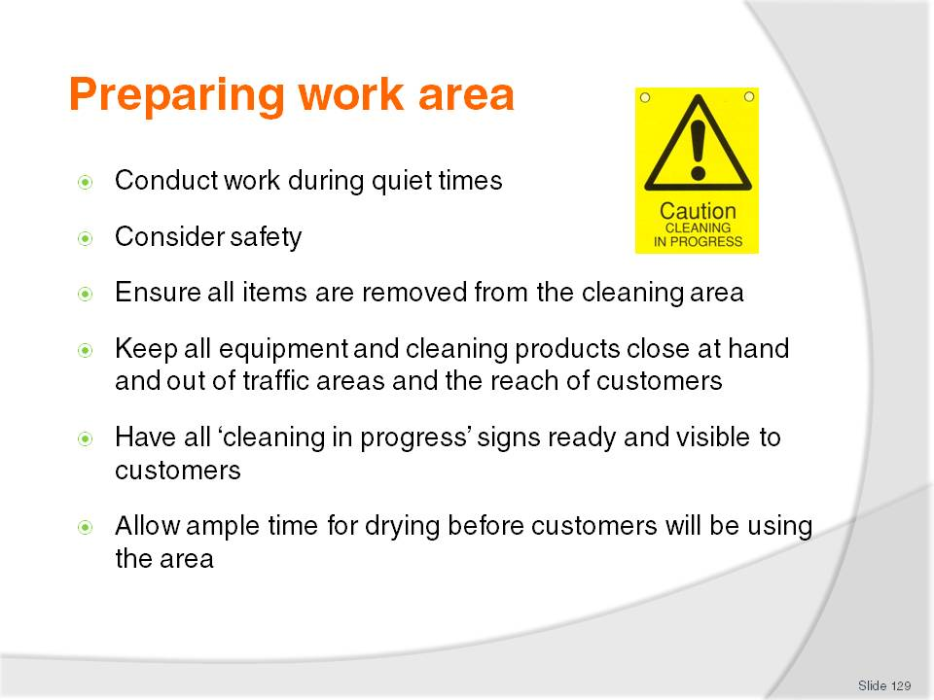
Slide No | Trainer Notes
Class Activity – Question
Why are these points important?

Slide
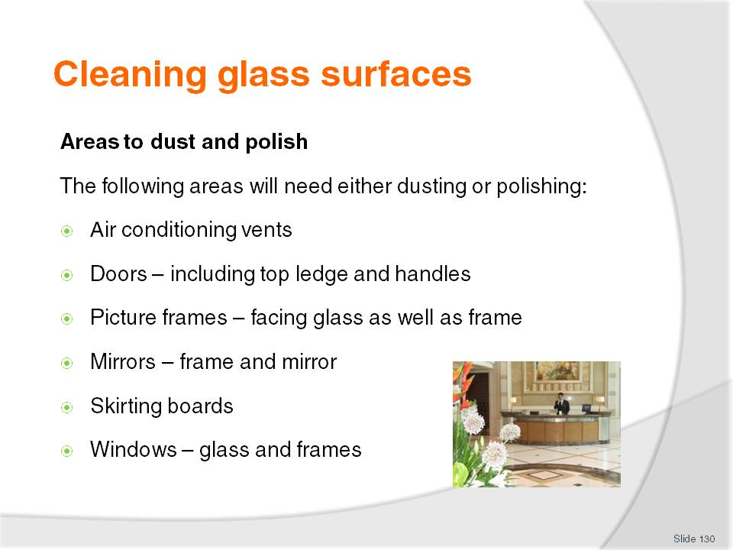
Slide No | Trainer Notes
Class Activity – Questions
Do you need to dust or polish each of these areas differently?
Is there any specific preparation you would need to do in relation to each of these items before they could be dusted or polished?

Slide
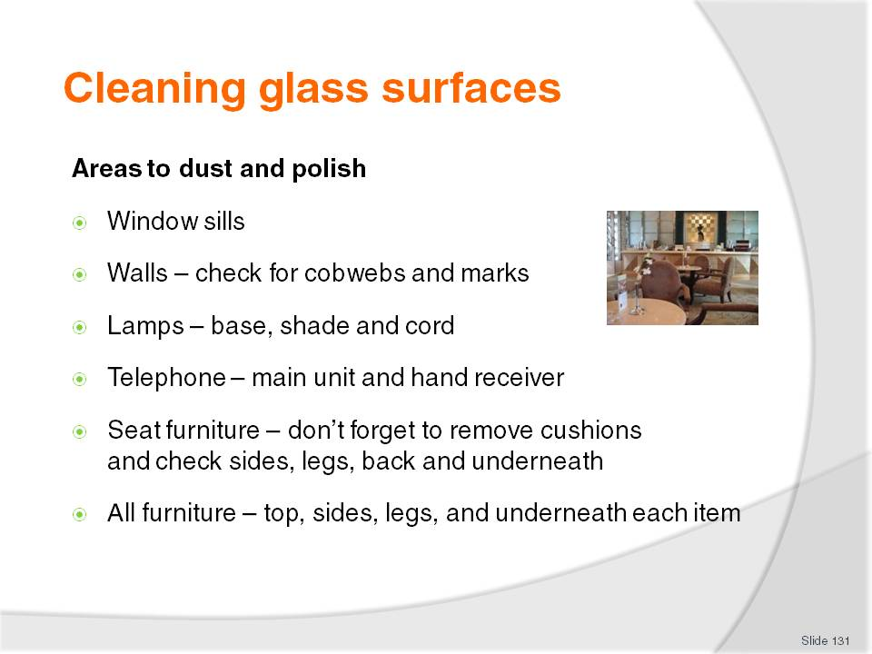
Slide No | Trainer Notes
Class Activity – Questions
Do you need to dust or polish each of these areas differently?
Is there any specific preparation you would need to do in relation to each of these items before they could be dusted or polished?

Slide
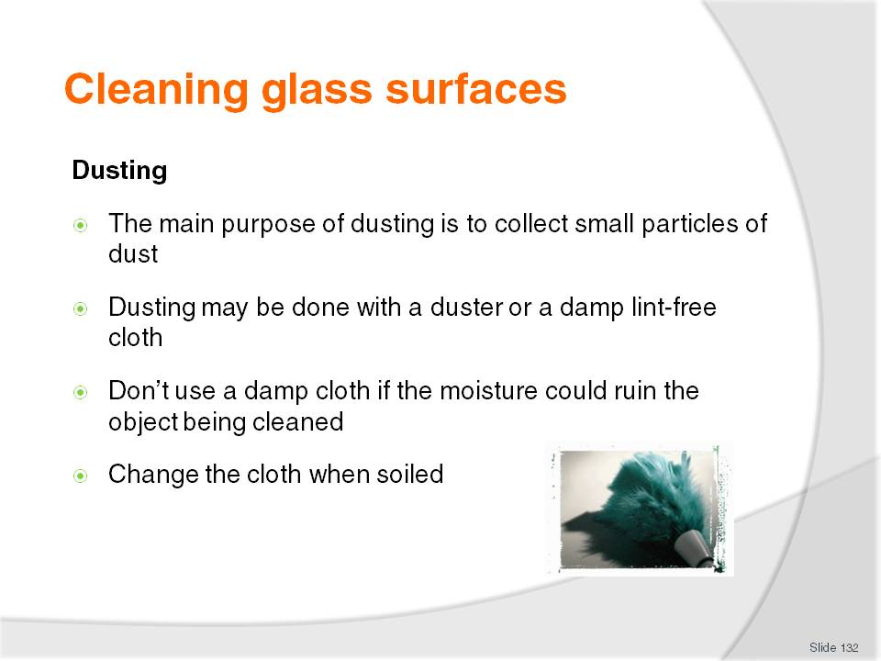
Slide No | Trainer Notes
Class Activity – Discuss steps and/or demonstration
Trainer to discuss steps and/or provide a demonstration.

Slide
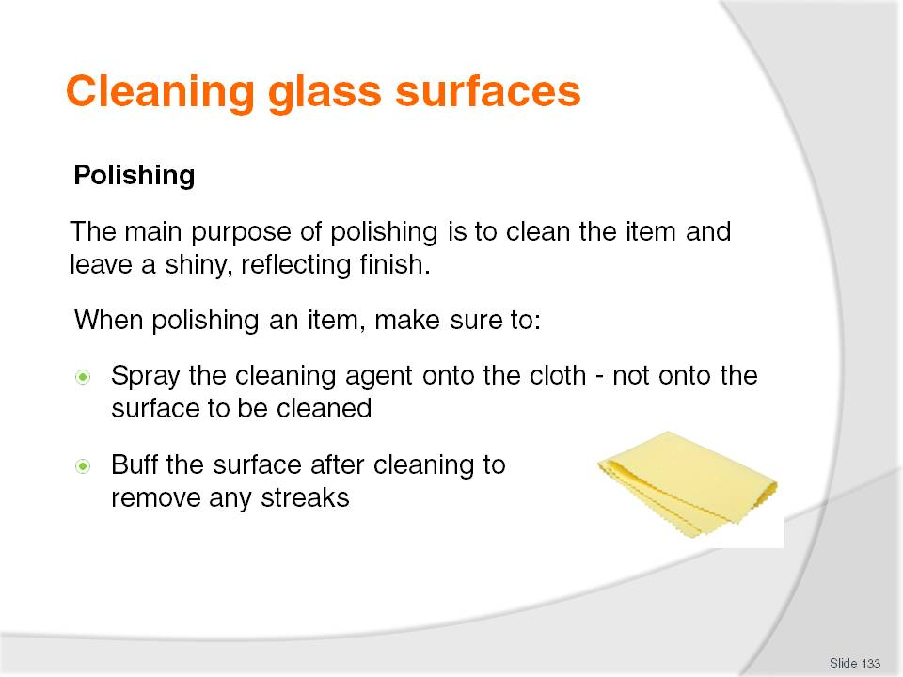
Slide No | Trainer Notes
Class Activity – Discuss steps and/or demonstration
Trainer to discuss steps and/or provide a demonstration.

Slide
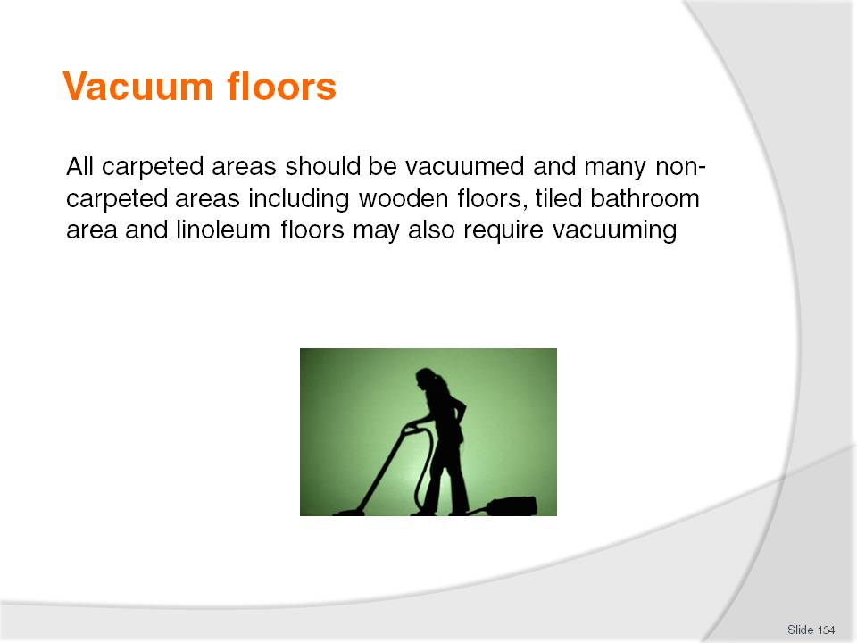
Slide No | Trainer Notes
Class Activity – General Discussion
What is the purpose of vacuuming?

Slide
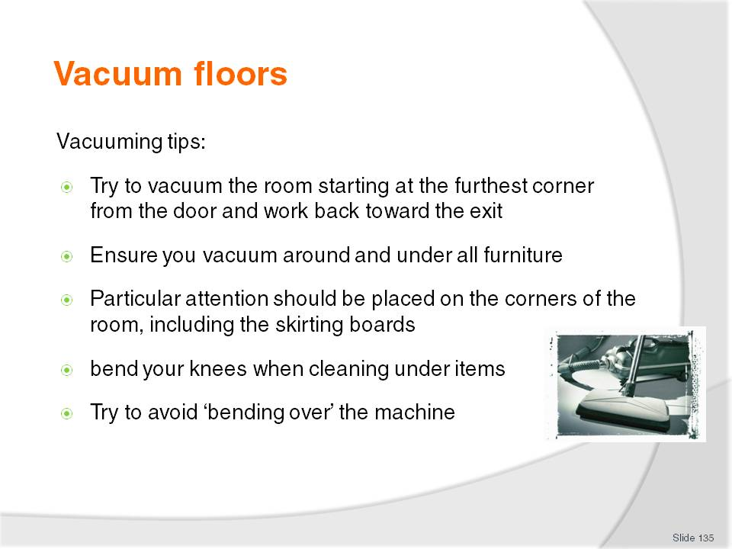
Slide No | Trainer Notes
Class Activity – General Discussion & Demonstration
Trainer to demonstrate and explain why steps are done as identified in the slide.
Audience members to practice vacuuming.

Slide
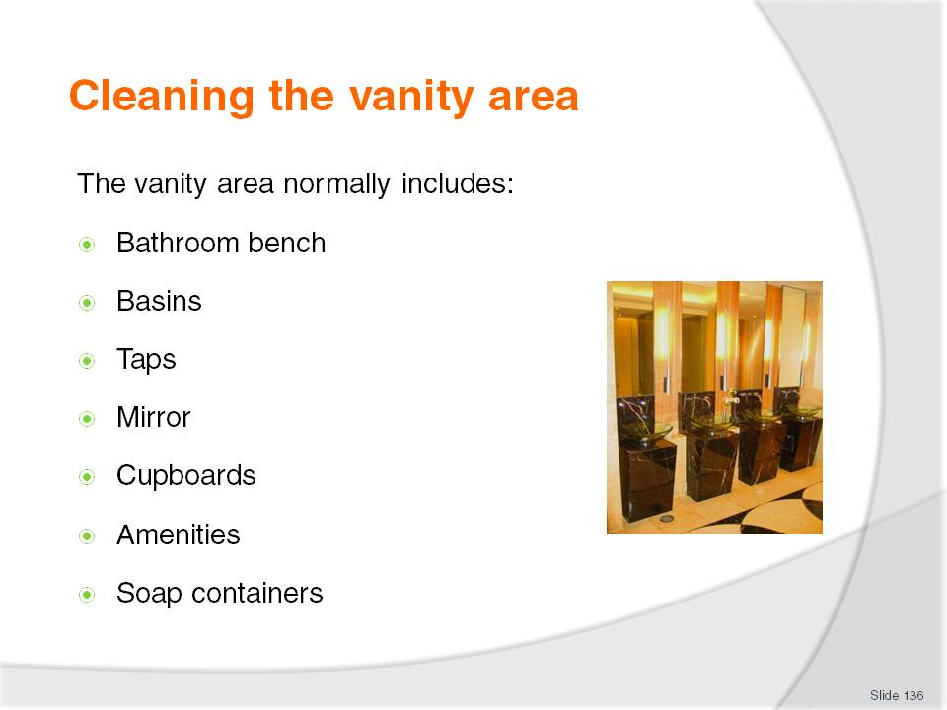
Slide No | Trainer Notes
Class Activity – General Discussion
What amenities are normally supplied in the vanity area?
What are appropriate amenities for men?
What are appropriate amenities for women?

Slide
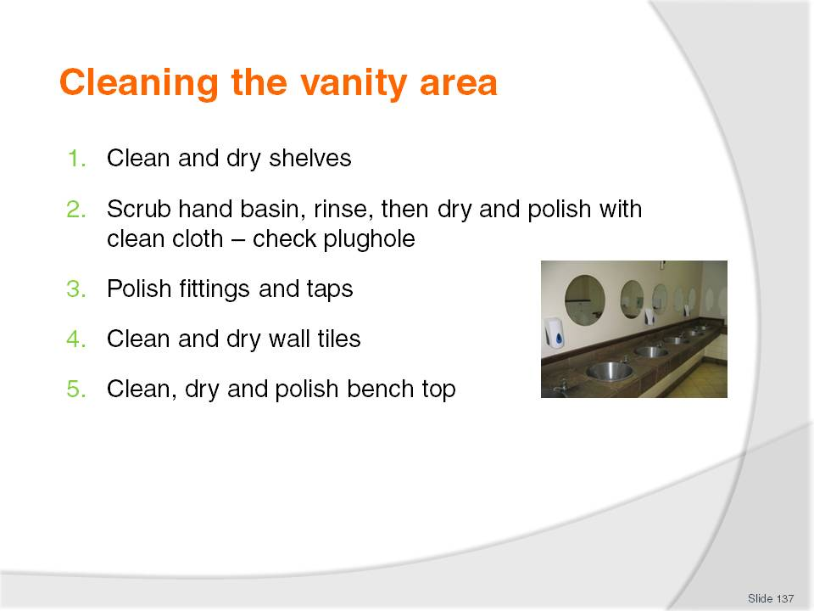
Slide No | Trainer Notes
Class Activity – General Discussion & Demonstration
Trainer to demonstrate and explain why steps are done as identified in the slide.
Members of audience to practice cleaning a vanity area.

Slide
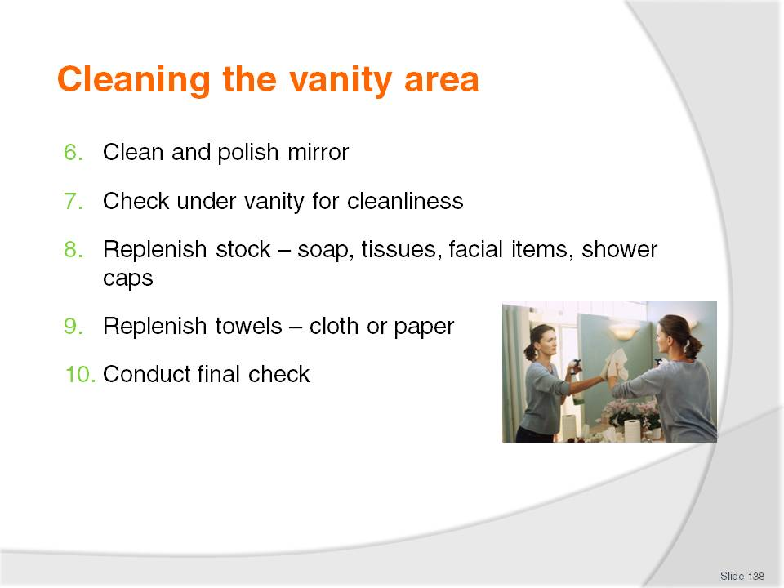
Slide No | Trainer Notes
Class Activity – General Discussion & Demonstration
Trainer to demonstrate and explain why steps are done as identified in the slide.
Members of audience to practice cleaning a vanity area.

Slide
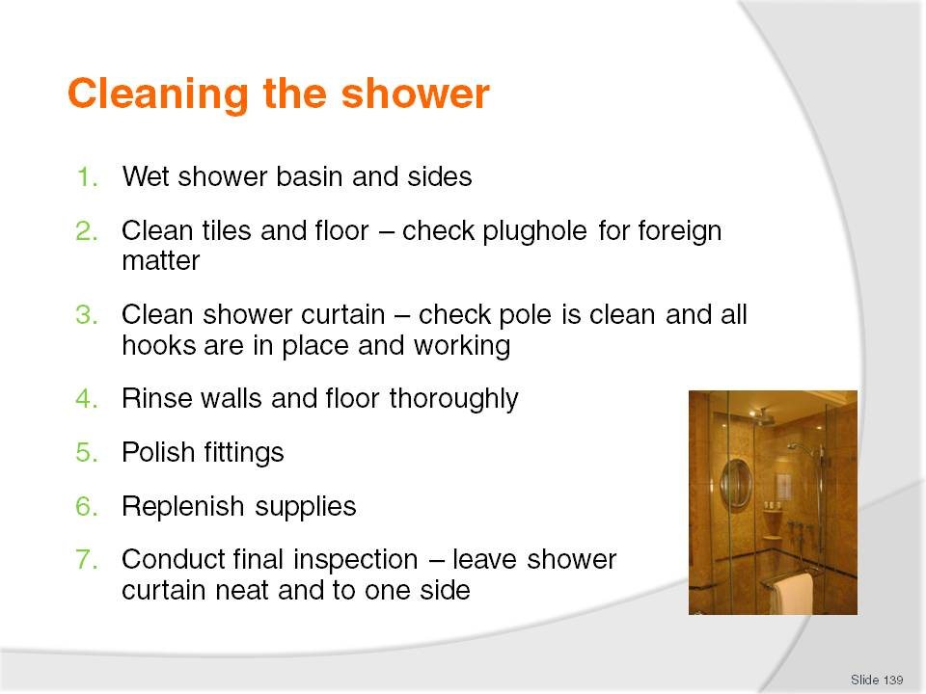
Slide No | Trainer Notes
Class Activity – General Discussion & Demonstration
Trainer to demonstrate and explain why steps are done as identified in the slide.
Audience members to practice cleaning a shower.

Slide
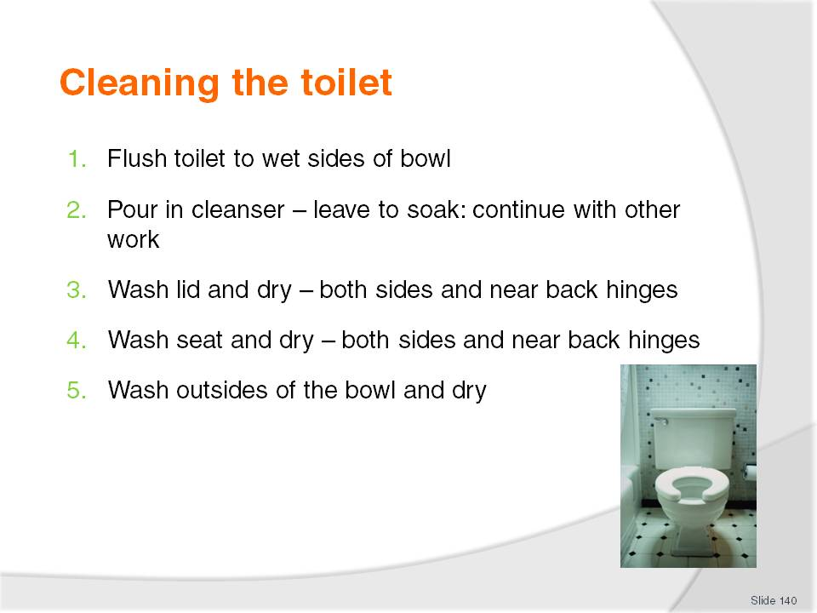
Slide No | Trainer Notes
Class Activity – General Discussion & Demonstration
Trainer to demonstrate and explain why steps are done as identified in the slide.
Audience members to practice cleaning a toilet.

Slide
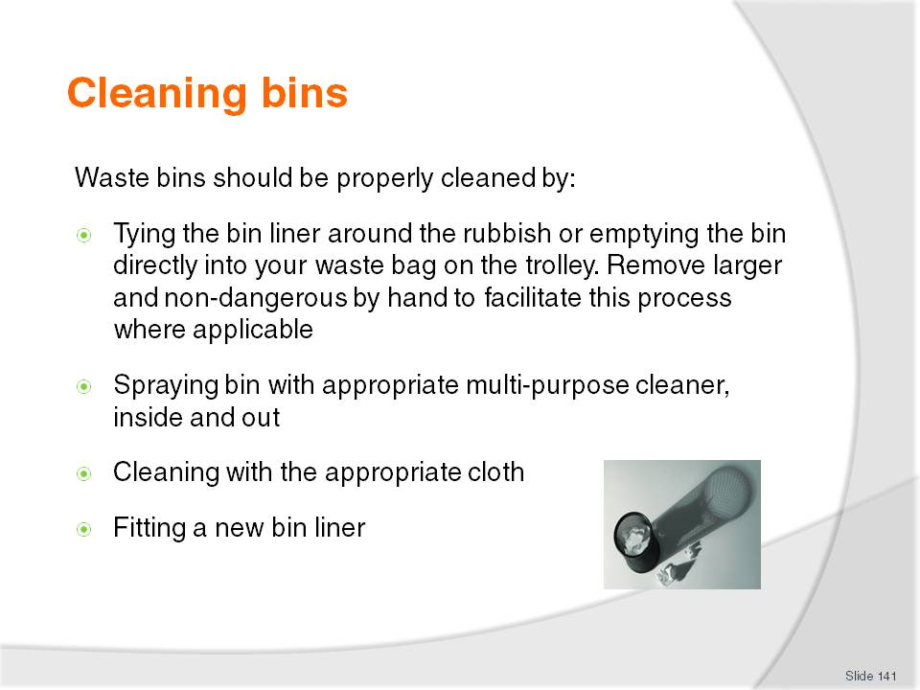
Slide No | Trainer Notes
Class Activity – General Discussion & Demonstration
Trainer to demonstrate and explain why steps are done as identified in the slide.
Audience members to practice cleaning a bin.

Slide
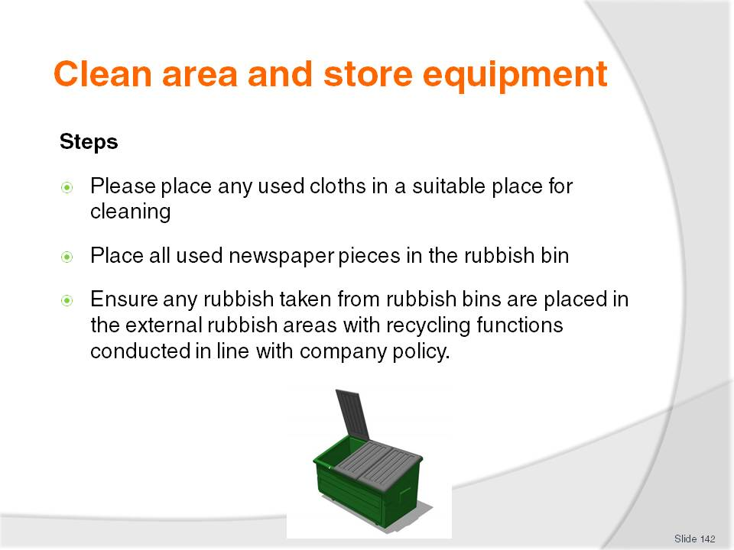
Slide No | Trainer Notes
Class Activity – Discuss steps
Why is each of the steps mentioned important?

Slide
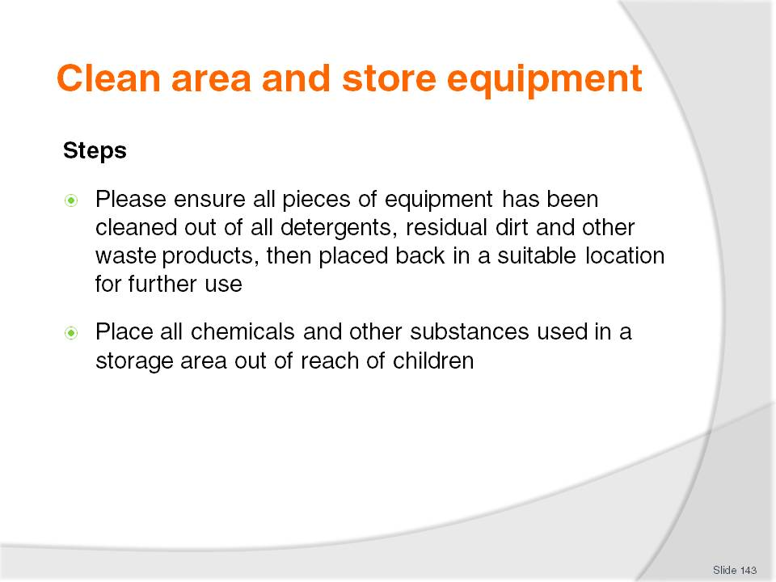
Slide No | Trainer Notes
Class Activity – Discuss steps
Why is each of the steps mentioned important?

Slide
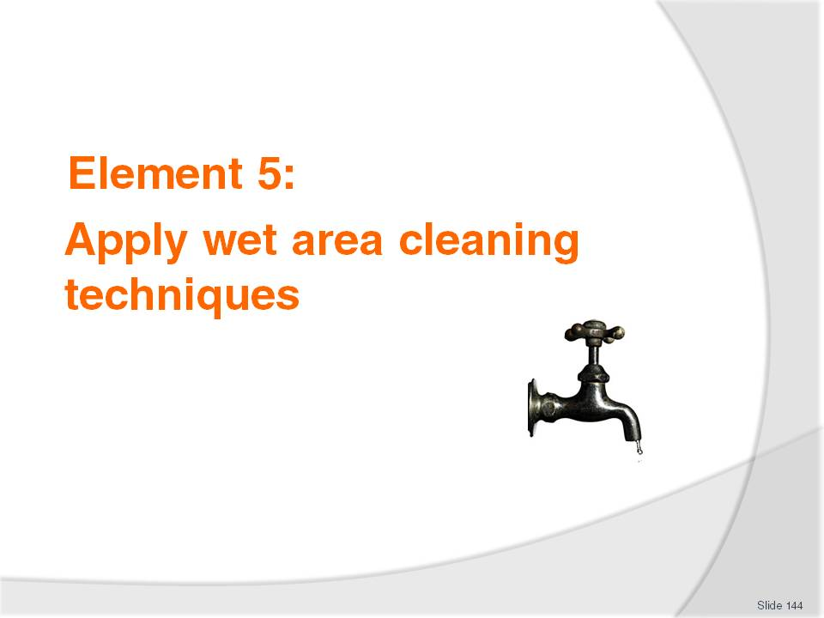
Slide No | Trainer Notes
Introduce topic.
Class Activity – General Discussion
Ask general questions:
What is wet cleaning?
What does it involve?

Slide
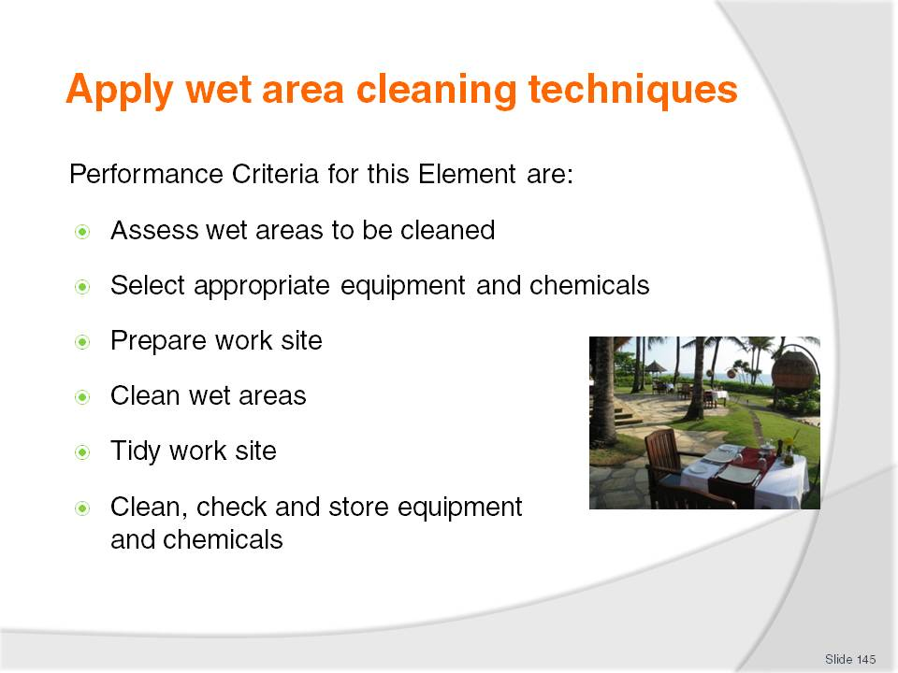
Slide No | Trainer Notes
 | Trainer identifies the Performance Criteria for this Element, as listed on the slide.

Slide
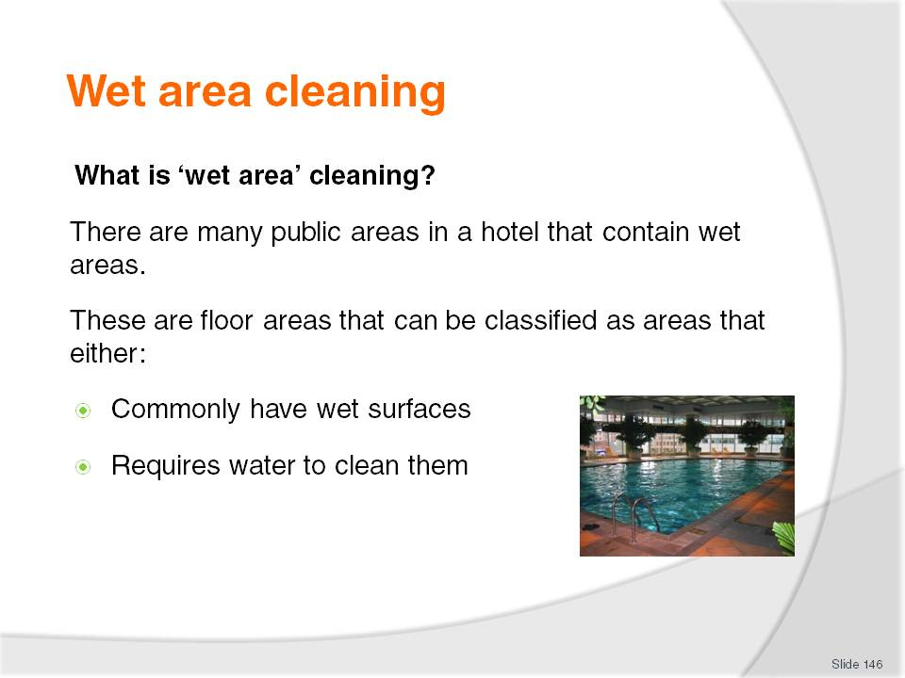
Slide No | Trainer Notes
Class Activity – Questions
How areas have wet surfaces and how do you clean them?
What areas require water to clean them?

Slide
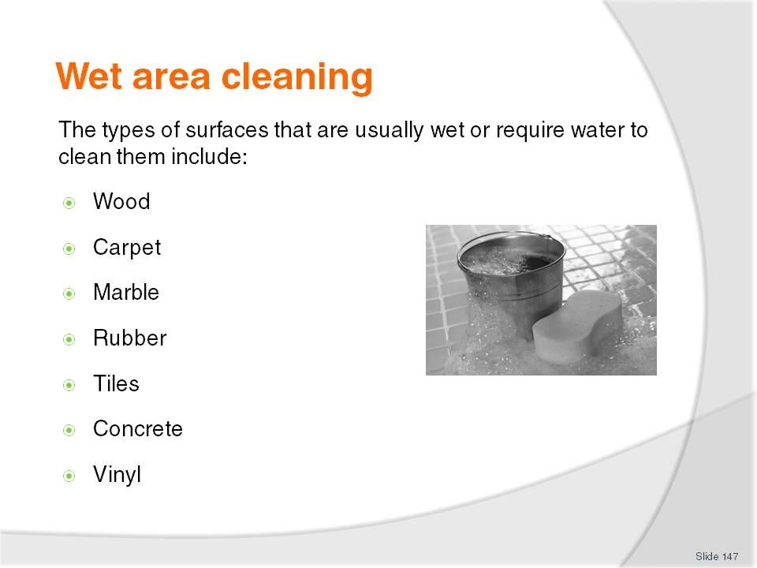
Slide No | Trainer Notes
Class Activity – Questions
What is the best way to clean these types of surfaces?

Slide
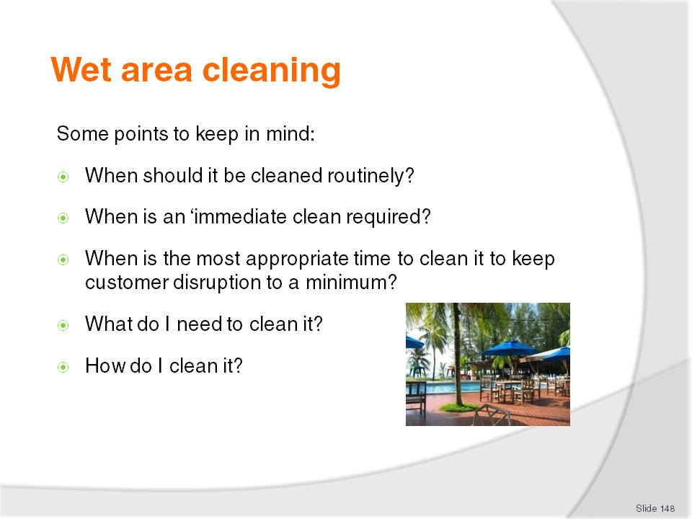
Slide No | Trainer Notes
Class Activity – Questions
Discuss the questions in the slide.

Slide
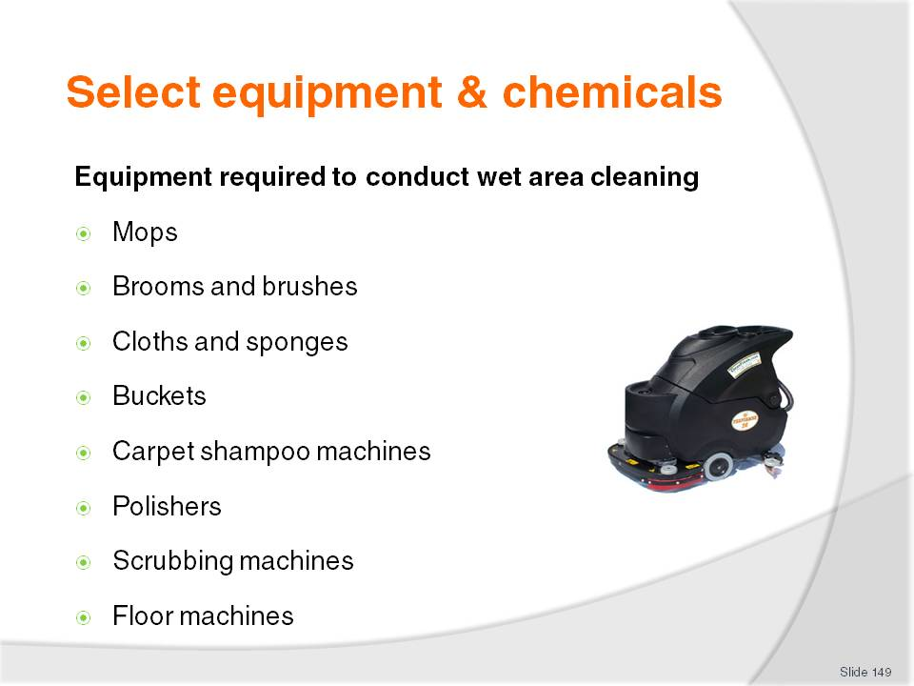
Slide No | Trainer Notes
Class Activity – Questions
What is each of the equipment items identified used for?
Please refer to the manual for detailed comment relating to each piece of equipment.

Slide
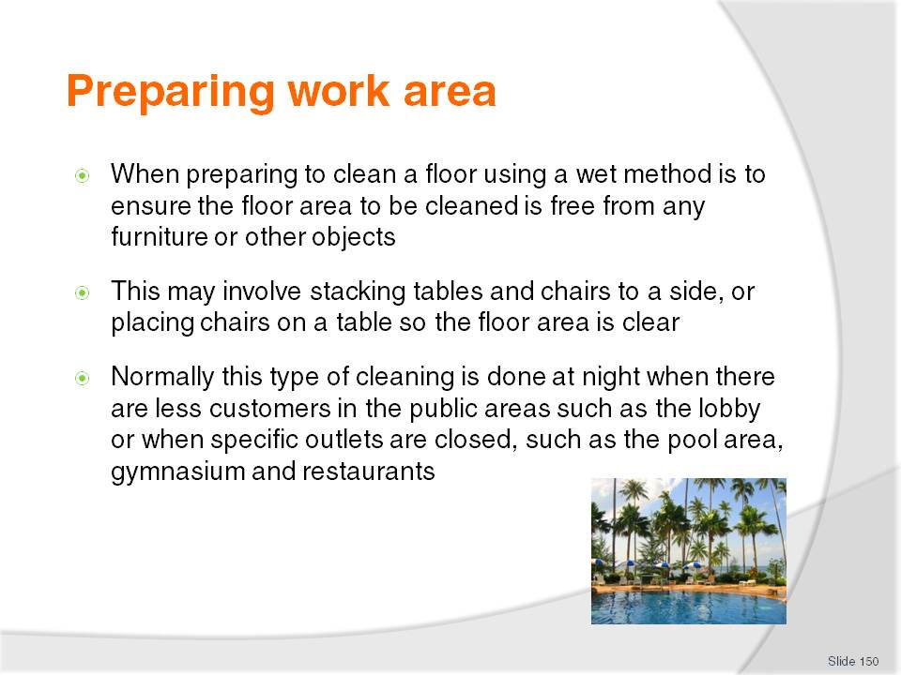
Slide No | Trainer Notes
Class Activity – Question
Why are these points important?

Slide
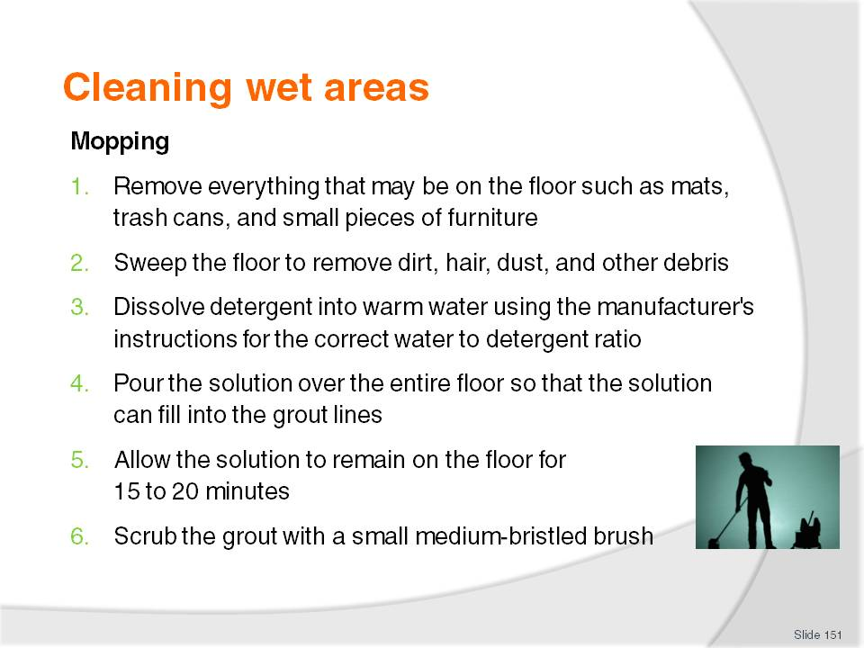
Slide No | Trainer Notes
Class Activity – General Discussion & Demonstration
Trainer to demonstrate and explain why steps are done as identified in the slide.
Audience members to practice mopping.

Slide
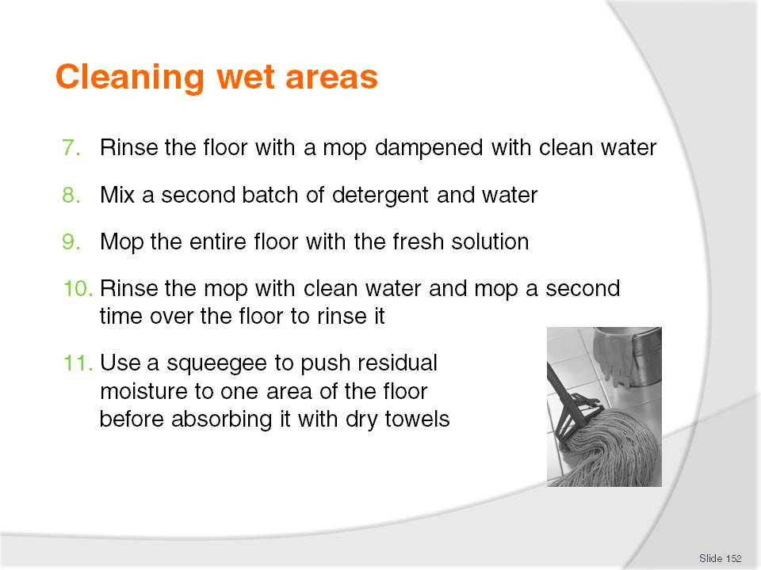
Slide No | Trainer Notes
Class Activity – General Discussion & Demonstration
Trainer to demonstrate and explain why steps are done as identified in the slide.
Audience members to practice mopping.

Slide
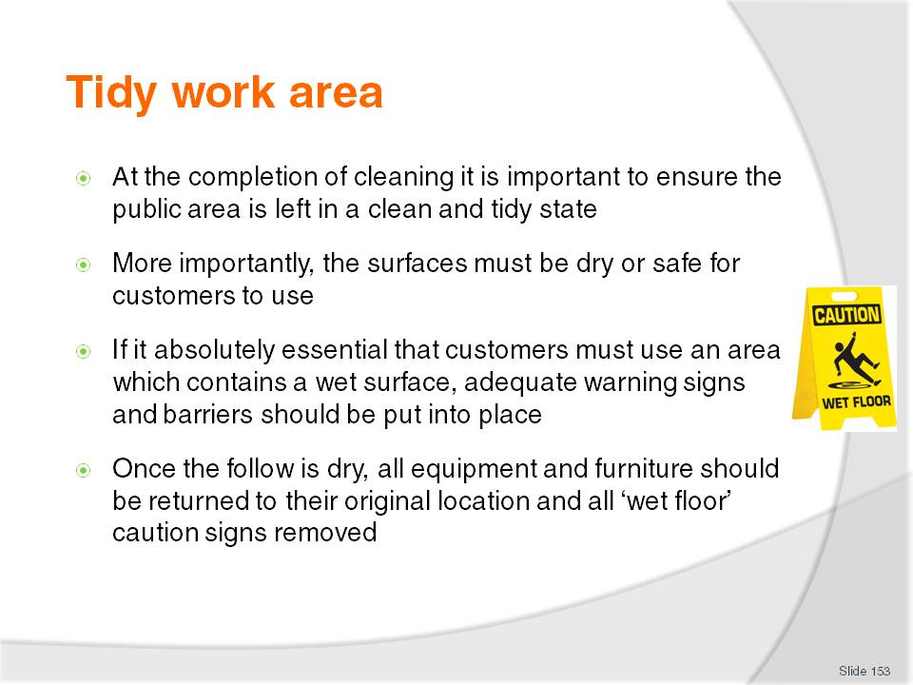
Slide No | Trainer Notes
Class Activity – Discuss steps
Why is each of the steps mentioned important?

Slide
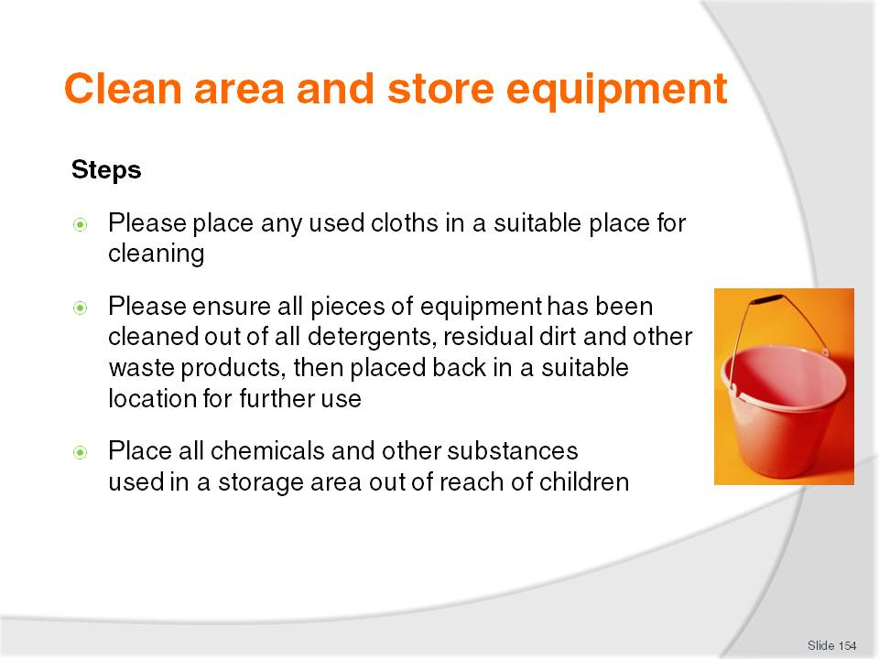
Slide No | Trainer Notes
Class Activity – Discuss steps
Why is each of the steps mentioned important?

Slide
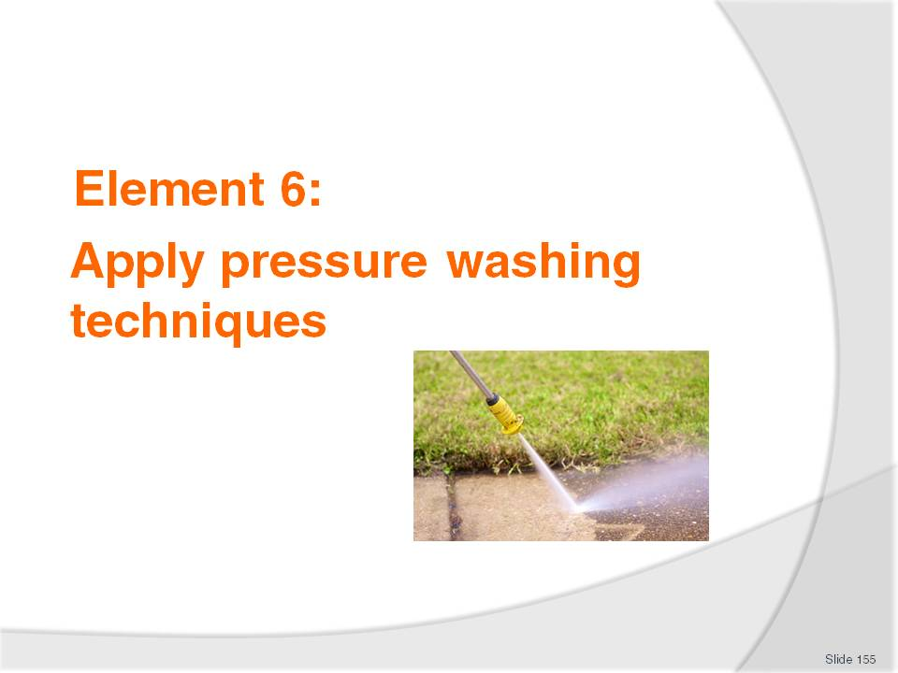
Slide No | Trainer Notes
Introduce topic.
Class Activity – General Discussion
Ask general questions:
What is pressure washing?
What does it involve?

Slide
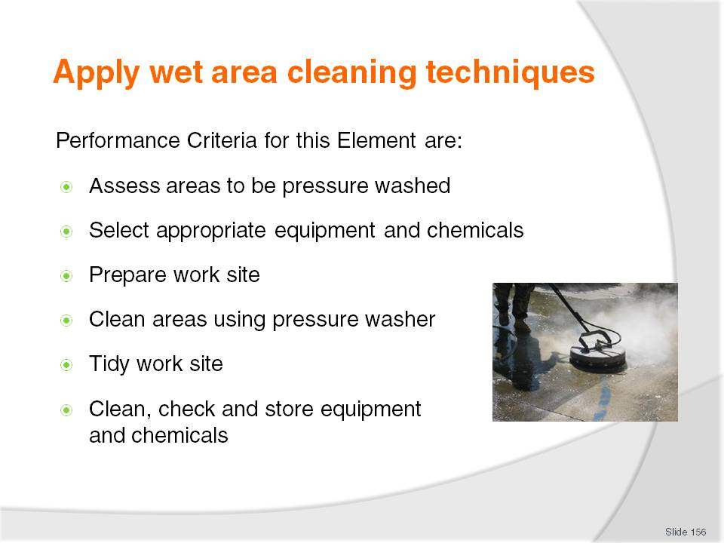
Slide No | Trainer Notes
 | Trainer identifies the Performance Criteria for this Element, as listed on the slide.

Slide
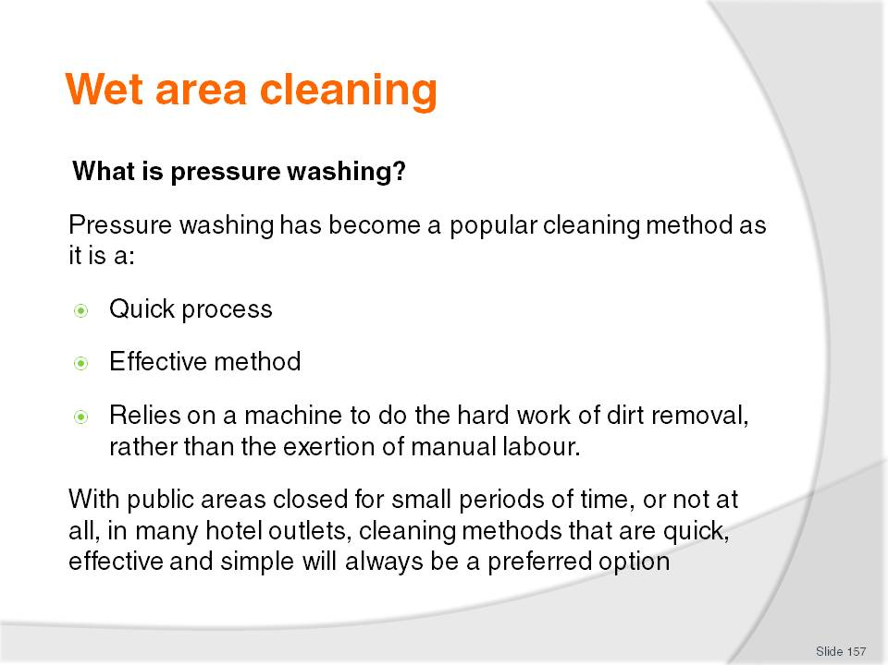
Slide No | Trainer Notes
Class Activity – Questions
What types of equipment can you use to pressure wash?

Slide
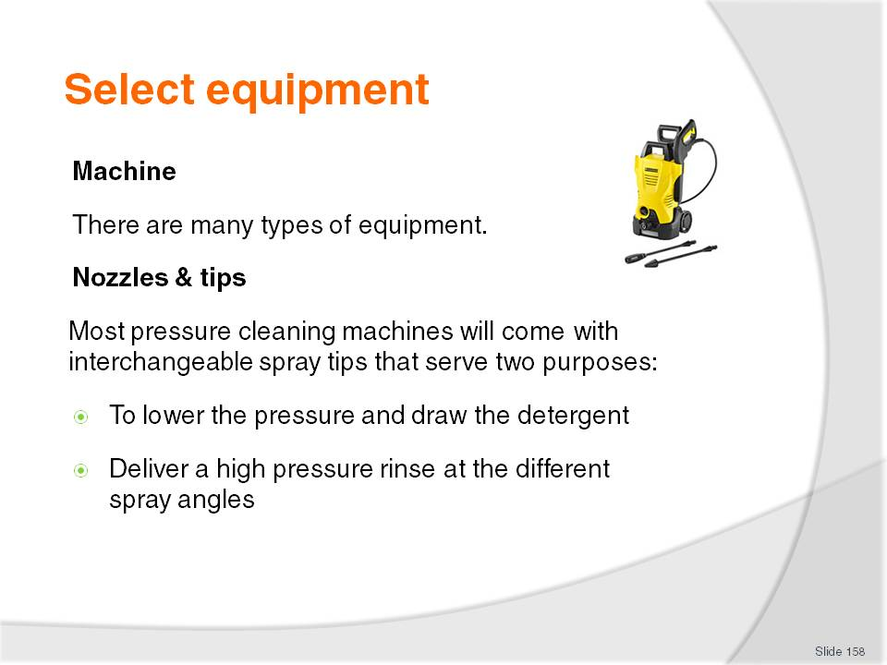
Slide No | Trainer Notes
Class Activity – Research activity
Trainer to get the audience to conduct research into:
Different types of machines used to pressure wash
Costs
Benefits and purpose.

Slide
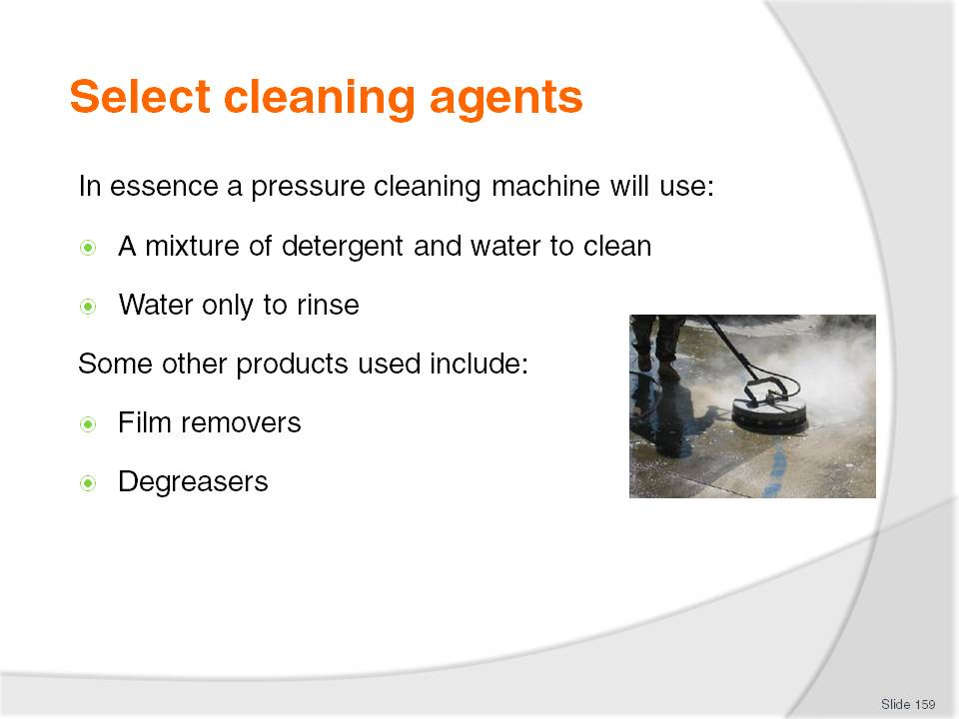
Slide No | Trainer Notes
Film removers – used for removing layers of dirt and grime using a light pressure clean. This includes the cleaning of cars, paths, roads (main driveway) and outdoor areas
Degreasers - used for removing heavy greaser and industrial cleaning.

Slide
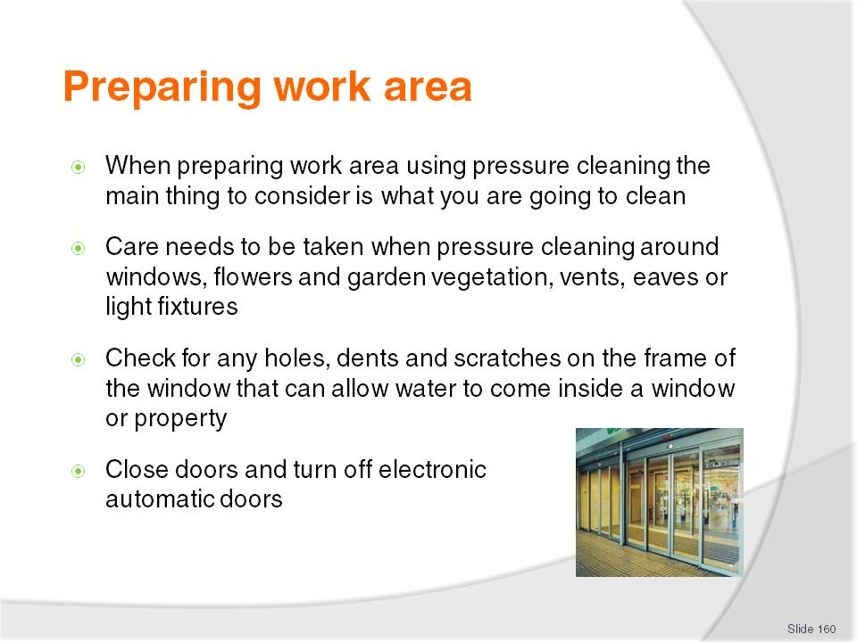
Slide No | Trainer Notes
Class Activity – Question
Why are these points important?

Slide
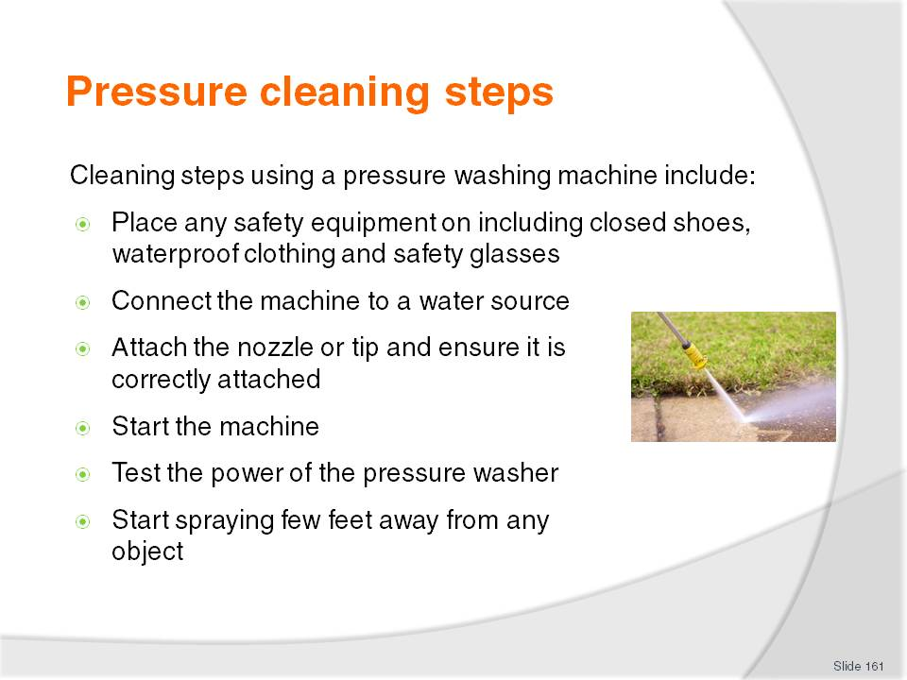
Slide No | Trainer Notes
Class Activity – General Discussion & Demonstration
Trainer to demonstrate and explain why steps are done as identified in the slide.
Audience members to practice pressure cleaning.

Slide
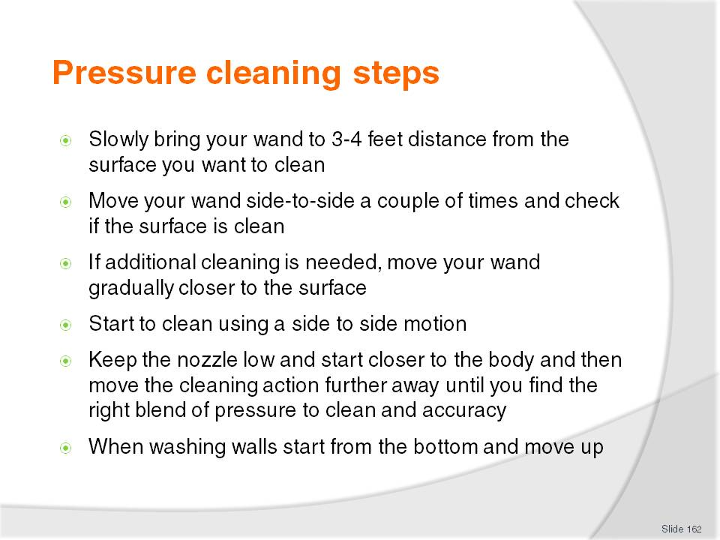
Slide No | Trainer Notes
Class Activity – General Discussion & Demonstration
Trainer to demonstrate and explain why steps are done as identified in the slide.
Audience members to practice pressure cleaning.

Slide
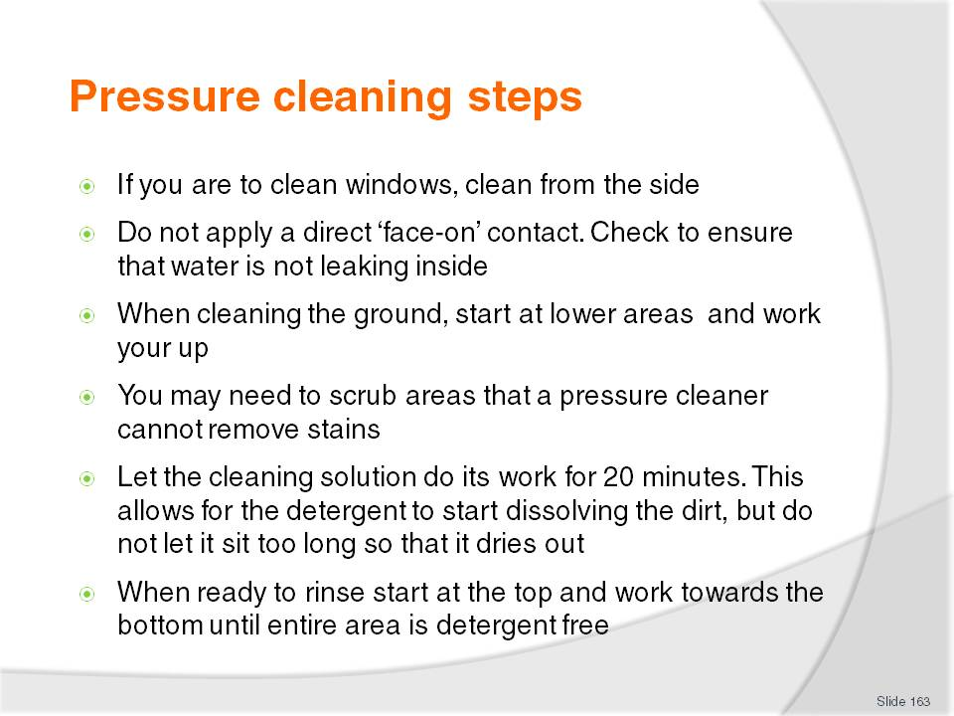
Slide No | Trainer Notes
Class Activity – General Discussion & Demonstration
Trainer to demonstrate and explain why steps are done as identified in the slide.
Audience members to practice pressure cleaning.

Slide
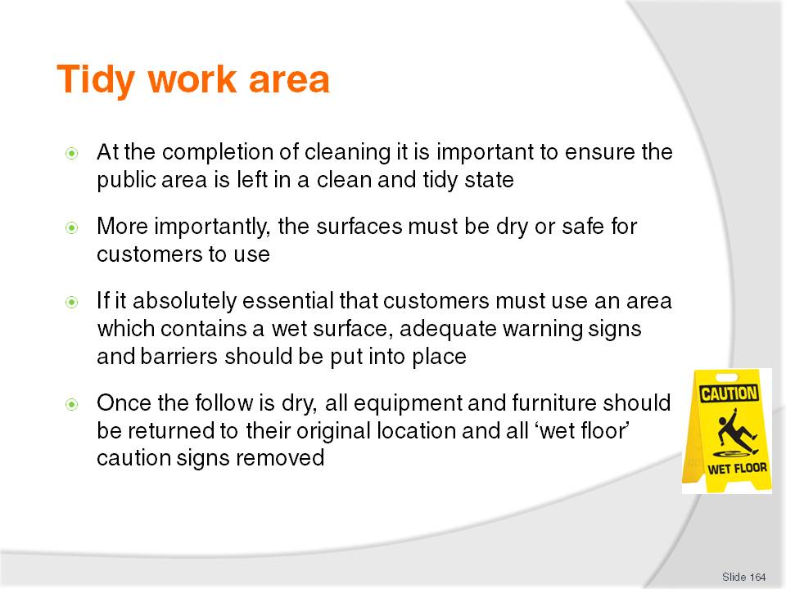
Slide No | Trainer Notes
Class Activity – Discuss steps
Why is each of the steps mentioned important?

Slide
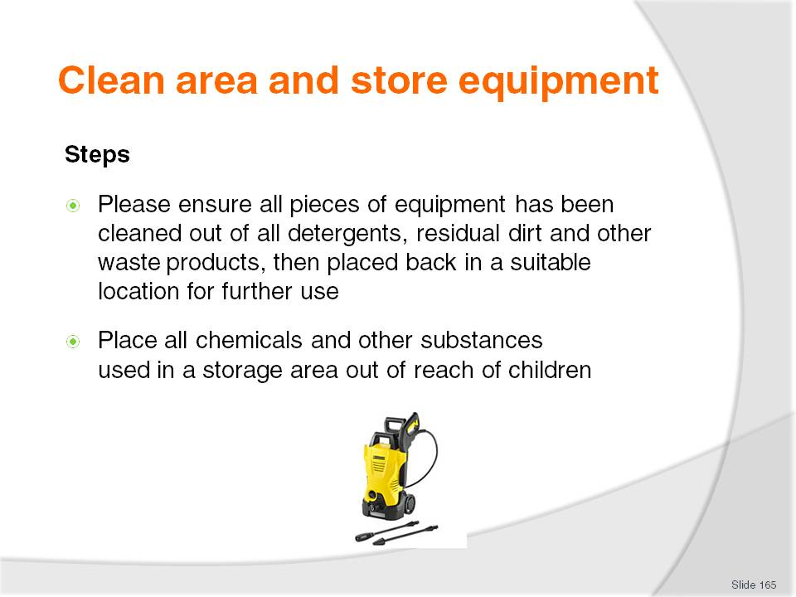
Slide No | Trainer Notes
Class Activity – Discuss steps
Why is each of the steps mentioned important?

Slide

Slide No | Trainer Notes
Introduce topic.
Class Activity – General Discussion
Ask general questions:
What is high level cleaning?
What does it involve?

Slide
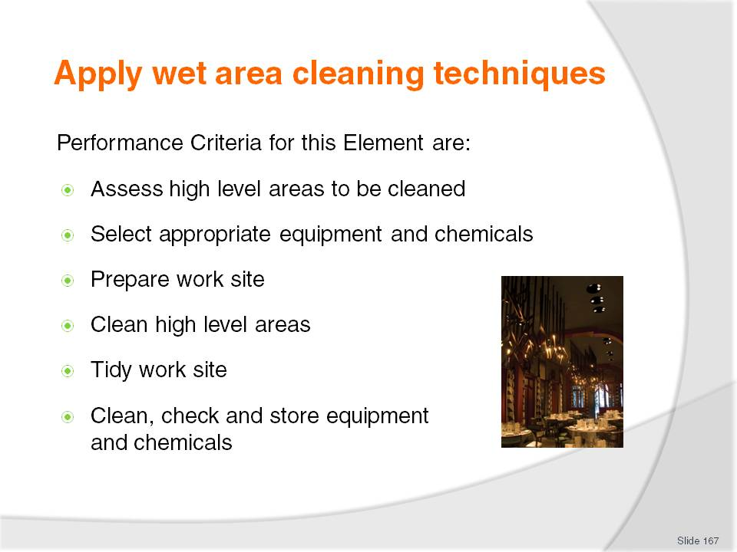
Slide No | Trainer Notes
 | Trainer identifies the Performance Criteria for this Element, as listed on the slide.

Slide
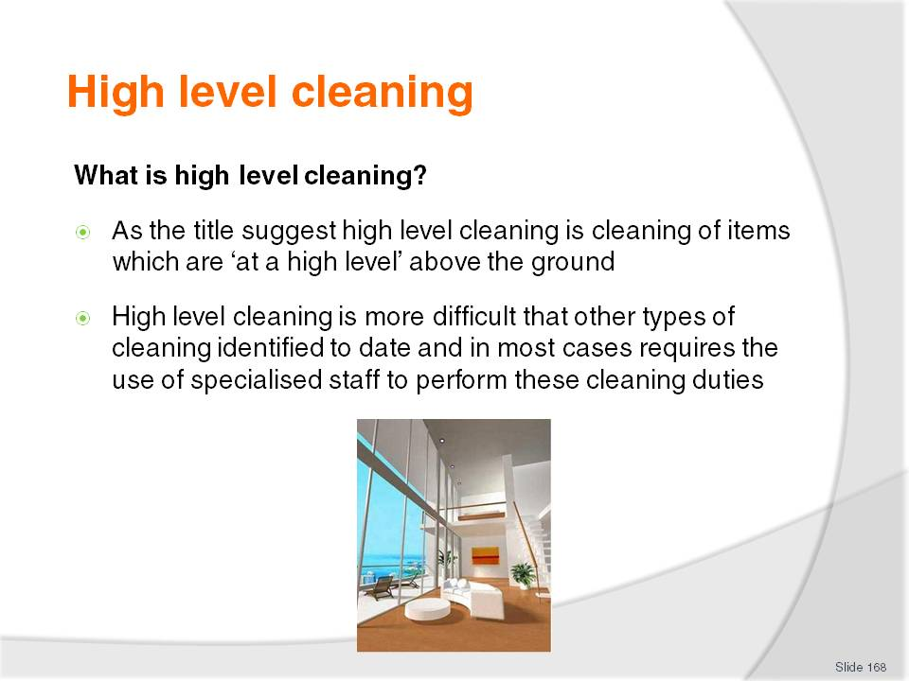
Slide No | Trainer Notes
Class Activity – Questions
What types of equipment can you use to undertake high level cleaning?

Slide
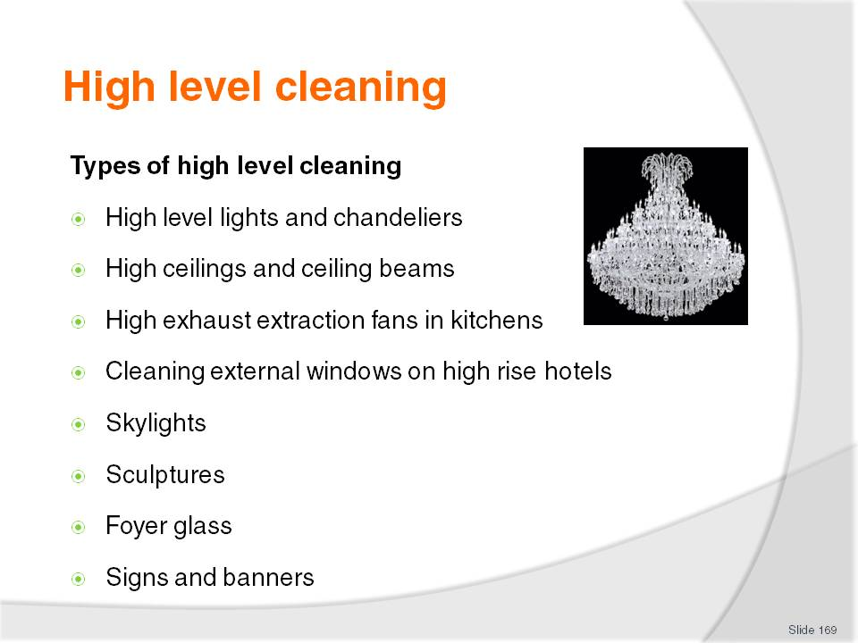
Slide No | Trainer Notes
Class Activity – Questions
How would you clean each of these items?

Slide
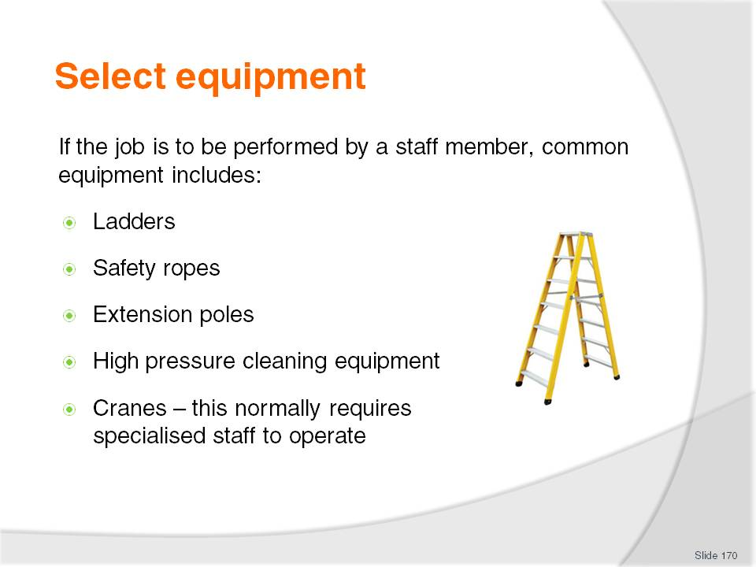
Slide No | Trainer Notes
Class Activity – Research activity
What is each type of equipment used for?
What other equipment could you use to perform high level cleaning?

Slide
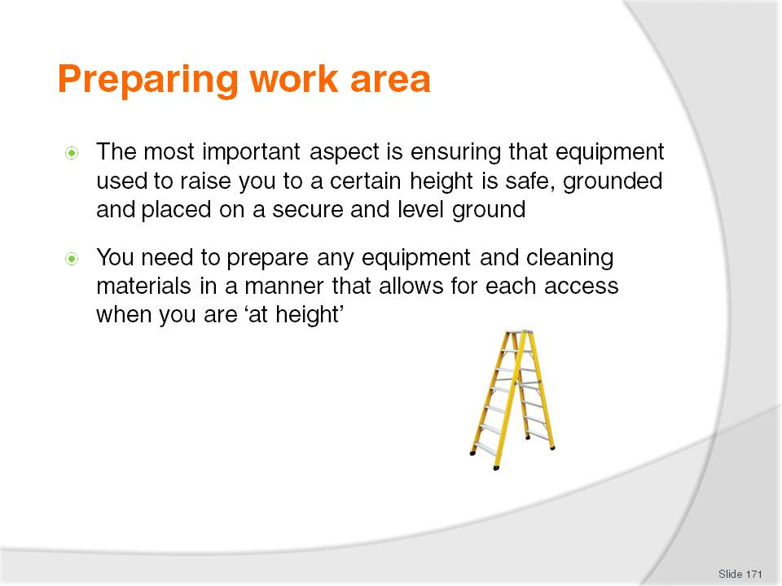
Slide No | Trainer Notes
Class Activity – Question
Why are these points important?

Slide
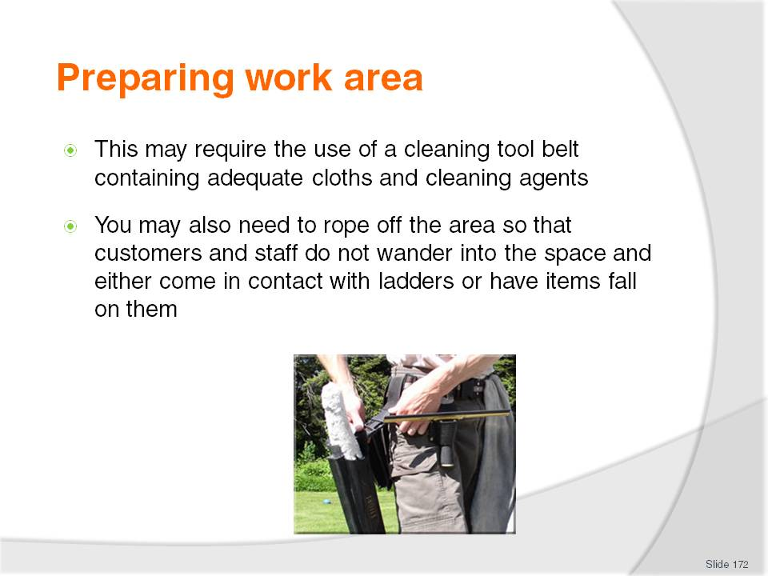
Slide No | Trainer Notes
Class Activity – Question
Why are these points important?

Slide
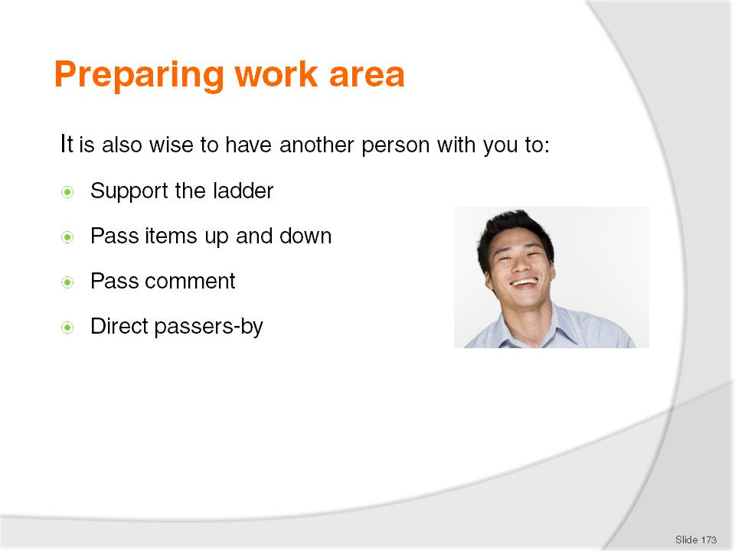
Slide No | Trainer Notes
Class Activity – Question
Why are these points important?

Slide
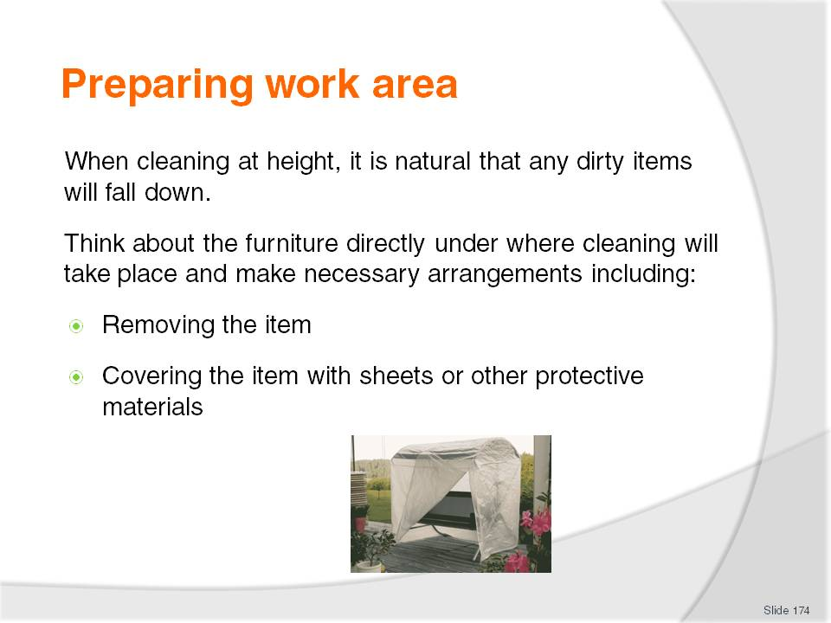
Slide No | Trainer Notes
Class Activity – Question
Why are these points important?
What can you cover items with?

Slide
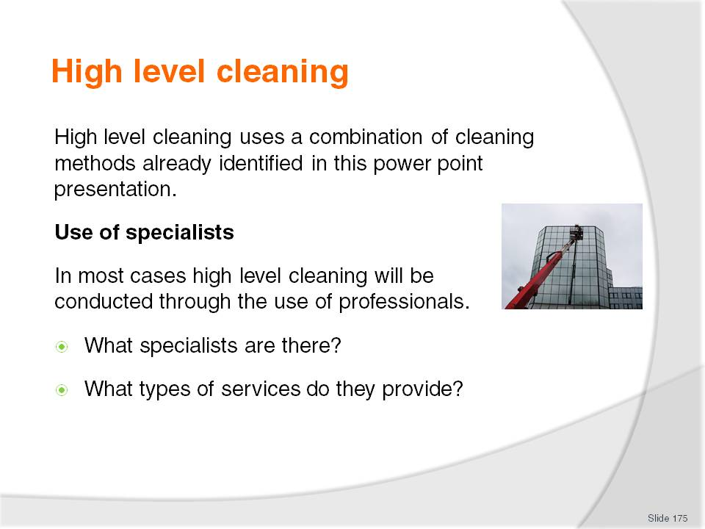
Slide No | Trainer Notes
Class Activity – Research activity
Trainer to get audience to conduct research activity to answer the questions in the slide.

Slide
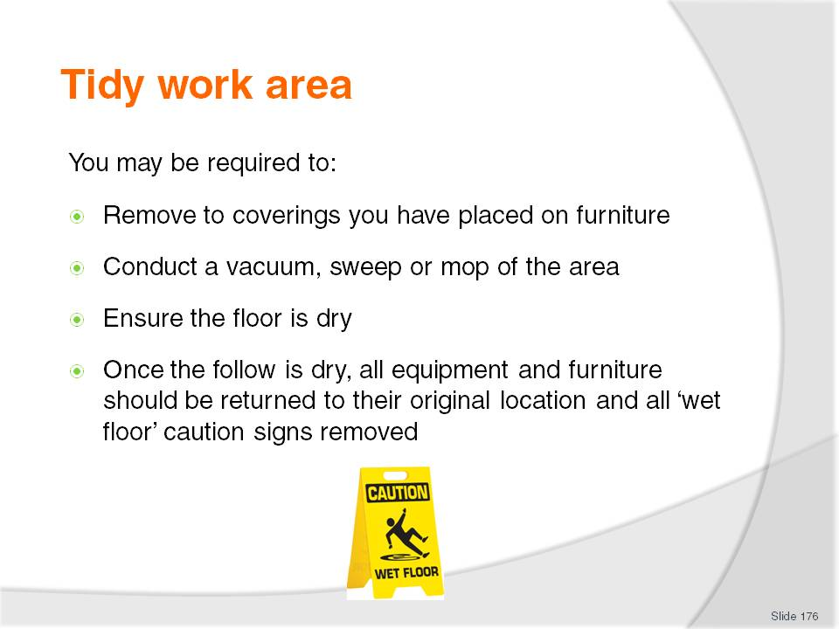
Slide No | Trainer Notes
Class Activity – Discuss steps
Why is each of the steps mentioned important?

Slide
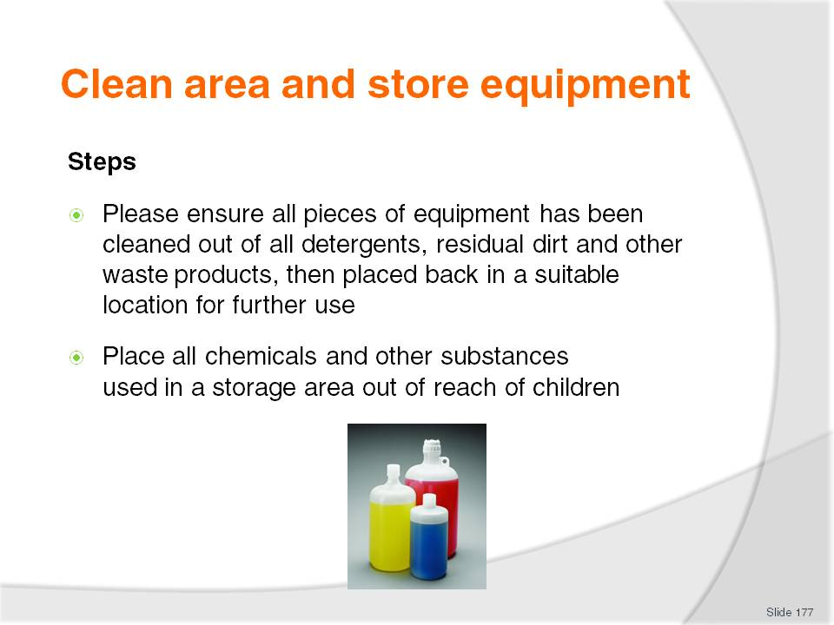
Slide No | Trainer Notes
Class Activity – Discuss steps
Why is each of the steps mentioned important?

Slide
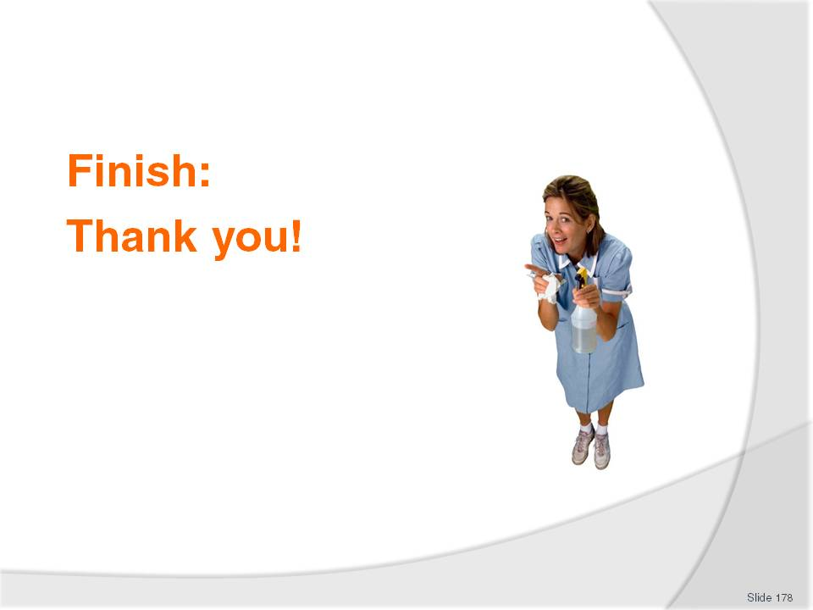
Slide No | Trainer Notes
This is the conclusion of the subject.
Trainer thanks the class and delivers assessments as required.

Recommended training equipment
Chemicals – various for cleaning
Communication documents used in workplace
Computer with internet and email access
Emergency procedures
Equipment – various including vacuum cleaner, brooms, mops, brushes, sponges
Equipment manuals and manufacturer’s instructions for cleaning
Examples of leather and fabric furniture coverings
Housekeeping trolley
Job descriptions
Manual handling techniques
Note pads and pens
Organisational Chart
Personal Protection Equipment
Policies and procedures for organisation, housekeeping and public area position
Posters
Rubbish removal procedures
Safety Signs
Standard Operating Procedures (SOP’s)
Schedules of cleaning activities
Telephone system.

Instructions for Trainers for using
PowerPoint – Presenter View
Connect your laptop or computer to your projector equipment as per manufacturers’ instructions.
In PowerPoint, on the Slide Show menu, click Set up Show.
Under Multiple monitors, select the Show Presenter View check box.
In the Display slide show on list, click the monitor you want the slide show presentation to appear on.
Source: http://office.microsoft.com
Note:
In Presenter View:
You see your notes and have full control of the presentation
Your trainees only see the slide projected on to the screen
More Information
You can obtain more information on how to use PowerPoint from the Microsoft Online Help Centre, available at: http://office.microsoft.com/training/training.aspx?AssetID=RC011298761033
Note Regarding Currency of URLs
Please note that where references have been made to URLs in these training resources trainers will need to verify that the resource or document referred to is still current on the internet. Trainers should endeavour, where possible, to source similar alternative examples of material where it is found that either the website or the document in question is no longer available online.

Appendix – ASEAN acronyms
AADCP | ASEAN – Australia Development Cooperation Program.
ACCSTP | ASEAN Common Competency Standards for Tourism Professionals.
AEC | ASEAN Economic Community.
AMS | ASEAN Member States.
ASEAN | Association of Southeast Asian Nations.
ASEC | ASEAN Secretariat.
ATM | ASEAN Tourism Ministers.
ATPMC | ASEAN Tourism Professionals Monitoring Committee.
ATPRS | ASEAN Tourism Professional Registration System.
ATFTMD | ASEAN Task Force on Tourism Manpower Development.
CATC | Common ASEAN Tourism Curriculum.
MRA | Mutual Recognition Arrangement.
MTCO | Mekong Tourism Coordinating office.
NTO | National Tourism Organisation.
NTPB | National Tourism Professional Board.
RQFSRS | Regional Qualifications Framework and Skills Recognition System.
TPCB | Tourism Professional Certification Board.







